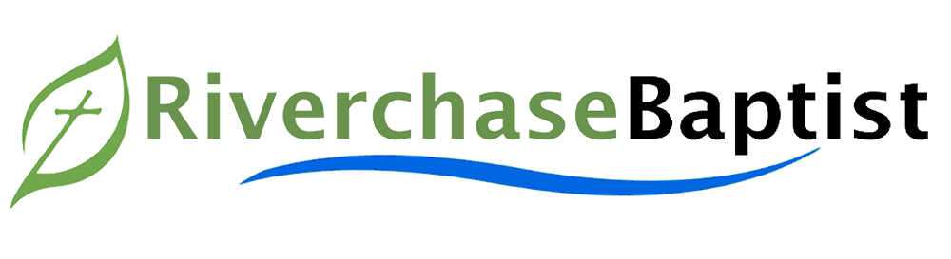
2023 PROPOSED BUDGET



2022 Proposed Budget-
$639,000
2023 Proposed Budget-
$650,000
- Missions- $60,000
- Personnel- $344,800
- Christian Education- $22,500
- Age Specific Ministries- $17,500
- Supportive Ministries- $23,200
- Property & Equipment- $182,000

- Missions- $36,500
- Personnel- $347,500
- Christian Education- $19,500
- Age Specific Ministries- $12,500
- Supportive Ministries- $22,400
- Property & Equipment- $200,600
2023 Total

2022 Total

ADDITIONAL MISSIONS GIVING GOAL:
$40,000

• Myers-Mallory Offering for State Missions (Alabama State Board of Missions)
- Easter Offering for North American Missions (North American Mission Board and CBF Global)
- Christmas Offering for Global Missions (International Mission Board and CBF Global)


RBC Planned Giving Opportunities
The RBC Finance Committee has developed an informational brochure highlighting planned giving opportunities for church members. These opportunities allow members to financially support our church while also maximizing donor benefits. Planned giving helps secure our church’s future by reducing risk, increasing congregational commitment and generosity, and celebrating an individual or family’s contributions to the church. As a donor, planned giving offers tax advantages and a path to creating a philanthropic legacy, even without having to give a large one-time gift. These brochures can be found in the foyer kiosk, the church office, or at riverchasebaptist.org/planned-giving-options.html.
As part of this community of faith and because I (we) have been blessed by God, I (we) commit to the following:

___ I (we) commit to support the ministries of this church by giving my (our) very best in prayer,
attendance, and service.

___ I (we) commit to give at least $____________, per week/month/year (circle one) to the general budget
during the calendar year 2023.

___ I (we) commit to give $____________ in additional missions giving during the calendar year 2023.

Name (please print): __________________________________ Signature: ___________________________
(You may choose to submit your Commitment Card anonymously. Please feel free to do so.)

Automated Gifts:
You may schedule automated gifts through Realm, our online giving platform. To schedule gifts visit: riverchasebaptist.org/giving. Financial commitments may also be created in Realm.
“As each has received a gift, use it to serve one another, as good stewards of God’s varied grace;”
— 1 Peter 4:10
2023 Commitment Card

