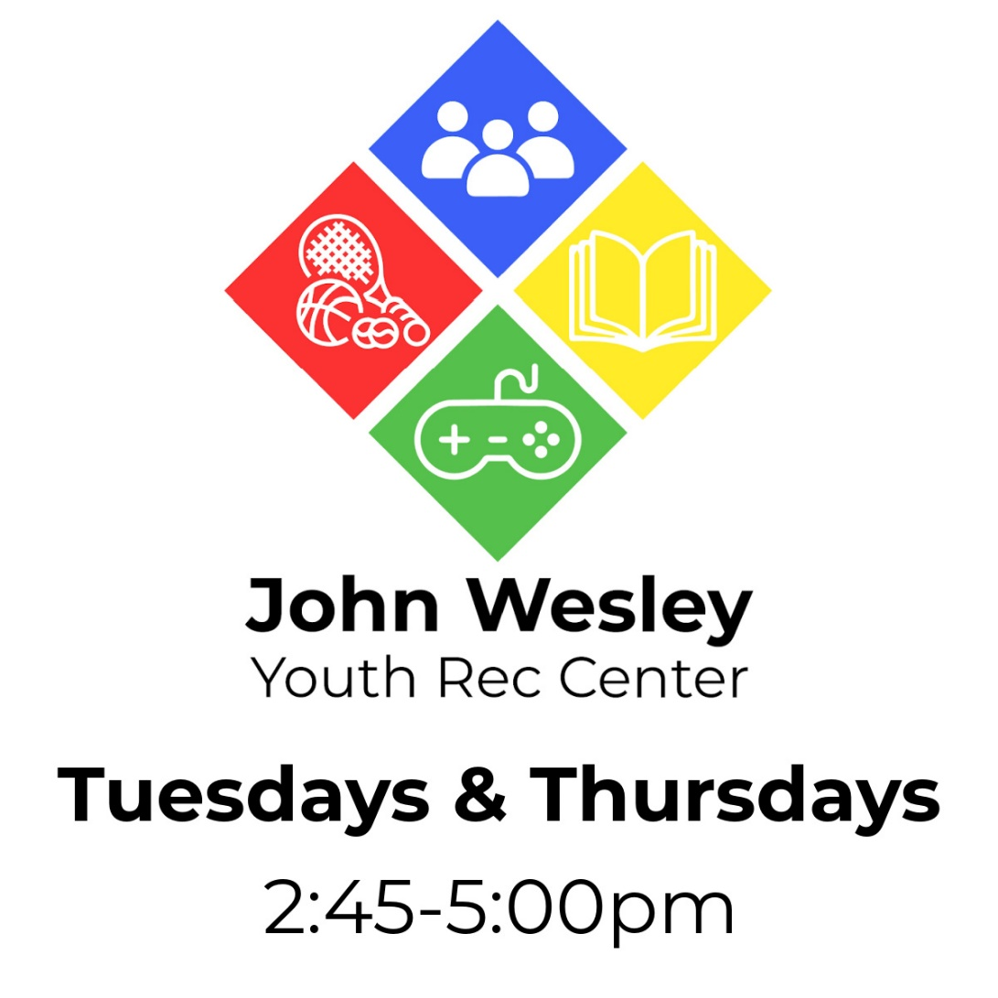
Calendar of Events:
February: March:
14: Valentine’s Day Cards 2: Painting Rocks
16: Paint a Canvas 7 Scavenger Hunt
28: UNO Tournament 9: MarioKart Tournament
14: Baking Cookies
16: Birdhouses
21: Go Fish Tournament
23: Ping Pong Tournament
28: Baking Brownies
30: Painting Flower Pots
The John Wesley Youth Rec Center is open to all middle schoolers (5th-8th grade) and their friends.
Address: 270 Gifford St. Falmouth, MA 02540
Location: Corner of Gifford St. & Jones Rd. The Youth Rec Center is accessible through the back parking lot of the church, next to the basketball hoop.
Our organization does not discriminate on the basis of race, color, sex, gender identity, disability, religion, marital status, national origin, age, sexual orientation or any other class protected by federal, state or local law.

