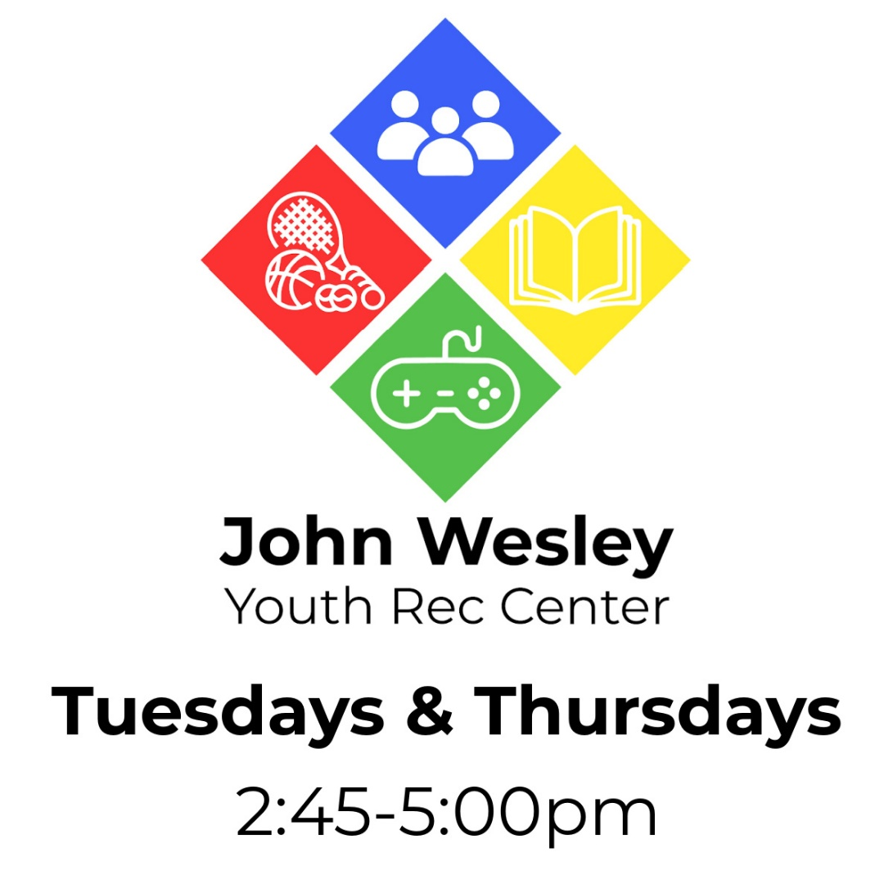

Calendar of Events:
April:
4: Uno 13: MarioKart Tournament
6: Stuffing Easter Eggs 25: Board Games
11: Easter Snack 27: Gaga Ball Tournament
The John Wesley Youth Rec Center is open to all middle schoolers
(5th-8th grade) and their friends.
Address: 270 Gifford St. Falmouth, MA 02540
Location: Corner of Gifford St. & Jones Rd. The Youth Rec Center is accessible through the back parking lot of the church, next to the basketball hoop.
Our organization does not discriminate on the basis of race, color, sex, gender identity, disability, religion, marital status, national origin, age, sexual orientation or any other class protected by federal, state or local law.

