North Carolina Synod Face Covering Distribution

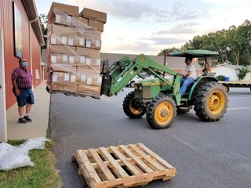
Earlier this year, the US Federal Emergency Management Agency (FEMA) established an opportunity for non-profit sector organizations (including faith communities) to receive allotments of face coverings (masks) for use in the operations of their organization. Pursuant to FEMA regulations, the masks are to be used by congregations in connection with their operational processes. They are not to be given-away to the general public, may not be sold, and may only be used inside the US, its Territories, and the Designated Boundaries of Tribal Nations.

In the past two weeks, a phenomenal crew of folks at St. Luke’s, Mt. Ulla, received our synod-requested supply of 200 boxed units (500 masks per box) into their multi-purpose building on their campus in Western Rowan County.

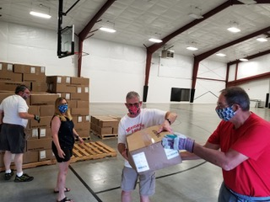
The masks will be available for NC Synod congregations to request and receive. At St. Luke’s, the packages will be sorted, packed, and prepared for delivery to a designated central location within each conference of the synod. Your congregation will need to arrange for pick-up from that location. Our goal is to complete deliveries by mid-September. To facilitate this goal, please complete and submit your form by AUGUST 15 (one form per congregation only, please).

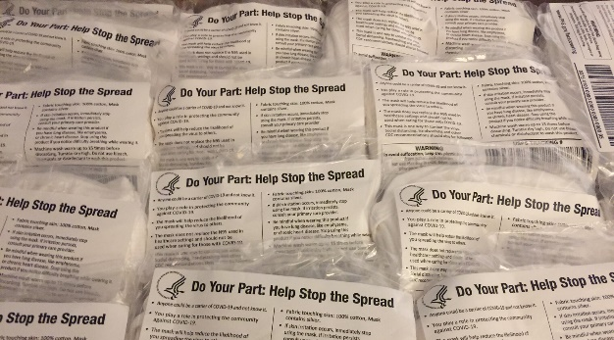
To receive a supply sufficient for your congregation’s needs, please complete this NC SYNOD FACE COVERINGS REQUEST FORM. This form must be completed and submitted by August 15.

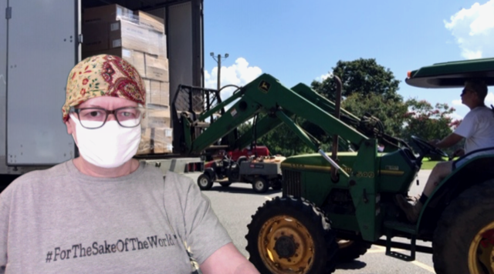
The face coverings are 100% cotton infused with silver to help prevent viral/bacterial growth. They are pre-packaged in sets of four (4), and all are adult—one size fits all. To avoid contamination, packages will not be opened for individual distribution.

If you have any questions, please email Deacon GeoRene Jones, NC Synod Liaison for Lutheran Disaster Response, at GJones@NCLutheran.org.

