October 6, 2020

Dear NC Synod,
Unfortunately, scammers are at it again. Several folks have received emails claiming to be from Bishop Smith. A close inspection will reveal that the emails are, in fact from an email address that is NOT Bishop Smith's. Scammers seem to be making the rounds across the ELCA and other denominations.
Please note:
- None of the synod staff will ever send an email to you directly asking for a personal donation of money or gift cards.
- In addition, no one from the synod staff will ever send an email asking you to send gift cards, perform "some tasks," or vaguely ask you for a "favor."
- NC Synod staff email addresses have the ending of "nclutheran.org."

To keep yourself safe, please take the following precautions:
- Always check the sender's email address. If you can’t see it outright, you can usually hover over the sender's name to see it. Note the red circle in this screenshot:
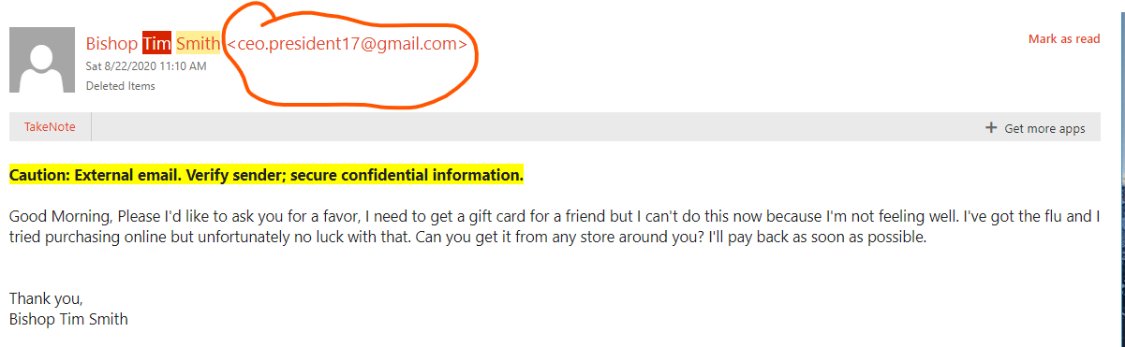
- Delete any suspicious emails. Do not reply to them.
- Don’t ever click on any link in a suspicious email.
- Don’t ever send personal or financial information in an email.
Call the synod office (704-633-4861) or email Catherine Fink, Director of Communications & Resources, if you ever have a question about the validity of an email you’ve received from synod staff.

To report a scam, file a report with the Internet Crime Complaint Center.
FTC.gov post: Worshipers Targeted Gift Card Scam
FTC.gov post: How to Recognize and Avoid Phishing Scams
Anatomy of a Spoof Email

