**Welcome to Our New Residents and Fellows**

Training the next generation of leaders in rehabilitative medicine is one of our most important responsibilities at Spaulding as a teaching hospital of Harvard Medical School. Beginning this month, we welcome our new class of residents and fellows to Spaulding. They are a diverse and talented group, and you will see them throughout the hospital. Please join us in welcoming them, and we look forward to joining with you to support their education and training.

**Spaulding PM&R Resident Class of 2026**

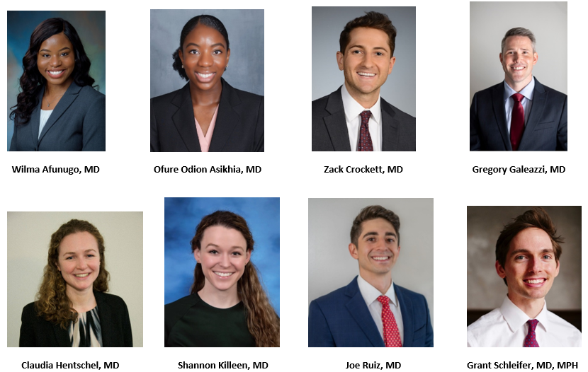

**Harvard/Spaulding Fellows 2023–2024**

