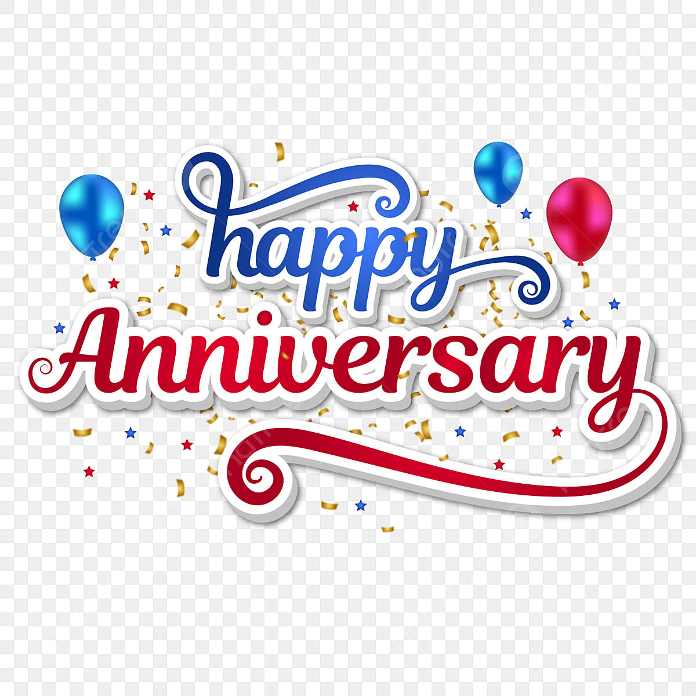

Deacon Bruce & Sarah Becker
July 10, 1976

Deacon Joe & Bernadette Visinsky
July 17, 1976

Deacon Brian & Bonnie Yurky July 27, 2007

Deacon Dan & Beth O’Dowd
August 1, 1981

Deacon Thomas & Helen Buige
August 9, 1969

Deacon Dan & Alison Heiser
August 17, 2002

Deacon David & Diane Lapinski
August 22, 1987

Deacon Laslo & Linda Ivanits
August 27, 1967

Deacon Samuel & Carol Albarano
August 28, 1971

Walter “Wally” & Melissa Zapotoczny
October 2, 2021

Deacon Jim & Karen Janosik
October 10, 1970

Deacon Jay & Nancy Pyle
October 13, 1961

Deacon Don & Cindy Gibboney
October 19, 2007

Deacon Fred & Kathleen Weaver
October 22, 1960

Deacon Thomas & Shirley Boldin
October 23, 1971

Deacon Allan & Joanna Duman
September 6, 1991

Deacon Michael & Barb Condor September 10, 1976

Deacon Mark & Janis Komula
September 11, 1983

Deacon John & Lisa Roth
September 13, 1985

Deacon Mike & Janine Anna
September 14, 1991

Brandon and Kelsey Solnosky
September 26, 2015

Deacon Richard & Jane Golden
September 28, 1974

