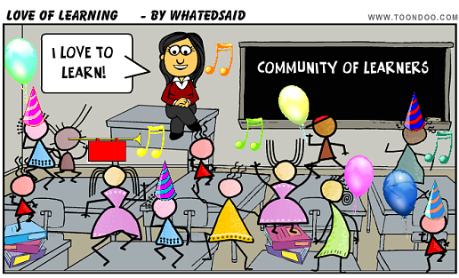  DPAS II Systems Refresher 2018-2019  Please join the Department of Education Educator Support Team as we discuss updates/changes to policies and the guide, examine ways to collect and use your school or district evaluation data to plan professional development, review and calibrate the rubrics and feedback, and discuss processes/protocols for observation and evaluation conferences. There will also be time to work through common Problems of Practice with other schools/districts. | Session 1: July 10-New Castle County-8:30-3:30  ────  Session 2: July 11-Kent County -8:30-3:30  ────  Session 3: July 12-Sussex County-8:30-3:30  ────  Session 4: July 31-New Castle County-8:30-3:30  ────  Session 5: August 1-Kent County-8:30-3:30  ______  Session 6: August 14-Sussex County-8:30-3:30  Register in PDMS for Course # 26998  For more information, please contact Melissa Oates  735-4179  Melissa.oates@doe.k12.de.us

