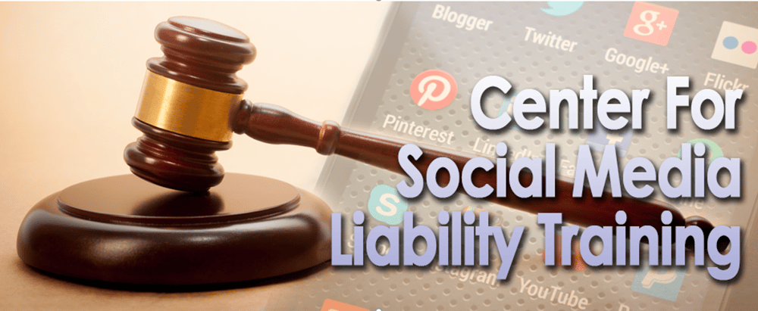
Why My Specialized Social Media Multi-Policy Shield System Are Essential
Recent U.S. Supreme Court, EEOC, FCC, and other agencies have redefined social media as a workplace social media hazard; this completely changes the negligence standards applied to your social media training and policies. Additionally, courts have blurred the lines between personal and work-related social media use by holding public employees and elected officials personally liable for violations related to public records, the First Amendment, and other laws.
Time to Address Social Media as a Workplace Safety Risk
When social media missteps occur, plaintiff attorneys often focus on non-compliant training and policies. To mitigate risk, government entities must shift from viewing social media as a mere communication tool to recognizing it as a significant human resource liability issue requiring expert-crafted policies and training.
This Type Of Specialized Policy Cannot Be Done In-House
In-house attorneys and public and private administrators agree that the new social media speech laws carry hidden risks and complexities. Lacking specialized expertise, they are unable to properly update their social media policies and training to comply with the new federal standards.
Affordable Pricing for All Entities
To accommodate both small and large businesses, I offer a pricing structure that encourages in-house attorneys and decision-makers to make the online course mandatory for all employees and part of their onboarding process. Given the pivotal role social media now plays in civil rights, harassment, defamation, and other legal issues, this two-hour course is a critical resource for defending against claims of retaliation, inadequate training, and negligent policies.
Please keep reading to discover details on our affordable online course and multi-shield policy system.

Questions? Call Now At 954-748-7698
Email: mark@newsocialmedialaw.com
Website: www.DigitalMediaAttorney.com

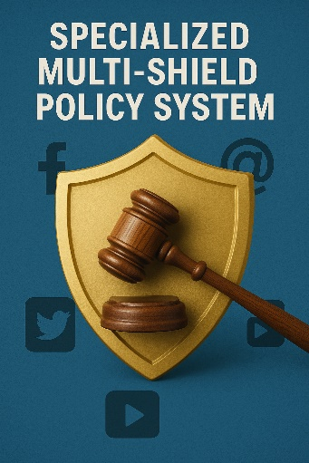
Purpose: These policies, grounded in state and federal law, draw on my 34 years of expertise in public sector digital media to significantly reduce risk for both employees and employers. For maximum protection, I recommend purchasing the complete policy set. If budget constraints exist, prioritize the Primary Employee Social Media Policy Update, Citizens Social Media Policy, and Personal Use of Social Media Accounts and Devices. While the primary policy covers personal use and content moderation, separate policies help counter claims of unawareness, reducing litigation risks.
Cost: $997 for one policy and $798 for each additional policy. If you would like to purchase all the policies, the cost is $4,900. You can purchase one or more policies.
Payment: We prefer you pay for the policy program by check. If you are purchasing both the online course and policy program, you can use one check for both services.
Registering For Policy Shield Program: Email me your choice of policies and I will send you a service agreement. Below are the current policies included in our Mult-Shield Policy System:
- Updated Social Media Policy: A critical policy aligned with new federal social media laws.
- Employee Personal Use Of Social Media And Mobile Devices Policy: A detailed policy clarifying the use of employee personal devices and private social media accounts, ensuring compliance with new federal laws, and eliminating claims of unawareness.
- Blocking, Deleting, Disabling Comments Policy: Essential guidelines for implementing recent U.S. Supreme Court rulings on managing online interactions.
- Customer Social Media Policy: Reduces legal exposure by educating existing or potential customers on the rules regarding use of your company social media sponsored platforms, website, and other electronic communications.

- Social Media Investigation Policy: Provides guidelines for responsible and lawful use of social media in surveillance and investigations.
- AI Policy for Employees: Addresses the hidden legal risks of AI usage in the workplace.

Questions: Call 954-748-7698 or email me at mark@newsocialmedialaw.com

