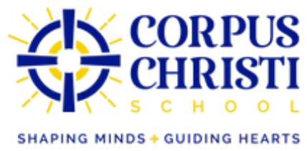

School Board
2025-2026

Fr. Nicholas Melo – Pastor
Ann Sarpu – Principal
Tom Shugrue – School Board Chair
Sarah Clark
Jordan Coe
Diane Edwards
Bernadette Foley
Travis Simpson
Aaron Soucy

Corpus Christi School
581 Silas Deane Hwy
Wethersfield, CT 06109
(860) 529-5487

