Brandon businesses care!

For the health and safety of customers, employees and the entire Brandon community, the following requirements will be in place in many businesses-

-Employees and customers must wear masks.

-Hand sanitizer provided must be used as you enter and exit.

-Limit unnecessary touching of items and surfaces.

-Maintain social distancing.
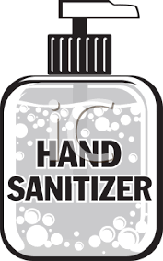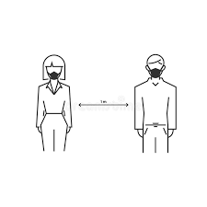

Keep smiling! We can see it in your eyes!

Per VOSHA- no one may enter if they have symptoms
of respiratory illness.

