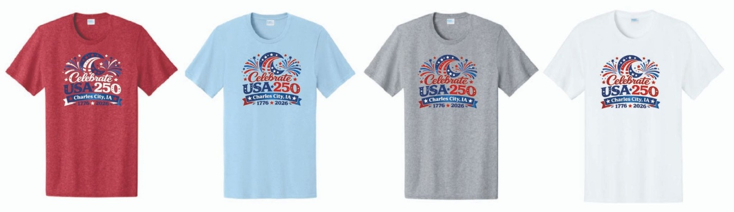
July 4th T-Shirt Order Form
Celebrate USA 250 in Charles City, Iowa with a Special Edition T-Shirt!

Customer Name:
Phone: Email:
2. Select Your Shirts Please enter the quantity desired for each size and color choice.
Size Category | Price | Red | White | Gray | Lt Blue | Total Qty
TODDLER (2T) | $15 |  |  |  | N/A
TODDLER (3T) | $15 |  |  |  | N/A
TODDLER (4T) | $15 |  |  |  | N/A
YOUTH (XS) | $15
YOUTH (S) | $15
YOUTH (M) | $15
YOUTH (L) | $15
YOUTH (XL) | $15
ADULT (S) | $20
ADULT (M) | $20
ADULT (L) | $20
ADULT (XL) | $20
ADULT (2XL) | $20
ADULT (3XL) | $25
ADULT (4XL) | $25
ADULT (5XL) | $25
ADULT (6XL) | $25
3. Order Summary & Payment
Payment Methods: Cash, Check (payable to Charles City Chamber), or Credit Card.
Note: Credit card payments will be assessed a $2.00 processing fee per item.
- Total $15 Shirts Ordered: x $15 = $
- Total $20 Shirts Ordered: x $20 = $
- Total $25 Shirts Ordered: x $25 = $
- If paying by Credit Card: (Total # of items) x $2 = $
GRAND TOTAL DUE: $
Payment Type: [] Cash [] Check (# ) [] Credit Card
[] Invoice (Chamber Members Only)
Please return this completed form with payment to the Chamber office:
Address: Charles City Area Chamber of Commerce, 401 N Main St, Charles City, IA 50616
Phone: (641) 228-4234 | Email: info@charlescitychamber.com

Order Deadline: 3 PM, FRIDAY, JUNE 5TH

