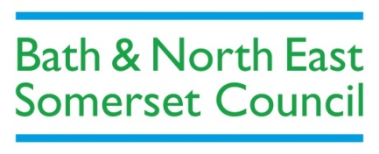

**Community Mental Health Services Review Consultation Pack**

**Find out what people have told us**

**Share your views on our plans**

**The consultation period continues until Friday 22 February 2019**

**This report can be made available in a range of languages, large print, Easy Read or audio format. To request an alternative format, please email** [**banes.yourvoice@nhs.net**](mailto:banes.yourvoice@nhs.net) **or call 01225 831 861.**

**What is in this consultation pack?**

In this pack, you will find out:

1. **What the Bath and North East Somerset community mental health services review is all about.**
2. **What people have told us so far.**
3. **What we (those who commission and provide community mental health services) are planning to do to improve support for people in B&NES.**
4. **How you can share your views and get involved.**

**Why are we reviewing community mental health services?**

Bath and North East Somerset (B&NES) Council and Clinical Commissioning Group (CCG) have been looking at the way community mental health services are delivered locally, so we can decide what improvements need to be made.

This builds on the priorities that were identified in the [your care, your way](https://www.bathandnortheastsomersetccg.nhs.uk/get-involved/project/ycyw) review of community health and care services in 2015-17, and will help us to achieve positive changes in mental health and wellbeing provision for people living in B&NES.

**What are community mental health services?**

The community services covered in this review include all those provided in people’s homes and in local care settings. This includes everything from the local community groups which meet across B&NES for mutual support and activity, to the specialist services and support available during a period of crisis. Inpatient services and dementia related services are not in the scope of the review. Although specialist children’s and adolescent mental health services (CAMHS) are also not in scope, we have considered the transition between these services and adults’ mental health community services as part of developing our outputs and recommendations.

**Get Involved**

Here’s how you can find out what we’re doing to improve community mental health services and share your views with us:

1. **Read our ‘You told us…What we are doing about it...’ summary** and find out what we (those who commission and provide community mental health services) are doing in response to what you’ve told us.
2. **Look at our new approach** for how community mental services could be provided in B&NES.
3. **Fill in the short survey in this pack or complete the survey online.**

**Any questions?**

If you have any questions, please don’t hesitate to contact us by:

Emailing: [banes.yourvoice@nhs.net](mailto:banes.yourvoice@nhs.net)

Calling: 01225 831 861

Writing to: Communications and Engagement Team, St Martins Hospital, Kempthorne House, Clara Cross Lane, Bath, BA2 5RP

**Timeline for the review**

The review is being carried out in four stages and we are involving the public throughout this process to ensure that your views and experiences shape changes that are made.

**Phase 1: Initial engagement**

**May – August 2017**

We asked people who use services, those who care for them, those who deliver services, and the wider public three questions; what is working well? what could be improved? What are the gaps in current services?

Find out what people told us in our phase 1 engagement report [here.](http://www.bathandnortheastsomersetccg.nhs.uk/get-involved/project/mental-health-services-review)

**Phase 2: Planning**

**August 2017 – January 2018**

We looked through all of the feedback and research from phase 1 and agreed the key areas that need to be looked at in more detail in phase 3.

**Phase 3: Developing changes and new ways of working**

**February 2018 – February 2019**

|  |  |
| --- | --- |
| **What did we do?** | **When?** |
| We formed six working groups to look at everything people are telling us and to develop options for how community mental health services could be delivered in the future. Each working group has membership from people across the Council, CCG, Community Champions (who represent the public, those who use services and those who care for and support those who use services), service providers and voluntary sector representatives. | March 2018 |
| We held workshops, inviting people who use services, their carers, those who deliver services, and the wider public, to come together to plan how we can improve how community mental health services are delivered. | June 2018 |
| We delivered further targeted face-to-face engagement with specific groups and communities, to ensure that a diverse range of views inform the changes we are planning make to services. | September-November 2018 |

We are consulting with the public from 1 February – 22February 2019 to share what people have told us and to get your views on changes we are making to the way community mental health services are delivered in B&NES.

**Phase 4: Putting everything into action**

**March – April 2019**

This is when we will put into action all of the agreed recommendations from the review and establish the new agreed ways of working.

**Who has shared their views with us?**

|  |  |
| --- | --- |
| **Since May 2017 we have engaged with more than 600 people** | **Over 300** **people have spoken to us in person** |
| **Over 200 professionals have fed back on our plans** | **8** **Community Champions (who represent the public) have been involved throughout the review as members of our working groups** |

We have met with a diverse range of groups in different settings, including: members of the Black and Minority Ethnic Senior Citizens Association (BEMSCA), carers and young carers via the Carers’ Centre and KS2 Group, young residents at The Foyer, (via Curo), a community group in Keynsham (via Southside Family Project), students at freshers’ fairs and Bath Spa University’s ‘Wonkee Wednesday’ event and young people aged 13-17, via Creativity Works.

We have also met people who use services via organisations, including Avon and Wiltshire Mental Health Partnership NHS Trust, Off the Record, St Mungos, Creativity Works, Bath Mind, Headlight and Healthwatch.

**What people have told us and what we’re doing about it**

People have told us that a new approach for delivering community mental health services must:

1. **Focus on helping people, wherever possible, from reaching a point of crisis and having to get support at hospital.**
2. **Improve community-based support and ensure people get the right support, at the right time from specialist mental health services, particularly when they’re experiencing crisis.**

**You said…**

* Pre-crisis and staying well are one and the same thing. We need an integrated approach to ensure that services engage with people early.
* Social prescriptions – which would be provided by GPs – should be offered as part of a staying well service.
* There are a lot of services that people don’t know about. We need to map these services and ensure that GPs are aware of them and can refer people to the appropriate support.
* We need community connectors/navigators who can support people to access services.

1. **Make sure that services are more joined-up and work together better.**

**You said…**

* People using mental health services currently have a disjointed experience and we need to make sure there are no gaps and overlaps between services.
* It is important for services to work together and be inclusive.
* People have to tell their story repeatedly to the professionals involved with their care.

1. **Make sure that more information is shared, and people are aware about what support is available.**

**You said…**

* We need to improve the signposting of services and ensure people don’t fall through the gaps.
* Services aren’t visible enough and more outreach is needed.
* We need a directory that GPs are aware of, so they can refer people to the appropriate support.

1. **Improve coordination across mental, physical, social and wellbeing services in the community.**

**You said…**

* There are a lot of different services in B&NES but they do not always work well together.
* People would like care coordination to be available in the community before people ‘enter the system’ e.g. community connectors in Frome.

1. **Improve how people are connected from one service to another and ensure people don’t fall through the gaps, as well as providing the right support for GPs and other healthcare professionals.**

**You said…**

* For many it is a disjointed experience and they are ‘passed around services.’
* There should be a single liaison service for substance misuse and mental health.

1. **Have a ‘Think Family’ approach, with strong links between children & young people’s and adult services.**

**You said…**

* Support for the whole family, not just the individual, is key.
* Some carers feel undervalued and may not get the support they need.

1. **Improve support for young people aged 16-25, including those moving from child to adult services.**

**You said…**

* There is a lack of information on what support and services are available for young people. We need an online directory (that is kept up to date).
* Wellbeing and mental health service provision needs to be grouped according to specific age groups e.g. 16+ and then older age groups.
* There needs to be more continued support for young people who transition from child to adult services and ‘shared transition standards’ developed for all services working with 16-25 year olds.

**Some of the things we are doing in response to what you have told us:**

* We have developed a Collaborative Framework that sets out how we expect all the organisations that provide mental health services in B&NES to work together and with individuals so people receive consistent care and treatment. It will require providers of adult and children and young people’s services to work collaboratively in the interests of children and young people at all times, in addition to ensuring safe and effective transitions between services.
* Virgin Care is developing plans for ’floating support’ to include drug and alcohol expertise and an overarching community navigation service to ensure consistent, up-to-date information and advice is readily available in a range of community settings. As part of this there will be community connectors, community navigators and Talking Cafes - services working at a local level, meeting people as part of their everyday lives. Virgin Care is also developing an Integrated Care Record. This will mean an individual’s health records, with their agreement, can be shared by all health professionals involved with their care so people only need to tell their story once.
* Providers of mental health services will need to consider the needs of family members who are supporting an individual with mental health issues. All commissioned service contracts will feature a requirement to embrace a ‘Think Family’ approach.
* A new Carers Charter sets out how carers can expect to be treated by community mental health teams. This Charter will be adopted by all organisations that provide mental health services in B&NES.
* Bath Mind and Virgin Care are working in collaboration to develop an evening safe space called ‘Breathing Space’ which will be open every evening throughout the year, even on bank holidays, to provide a safe space for people at the point of crisis.
* We have developed ‘transitions standards’ which all mental health organisations who work with young people aged 16-25 will be required to adopt.

* The CCG and AWP are working together to improve the physical health of people with mental illness. There are schemes under way to improve the physical health checks undertaken both on AWP wards and in primary care.  Further work to build on these initial developments will be progressed via the Collaborative Framework.
* AWP has worked with Oxford Healthcare to ensure closer collaboration and earlier involvement during the transition from childrens’ and adolescent mental health (CAMHS) to adult services, developing shared protocols and establishing a transitions panel.  This has also enabled the development of common transition standards to be adopted across all mental health providers working with young people aged 16-25.
* We are working with AWP and third sector organisations to build on existing collaboration with schools and universities to ensure that services are better planned and joined up, to provide improved services to young people.

**Read our ‘You told us…What we are doing about it...’ summary** for more information about the feedback we have received and what we are doing in response to what you’ve told us.

**Our proposal – a new approach for accessing mental health support**

We are proposing a new approach for how we deliver community mental health services in B&NES, to make sure that people get the right support, in the right place, at the right time.

Over time, a wide range of community services providing advice, support and treatment for people with mental health needs has evolved across B&NES. Whilst providers of these services have tried to ensure that they work together and meet the range of needs of the whole of the local community, in the absence of a comprehensive and system-wide approach, this has not always been possible.

Our current approach for providing mental health services focuses on experts organised around specific community service functions who work with you at different stages of your need. People have told us that it can be difficult to access the advice, support or care that best meets their needs quickly and easily. At the same time, it is not always easy for providers of services to know which other partner organisations might be most appropriate to offer additional support to an individual, their carer(s) or families. The different services currently available are set out in this diagram:

|  |  |  |  |  |
| --- | --- | --- | --- | --- |
| **Tier 1**  self-directed help and health & wellbeing services | **Tier 2**  Primary Care Talking Therapies | **Tier 3**  Specialist community mental health services | **Tier 4**  Highly specialist condition-specific mental health services | **Tier 5**  High intensity mental health services |
| Support usually involves responding to stress and mild emotional difficulties and may be resolved through making lifestyle adjustments and adopting new problem solving and coping strategies. | Support usually involves responding to mental health and emotional difficulties such as anxiety and depression. Support may involve talking therapies and lifestyle advice. This approach may also support people who have a range of long-term health conditions. | Responding to mental health problems that are adversely affecting the quality of personal, daily and/or family, occupational life. Recovery focused treatment may include psychological and/or drug therapies. | Providing care in response to complex/specific mental health needs. Includes specialist programmes of recovery focused support. | Supporting those in full mental health crisis. Involves intensive recovery and focused support and treatment at home or in a hospital. |

Traditionally people experiencing difficulties that could be related to their mental health are first identified by tier 1 services, for example by their GP or the Primary Care Liaison Team. They may then be referred onto more specialist community services (tier 2 and 3) whilst step 4 and 5 services provide highly specialised, intensive care.

**What we are proposing to change?**

We have identified the Thrive model of provision as the preferred model of mental health provision in B&NES. This approach has recently been adopted to support children and young people locally and builds on a needs-based, whole system approach to supporting people’s mental health.

The Thrive approach replaces the current ‘tier’ pathway or model of care with ‘clusters’ or ‘groups.’ These groups are:

* **Staying Well** - Signposting people to services and equipping them with the skills to self-manage or control mental ill health.
* **Getting Help** –Supporting people to create a goals-based treatment plan, specialist counselling or medical advice, helping them build resilience through support networks.
* **Crisis** - Rapid and intensive evidence-based intervention, extensive treatment, risk management and crisis response.

Thrive recognises that people may access services across all of these groups or just one and will need to be supported appropriately whatever their level of need.

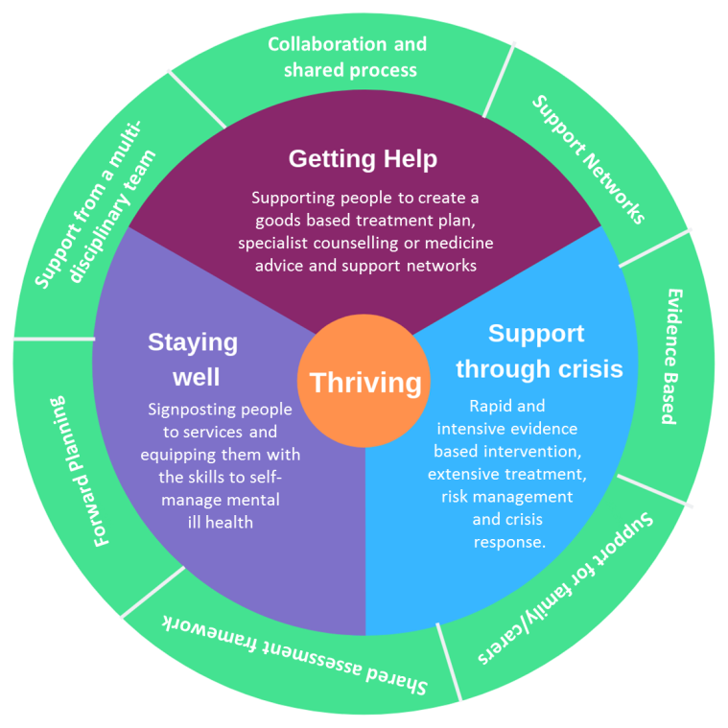

**Principles of Thrive**

Thrive supports the provision of mental health services using a whole-system, population-based approach which focuses on promoting mental health across the whole community, including groups who may be at risk of, or have, mental illness. A population-based approach looks at the mental health and mental illness needs of different groups of people rather than the needs of individuals. It enables integration across health, education, social care and voluntary sector, with a central focus on delivering improved outcomes for people.

Implementation of the Thrive approach, which is expected to take place between April 2019 and March 2020, includes the following:

* Implementing a new approach to assessment with joined-up decision-making across the different organisations involved in supporting an individual. Health and care professionals work with people and their families to identify their needs, determine which Thrive group they fit into, agree the preferred type of support and where it will be provided and to set goals.
* Ensuring everyone leaves services with a forward plan that sets out a bespoke programme of future care and treatment that will best meet their individual needs.
* Providing effective signposting services to promote and embed our comprehensive and integrated network of community providers.
* Building local peer-support networks.
* Developing shared outcomes measures across health, care and voluntary sector services.

**Measuring success**

It is important that we are able to understand the impact that this new approach will have in terms of improving people’s health and wellbeing. To this end we are proposing to introduce a new outcomes framework that will be adopted consistently across all providers in order to incentivise collaboration and a more joined up approach to provision. The framework will contain measures to help mental health providers evaluate their progress to deliver improvements to services.

The draft framework is available as part of this this consultation pack.

**How are services funded?**

Our budget for Community Mental Health Services is £9 million annually. A large element of this budget we give to each provider as a set payment (known as a block contract) to deliver a pre-agreed range of services. We aim to maximise the use of resources by ensuring we spend our budget in a way that will deliver the most effective, safe care for people at the best obtainable value. We will continue to do this as we move to adopt the Thrive approach.

In line with the aspirations set out in NHS England’s Long Term Plan we will also accelerate the roll out of Personal Health and Care Budgets to give people more choice and control over how their care is planned and delivered. This allows people to join up their health and care funding to get the most out of it together.

**What do you think?**

Please fill in our short survey below to tell us what you think of our proposal to change how people access community mental health services in Bath and North East Somerset.

Please note, this survey is also available online.

**Survey:**

1. **Are you responding as (please tick all that apply):**

□ A person who uses/has used community mental health services

□ A person who cares for, or supports, someone who uses/has used community mental health services

□ An interested member of the public

□ A professional

□ Other (please state):

1. **What do you like about the Thrive approach and our plans for mental health services in B&NES?**
2. **Is there anything you don’t like about the Thrive approach and our plans for mental health services? Is there anything you think could be improved?**
3. **What do you think is the most important part of the approach to get right?**

**Equality and diversity information**

It's really important that we ask a diverse group of people for their views about our plans.

To check we are aware of particular issues and needs of different groups in the community, we ask people to give us some information about themselves. This information is completely anonymous.

1. **What is the first part of your postcode?**
2. **How old are you?**

🗆 Under 16

🗆 16-24

🗆 25-34

🗆 35-44

🗆 45-54

🗆 55-64

🗆 65+

🗆 Prefer not to say

🗆 Prefer not to say

1. **How would you describe your gender identity?**

🗆 Male

🗆 Female

🗆 Prefer not to say

🗆 Prefer to use my own term (please specify here):

1. **Do you have a religion or belief?**

🗆 Buddhism

🗆 Christianity

🗆 Hinduism

🗆 Islam

🗆 Judaism

🗆 Sikhism

🗆 No religion

🗆 Other (please specify here):

🗆 Prefer not to say

**3. Is your gender different to the gender**

**that you were assigned at birth?\***

🗆 Yes

🗆 No

🗆 Prefer not to say

\**Transgender is an umbrella term for people*

*whose gender identity in some way differs from*

*the gender they were assigned at birth.*

**6.How would you describe your ethnic group?**

Ethnic origin is not about nationality, place of birth or citizenship. It is about the group to which you perceive you belong. Please tick the appropriate box below:

**Other ethnic groups:**

🗆 Arab

🗆 Any other ethnic group (please specify here):

🗆 **Prefer not to say**

**Asian or Asian British:**

🗆 Indian

🗆 Pakistani

🗆 Bangladeshi

🗆 Chinese

🗆 Any other Asian background

(please specify here):

**Black or Black British:**

1. **What is your sexual orientation?**

🗆 Bisexual

🗆 Gay man

🗆 Gay woman/lesbian

🗆 Heterosexual/straight

🗆 Prefer not to say

🗆 Prefer to use my own term

(please specify here):

🗆 Caribbean

🗆 African

🗆 Any other Black background

(please specify here):

**Mixed or multiple ethnic groups:**

🗆 White and Black Caribbean

🗆 White and Black African

1. **Do you consider yourself to have a disability or health condition?**

Please tick all that apply:

🗆 Physical or mobility impairment

🗆 Sensory impairment

🗆 Mental health condition

🗆 Learning disability

🗆 Long-term condition (such as cancer, HIV, diabetes, chronic heart disease, or epilepsy)

🗆 Prefer not to say

🗆 White and Asian

🗆 Any other mixed background

(please specify here):

**White:**

🗆 English

🗆 Welsh

🗆 Scottish

🗆 Northern Irish

🗆 British

🗆 Irish

🗆 Gypsy or Irish Traveller

🗆 Any other White background

(please specify here):

**Thank you very much for sharing your views with us.**

We will review all of the feedback we get and use this to help inform the new approach to community mental health services in B&NES.

We will share a full engagement report in Spring 2019.

**Please send your completed survey to:**

**Communications and Engagement Team**

**St Martins Hospital**

**Kempthorne House**

**Clara Cross Lane**

**Bath**

**BA2 5RP**

**Alternatively hand the survey into your local GP surgery and we will collect it.**