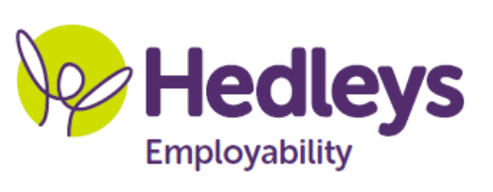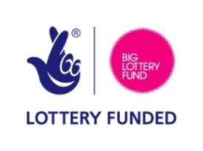
Registration Form
‘An insight into hidden impairment and disability’.
28th April 2017
at
The Britannia Hotel (next to Newcastle international Airport)
Ponteland, Newcastle upon Tyne
NE13 8DJ
8.00am – 9.30am

Name/s:
Position/s:
Organisation:
Address:

Telephone:
email: please supply for joining instructions
Additional requirements: Access, dietary, communication etc.

Employability Project, Station Road Forest Hall Newcastle upon Tyne NE12 8YY Telephone: 0191 2665491 www.employabilityphf.org.uk

Please complete and return this form to dionne.smith@percyhedley.org.uk
Please note booking conditions below

