**SAVE THE DATE**

**New York State 2018**

**Lifespan Respite Sustainability Summit**

**October 18, 2018**

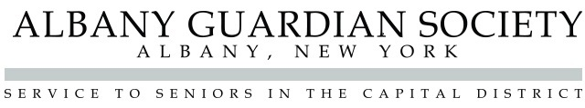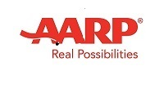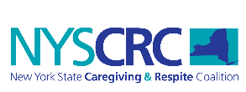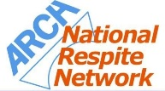Hearst Media Center, Albany, NY

The purpose of the Summit is to: strengthen state and community partnerships to sustain Lifespan Respite activities; develop strategies to maximize use of existing respite resources and identify and leverage new respite funds; engage in sustainability planning; and generate innovative activities for future development.

Consistent with other states’ summits, this event aims to connect policymakers, researchers, family caregivers, and statewide partners to exchange knowledge and expertise, leading to the development of a statewide strategy for strengthening the respite care system for all individuals and caregivers, across the lifespan.