REST programs can be customized around your organization’s requirements.
This full day training is presented in an interactive format.
Participants meet classroom style and in
small-groups to cover all subject matter.
────
Capital Region site 10:00 am - 6:00 pm

────

Scholarships available for NY attendees. For pricing outside of NY,
for more information, or to register, contact
scackett@lifespanroch.org
585-329-9814
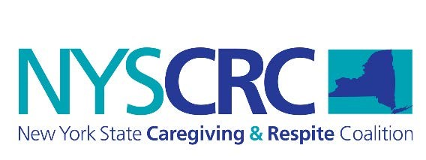

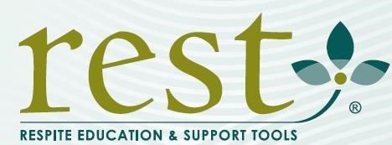TRAIN-THE-TRAINER
June 13, 2019

Do staff or volunteers in your organization provide respite?
Respite, or short-term temporary relief, supports caregivers who are caring for loved ones. Respite allows caregivers to step away from their duties to refresh and recharge.
Respite is often referred to as “giving the gift of time.”
Why should your organization use the REST training?
Hundreds of representatives from religious and healthcare organizations, volunteer organizations, senior living facilities, schools or other groups have taken advantage of this training opportunity.
REST in your NYS respite program can benefit your organization
Consistent, comprehensive evidence-based training aligned with the national guidelines for respite.
Customizable sections to add your specific policies & procedures & scenarios relevant to your population.
Practice and feedback built into the training.
Programmatic support from the NYS Caregiving & Respite Coalition and the New York State Office for the Aging.

NYSCRC is Funded by the federal Lifespan Respite Act Administration for Community Living

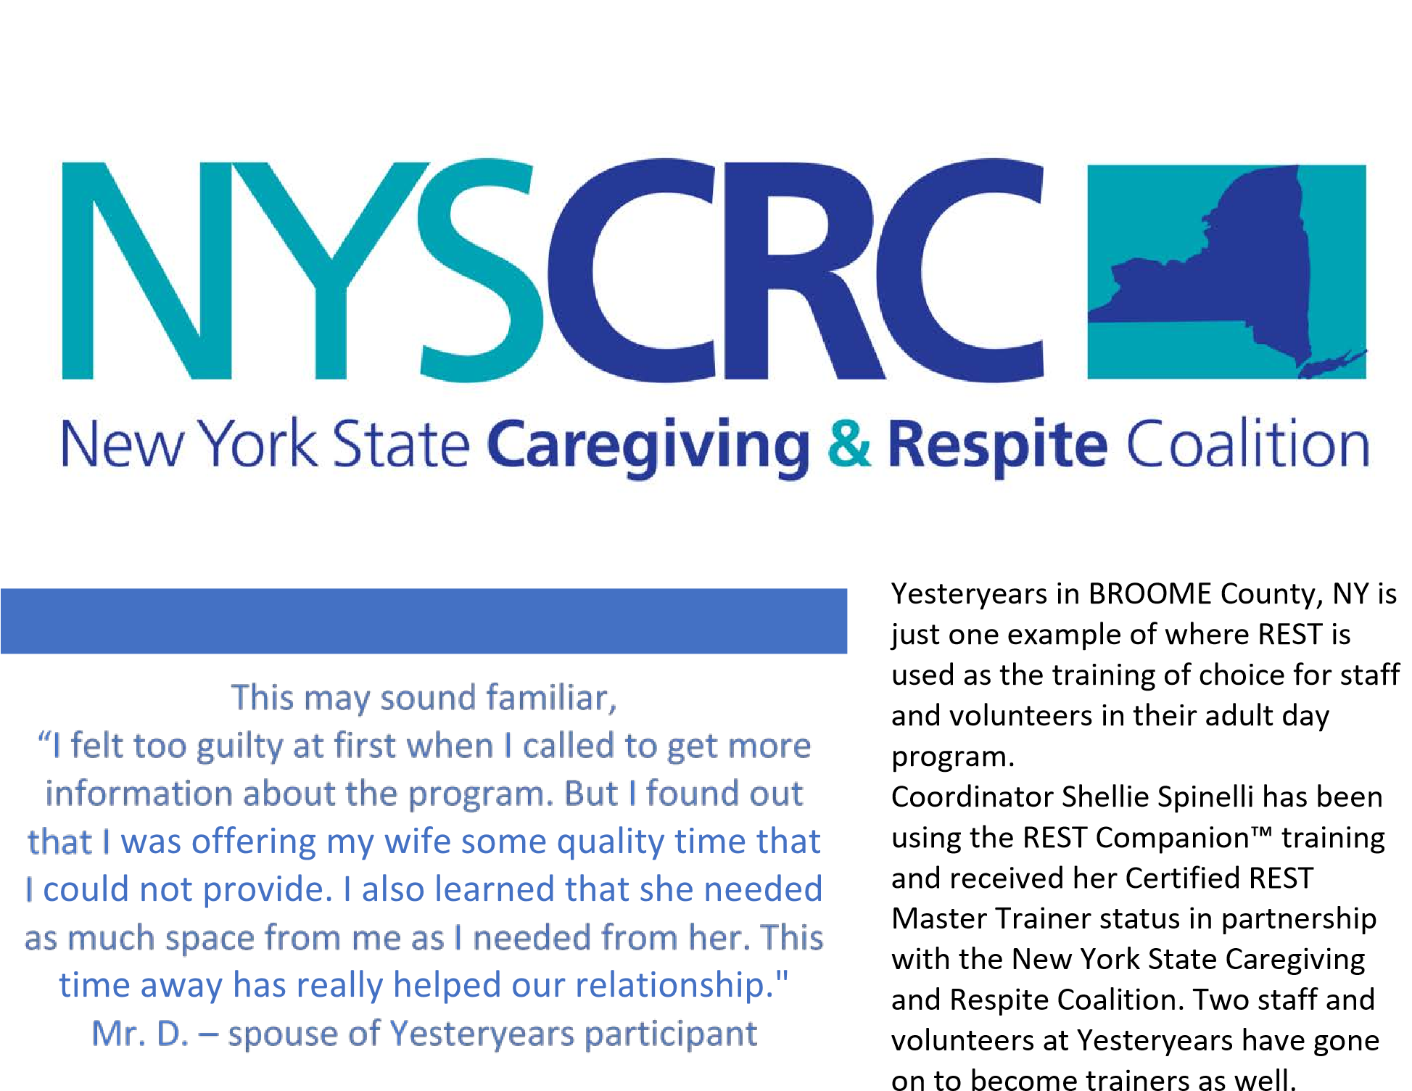

We asked Shellie why she chooses to use REST when training staff and volunteers.
“The Yesteryears Program began using the Rest Companion™ training Course for new staff and volunteers in June of 2017. The course covers all the critical areas of training to comply with our state regulations. One of the biggest advantages of the program is discussions it generates within the group. These discussions help staff and volunteers to look at issues and topics in a new light. The interactive activities provide them with insight into real situations. The number of personal stories exchanged help staff and volunteers to think about how they will react in caregiving situations. People who attended the REST Companion™ training have felt it to be informative, relevant and engaging.”
Shellie Spinelli, Coordinator - Yesteryears

