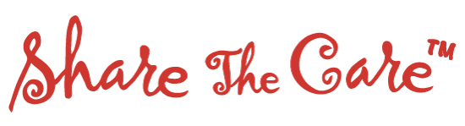

**SAVE THE DATE**

**September 13, 2018**

CareFirst, Painted Post NY

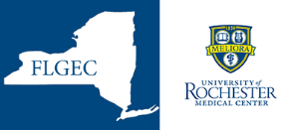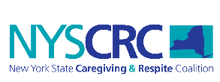

The Share The Care™ model has helped patients and families across the USA and other countries manage the caregiving needs of multiple illnesses, disabilities, or difficulties associated with aging. This unique team approach systematically creates a network of friends, neighbors, work colleagues, etc. to provide caregiving help for the patient and their entire family as well as emotional support for all the caregivers involved.

*Program is FREE. Space is limited. Open to any professionals, volunteers or members of faith communities who support families and caregivers in the following counties: Allegany, Cayuga, Chemung, Cortland, Genesee, Livingston, Monroe, Ontario, Orleans, Schuyler, Seneca, Steuben, Tioga, Tompkins, Wayne County, Wyoming and Yates.*

**Continuing Nursing Education Activity – 6.25 hrs.**

This continuing nursing education activity was approved by the Northeast Multistate Division

(NE-MSD, an accredited approver by the American Nurses Credentialing Center’s

Commission on Accreditation.

**To receive certificate, Nurses must attend the entire training and complete all required**

**paperwork including: pass a quiz and complete required evaluations of the training.**

No commercial support was received for this event

NYSCRC is Funded with a federal grant for Lifespan Respite awarded by the Administration for Community Living to the New York State Office for the Aging. Award Number 90L10023-02-2