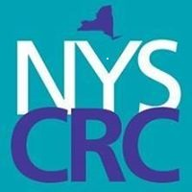
NYSCRC Business Meeting Agenda
Webinar | July 11, 2018 | 11:00 - 12:00
11:00 – 11:05 Welcome: Doris
11:05 – 11:15 Taking Stock – Deana
11:15 – 11:30 - Doris
- Report on Story Growing - present the Video
- National Conference Report
- Volunteer opportunities
11:30 – 11:40 Report on REST initiative – Sharon
11:40 – 11:50 Sustainability Kickoff – Doris and Deana
- Report on preparations for the Sustainability Summit
- Launch of Paid membership – Doris
11:50 – 12:00 – Group Discussion and Next Steps

Thank you for your support!

