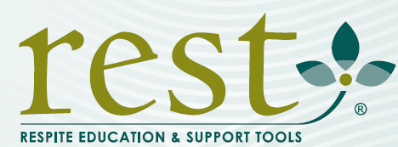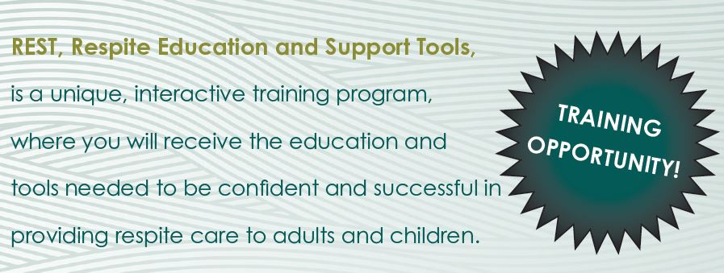

Become a REST Companion**™**

[**www.restprogram.org**](http://www.restprogram.org)

**Kimberly Lyons**

**The Living Well**

**315-536-0838**

Become a Respite Provider for Caregivers

**For Information, Contact**

***Delivering education and***

***support to those offering***

***a break to caregivers.***

**Upcoming REST Companion Essentials Training**

SAVE THE DATE

THURSDAY SEPTEMBER 27, 2018

ST. PAUL’S LUTHERAN CHURCH

135 Hamilton Street