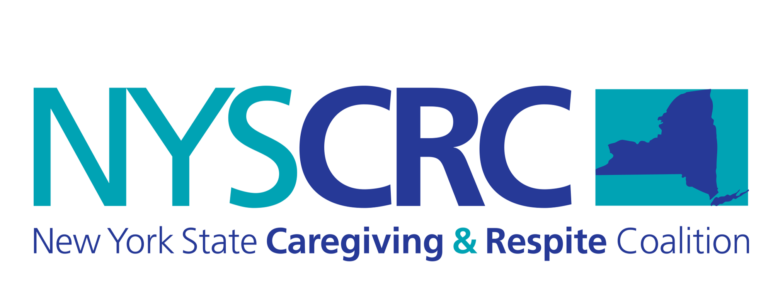
MONDAY AUGUST 20 at 3PM

Monthly NYSCRC REST Trainer Call
NEW CALL IN INFORMATION:
1-515-604-9379 Access code 794843#

- Walk through updated reporting for REST classes completed, REST volunteer hours to be completed by trainers

- If you are a REST Trainer who also happens to provide respite informally, you can enter your hours here.

Conference updates!
- NYS Lifespan Respite Summit October 18, 2018 Hearst Media Center, Albany, NY

- National ARCH Conference in Buffalo, May 2019.
Want to be involved? We are glad to have you join us! Call for proposals online at https://arch.wildapricot.org/Conf2019

- Topic for this month’s call:
ARCH National Respite Guideline –Communication
REST Core Competency-
How to cover this topic in your REST Companion Training

- Powerful Tools for Caregivers Leader Trainings – New format for parents and caregivers of children with special needs.
- ™ FREE Training Opportunity - Thursday September 13 for Finger Lakes region! Click here to register

