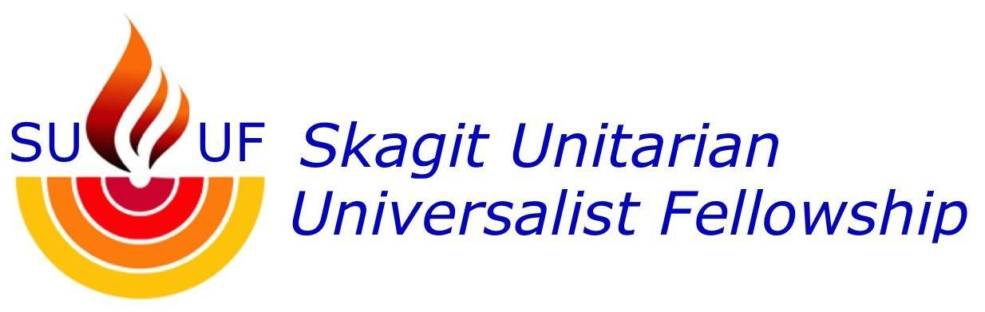

ORDER OF SERVICE
“In Quest of ‘Living Religion’”
March 19, 2023
Speaker: Rev. Bruce Bode
Celebrant: Rosemary Stevens
Introducing New Members: Linda Kuller
Music: Sally Riggers
Media: George Rogers-Clark

Call to Service

Greeting & Congregational News

Chalice Lighting

Introduction of Speaker

Greeting by Minister & Introduction of Theme]

Reading of Article II of the UUA Bylaws

Opening Hymn #131 – “Love Will Guide Us” traditional music, arr. by Betty A. Wylder

Sharing of Joys and Sorrows

Offering & Offertory

Reception of New Members

Reading – “Kindness Is My True Religion,” (Tenzin Gyatso, The XIVth Dalai Lama)

Meditative Song “How We Love,” Beth Nielson Chapman, composer and singer.

Sermon: “In Quest of ‘Living Religion’

Closing Hymn #1057 – “Go Lifted Up” – Mortimer B. Barron, words & music

Closing Words

Extinguishing the Chalice

Circle Song

Goodbye to Zoomers

Contacts:
Board Contact
Emily Bianconi
617-276-6255
pres@skagituuf.com

Office Administrator
Claire Phillips
12-4 Tues and Thur
360-419-9014
skagituu@gmail.com

Covenant Circle meets on Zoom at 5:30 pm on Tuesdays.

The link is in the newsletter

To volunteer to be a greeter, call Doreen Sadler
360 610-1074

New to SUUF? Email skagituu@gmail.com to receive newsletter with Zoom links

Visit our website www.skagituuf.com

The Worship Team values your input, ideas, and feedback! Please email pres@skagituuf.com

Skagit Unitarian Universalist Fellowship

