TAP Ministries, Inc
February 2020



Acts 17:11 These were more noble than those in Thessalonica, in that they received the word with all readiness of mind, and searched the scriptures daily, whether those things were so.

Our goal at TAP is to ship the resources necessary to help churches reach people with the Gospel and to allow followers of Jesus Christ to search and study the Scriptures just as the church in Berea. Thank you for being a part of our mission!



 | 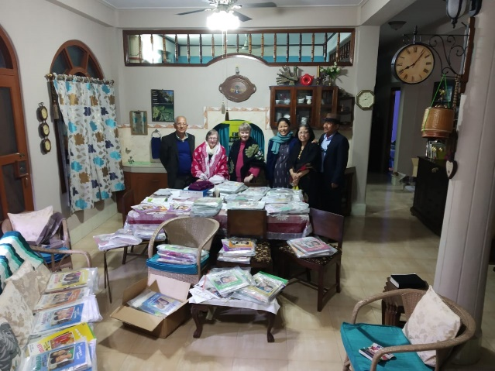
  Sunday School material arrives!
  Our goal in 2019 was to put together a large shipment of Sunday school material and raise the funds to send it. Praise the Lord - this was accomplished! We raised about $800 to ship over 310 pounds of RBP Sunday school material to Missionary Sanatomba & Nancy Singh (Baptist MidMissions) in north/central India. We had many obstacles due to their rural location and the customs department in India which delayed shipping and delivery. To the right is a photo of the teachers unpacking their new material. Thanks to all that had a part in seeing this vision come to fruition.

 | 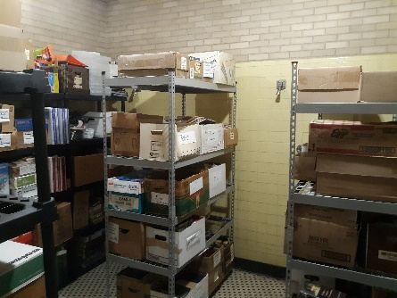
  New Shelving
  We were able to purchase some new warehouse style shelving units. These heavy duty units are great for holding boxes of books - thus helping us better organize our inventory.

Phone Numbers & Contact
We are in the process of updating our phone company. Our old land-line phone number is still in use and will be for a few more months. Our new phone number (which is mobile) is listed at the bottom of this newsletter. Both are available at this time.

Email is really the best way to get a hold of us as we are not regularly in the TAP facility.

 | 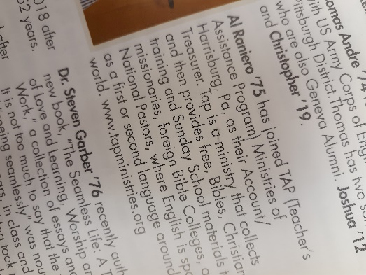
  Mention in Geneva Magazine
  Al Raniero is our treasurer at TAP. He is a graduate of Geneva College and they did a snapshot of their alumni and were able to highlight Al's involvement at TAP, thus giving our ministry a little write up in their magazine.

Online Donations
We have set up online donations. This is available through the online version of this Newsletter and through our website. We are using PayPal to process all donations. Thank you to those of you that have begun to use this avenue of donations.

Monthly Statistics

During January we were able to ship our 12 cartons (312 pounds) of Sunday school material to India. This process took most of the month as there were a number of issues involved in clearing customs in India. We had to re-submit paperwork a number of times, but we did receive confirmation of the final delivery. Praise the Lord! Thank you to the many churches and individuals that made this shipment possible. In addition, we shipped 2 cartons (58 pounds) to CLI for the prison library ministry. We also were able to supply some large print Bibles to a local Nursing home Bible study.

Just before Christmas, Pastor Wes was able to speak at the Christmas banquet at North Hills Bible Church and not only share a Christmas message but also thank this faithful supporting church who has partnered with TAP for many years.

Would you pray with us for an increase in supporters and opportunities to share our ministry with area churches.

For a Printable Version click here

TAP Ministries Inc
717-678-4760
tapministriesinc@gmail.com
tapministries.org

