Employment First Summit: Collaborating for Success
Speaker Information

Bette Ann Mobley has worked with state and national organizations in the field of intellectual and developmental disabilities for more than 35 years. She has served in many leadership roles supporting people with disabilities through advocacy, developing and implementing quality systems, and providing consultation to organizations that provide supports and services. She previously held the position as the Assistant Director for Programs with the Maryland Developmental Disabilities Administration where she was able to establish relationships with key stakeholders and leaders throughout Maryland.
As she begins her work in this new position, she is looking forward to being a part of the development and implementation of the new Maryland ABLE program. Throughout this process Bette Ann welcomes input and feedback to ensure that the program is designed and implemented to help people throughout Maryland with their investment and savings needs without jeopardizing their benefits.
bmobley@marylandable.org www.marylandable.org

Christy H. Stuart, Ed. D., Section Chief for Secondary Transition, Maryland State Department of Education, Division of Special Education/Early Intervention Services
Dr. Stuart is the Section Chief for Secondary Transition at the Maryland State Department of Education, Division of Early Intervention/Special Education Services. In this role, she oversees a State secondary Transition team of specialists who provide consultative services and technical assistance to all local school systems in Maryland that focus on a student’s transition planning process and transition service delivery within a local school system. This position also supports any statewide initiative that leads to the continuous improvement of services as specified through our federally reported secondary transition indicators (Graduation, Drop-Out, Secondary Transition- IEP, and Post-School Outcomes). She is the project lead for a Statewide Core Leadership group through the National TA Center on Transition titled “State Agency’s Transition Collaborative of Maryland”. Dr. Stuart has over 25 years of experience in the fields of special education, school-to-work transition and employment and training of persons with disabilities, especially those with significant support needs. She has several journal publications and has developed numerous products ranging from 411 on Disability Disclosure: A Workbook for Youth with Disabilities, Road to Self-Sufficiency: A Guide to Entrepreneurship for Youth with Disabilities, A Guide to Developing Collaborative School-Community-Business Partnerships and various web-based training materials focusing on integrated employment, self-advocacy, and inclusive higher education transition programs.

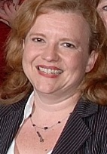
Jade Ann Gingerich has over 20 years of experience in Maryland government most recently as Director of Employment Policy for the Maryland Department of Disabilities. Accomplishments include co leading Maryland’s earliest Employment First efforts, creation of the Employed Individuals with Disabilities program, Maryland’s Medicaid Buy In, leading the Maryland Medicaid Infrastructure grant and co-founding the Maryland’s Youth Leadership Forum.
In addition to her policy work, Ms. Gingerich serves as Project Director for Maryland PROMISE grant, a 5 year research grant awarded to Maryland in October 2013 by the US Department of Education. PROMISE, a cross agency partnership, is intended to increase education and employment outcomes for youth between the ages of 14 and 16 on SSI and their families. Over 85 percent of the 996 PROMISE youth and families receiving the enhanced interventions have completed three or more of the core interventions.
Jade.Gingrich@Maryland.gov

Jill Pierce is the Staff Specialist for Transition and Supported Employment Services with the Maryland State Department of Education, Division of Rehabilitation Services. Throughout her education and career, Ms. Pierce has focused on services that benefit transitioning youth. As a graduate of the University of Alabama she obtained a Master of Arts degree in Educational Psychology focusing on youth with disabilities and moved to Maryland to continue her career in the field.
Jill.Pierce@Maryland.gov

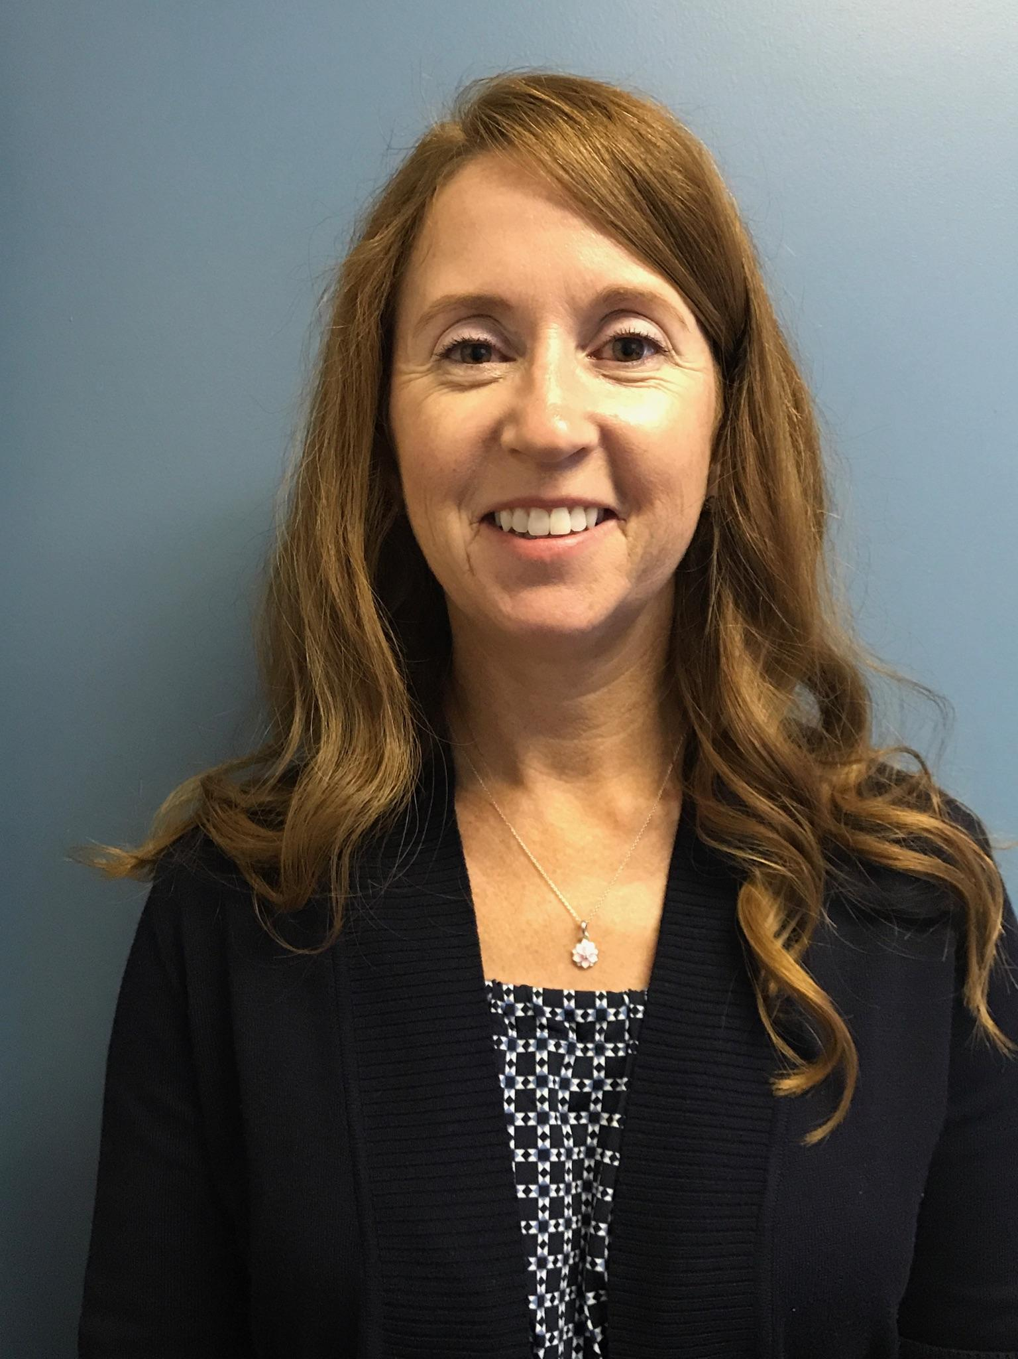
Katie Gell is the Deputy Director of Somerset Community Services. She has worked supporting people with developmental disabilities for over 20 years. Katie started her career in Delaware as a counselor for Children and Families First where she worked with children with disabilities in both the residential and school setting. She was hired by Somerset Community Services in 2000 as a Program Coordinator and received several promotions over the years leading to her current position as the Deputy Director. Mrs. Gell is responsible for the management and supervision of the entire program which supports people throughout Wicomico, Worcester and Somerset Counties. She holds a Bachelor’s Degree in Psychology from Salisbury University and a Master’s Degree of Education in Guidance & Counseling from the University of Maryland Eastern Shore.
katie.gell@somersetscs.org
www.somersetcommunityservices.org

Mara Clawson is an award-winning artist whose work has been juried in to exhibitions all over the United States. She uses pastels and iPad technology to convey her perception of the world. In 2015, Mara started her business, which she named When Colors Get AlongTM. Mara says she knows when an art piece is completed – it’s ‘when colors get along.’

As a 2016-2017 winner of the Kennedy Center and VSA’s Emerging Young Artists with Disabilities award, Mara’s award-winning video, To Survive, was shown nationally in several art museums as part of the exhibition (Re)Invention. Mara’s artwork is continuously exhibited at Art Enables in Washington DC, in periodic shows at VisArts in Rockville, MD and in juried exhibitions nationally. Mara’s solo exhibition of over 40 artworks grossed more sales for the Goldman Gallery in Rockville MD, than all their 2016 shows combined.

Based on Mara’s proposed business plan, the Maryland’s Division of Rehabilitation Services (DORS) awarded her a Reach Independence through Self-Employment (RISE) Program grant in 2017. Mara has taught iPad drawing classes at SCALE and V-linc’s Camp. She has developed a line of products she sells through her website (MaraClawson.com), as well as at art fairs and popup shops. Mara is proud to give back to the state of Maryland by sharing her innate joy for art + life, as well as her income and sale tax dollars.

Mara is the subject of a recently completed documentary film, entitled Living Art by Ground Media’s producer, David Rochkind. The film is an education campaign about disability and inclusion. Sneak previews of the film can be seen in Baltimore at the American Visionary Art Museum’s Bazaart holiday market on November 23rd + 24th, as well as at https://www.filmindependent.org/programs/fiscal-sponsorship/living-art/ .

Rick McAllister has over 30 years of experience in consulting, training and the day-to-day managing of service-based organizations. He is a nationally recognized speaker on employment strategies, leadership, management, and designing creative and effective organizational structures. He has extensive experience providing technical assistance to private, federal, and state sponsored employment initiatives. Specific focus of Rick’s with work state and regional employment programs has been system-wide financial and operational sustainability models. Rick has a bachelor’s degree in business administration and a master’s degree in applied behavioral analysis. He is the Managing Partner/EVP of Management Analytics Resource Collaborative, LLC, a consulting group based in New Hampshire.

Sandy Adkins began his career in 1969 as a volunteer big brother for an individual residing at Rosewood Center. He then began working at Rosewood as a social worker from 1970 until 1985. The last two years were in the newly formed Central Maryland Regional Office coordinating community residential placements into the HCB Waiver. He began working at DDA Headquarters in 1985 as the State’s Waiver Coordinator. Mr. Adkins wrote the Waiver Amendment that first added Supported Employment as a Waiver covered service. In 1990 Mr. Adkins transferred to the DDA Southern Maryland Regional Office as Deputy Regional Director. In 1993 Mr. Adkins left DDA after 23 years and was hired as the Executive Director of Somerset Community Services. During his tenure SCS has grown from a $1.1 million program to a $15 million program. In July 2018 SCS closed its Sheltered Workshop.
sandy.adkins@somersetscs.org

