
May 2026
Ag Insights

Evolving Thoughts on Summer Mineral Intake
Dana Zook, NW OK Area Livestock Specialist
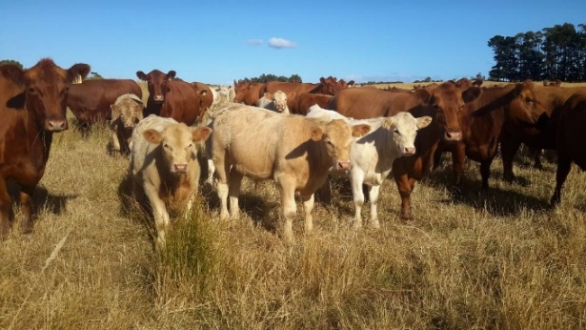
I would say, “Summer’s here!” but as I write this article on May 6th, morning temps were barely 50 degrees. I’m in my flannel shirt this morning but pushing back on the unseasonably cold temperatures to write about a summer topic dealing with mineral intake. Mineral supplementation seems to be an obvious, over-addressed topic however recent research out of Mississippi brings to light surprising results on mineral intake in mature beef cows. It’s a study that every cattle producer should ponder as minerals are offered this summer.
To begin with, minerals are most commonly offered to cattle either by hand-feeding a mineral containing ration or providing a mineral supplement free-choice. Incorporating minerals in a diet that is hand-fed provides the most accurate mineral intake. On the other hand, providing minerals free choice is convenient for producers who have cattle on pasture, and may not necessarily be feeding every day. Mineral intakes within these two systems can be starkly different and Mississippi State researchers revealed the challenges that can come with inconsistent intakes.
In this study, Dr. Isaac Jumper and others evaluated consumption of chlortetracycline (CTC)-medicated mineral to gestating Angus-Charolais cross commercial cows on pasture in Mississippi. To give some clarity, it is common to use free-choice mineral supplements as a vehicle to deliver a variety of medications to cattle on pasture (McDowell. 1996, Arthington and Ranches. 2021, and Tait and Fisher. 1996). In this study CTC was the medication utilized within the mineral to minimize the symptoms of Anaplasmosis. Cows ranged in age from 3-17 years but averaged 6 years of age. While on the study, cows grazed a blend on standing forages containing fescue, dallis grass, and common bermuda. These cows were split into three groups and first fed a corn distillers + salt mixture for 27 days to adapt the animals to the Smart Feeder. After this adaptation period, the DDG mixture within the Smart Feeder was instead filled with CTC medicated commercial mineral and fed for 46 days. Radio frequency identification (RFID) tags on each animal were used to track mineral consumption using a Smart Feeder.
The combination of the RFID tags with the Smart Feeder revealed interesting results. During the 27-day adaption period (DDG+Salt), 76.3% of cattle visited the mineral feeder daily. In contrast, during the 46-day mineral feeding portion of the trial, only 27% of cows visited the feeder daily. I wasn’t surprised to read that cattle also consumed more of the DDG blend on each visit than the CTC mineral. In fact, during the 46-day CTC mineral period, the average consumption was only 0.09 pounds which is well below the typically recommended consumption rate of 0.25 pounds (or 4oz.). Because of this poor consumption level, CTC was consumed well below the labeled rate.
Target consumption for minerals was to provide 1.1 mg CTC/kg bodyweight per day, and cattle only consumed the labeled rate of CTC on average 6.4 days out of the 46 days in the trial period. This brings to question the efficacy of this level of CTC and the compliance with the label. The reality is that free choice feeding rarely leads to accurate consumption – think hay consumption and grain feeding in a self-feeder. Mineral is the same way, but convenience is important to an industry with an ever-growing to-do list. Is there a solution here? I’m not sure but I know that KNOWLEDGE IS POWER! I challenge producers to look at your mineral label and track mineral consumption this summer. Extension has a handy mineral rack card that allows producers to easily track each time mineral is fed. Tracking mineral can help you evaluate mineral consumption but also help ensure cattle are accurately consuming those very important additives for Anaplasmosis and Fly control. Reach out to your county educator for help evaluating mineral consumption. We are here to help!

