  Winterkill Is More Than Just Cold Temperatures
  Mingying Xiang, PhD, Professor of Turfgrass Science / Turf Extension Specialist and Dennis Martin, PhD, Professor of Turfgrass Science / Turf Extension Specialist
  At this time of year, county Extension offices often receive questions about brown turf areas that have not greened up, and many homeowners begin to wonder what happened to their lawns. While these issues are commonly attributed to “winterkill,” turfgrass losses are not always caused by freezing temperatures alone. In turf systems, winterkill is better understood as turfgrass death occurring during or following winter due to multiple interacting stresses. In many cases, cold temperatures are only one part of a much larger, cumulative problem.
  
  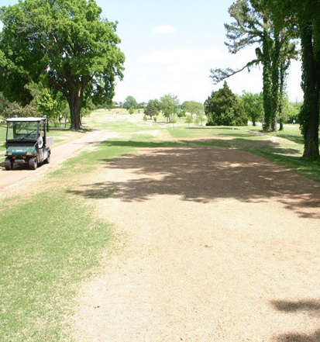
  IC: Dennis Martin

Research and extension observations across the transition zone have shown that winter injury can result from combinations of:
- Drought stress in previous years and winter desiccation
- Root damage from insects such as white grubs
- Disease pressure
- Herbicide injury, especially overuse of pre-emergent herbicides
- Poor drainage
- Nutrient deficiencies and soil compaction
- Poorly adapted species or cultivars
- Shade stress
- Shallow or sandy soils with limited water-holding capacity

One increasingly important consideration is the interaction between drought stress and insect damage. During drought years, irrigated turf areas may attract greater beetle egg-laying activity, potentially increasing white grub pressure in managed lawns and landscapes. Turf already weakened by root-feeding insects can enter winter with compromised rooting and reduced carbohydrate reserves, making it more vulnerable to desiccation and other winter stresses.

In addition, reduced use of preventative insecticide programs over the past decade, partly due to environmental and pollinator concerns may have unintentionally contributed to increased grub injury in some landscapes. While this shift reflects important environmental stewardship efforts, it also highlights the need for careful monitoring and integrated pest management rather than assuming insect pressure is no longer a concern.

Management decisions made during the growing season can also influence winter survival. Repeated applications of long-residual herbicides, particularly on already stressed turf, may further compound injury risk when not paired with proper site assessment and stewardship.

Current bermudagrass winterkill management guides emphasize that successful winter survival depends heavily on maintaining healthy turf throughout the year through proper irrigation, drainage, fertility, cultivar selection, pest management, and stress reduction.

Key Takeaways for Turf Managers and Homeowners
- Winterkill is often caused by multiple cumulative stresses, not just cold temperatures
- Turf weakened by drought, insects, disease, or herbicide injury is more susceptible to winter injury
- Winter desiccation can be especially severe on exposed, windy, elevated, or excessively thatchy sites
- Proactive scouting and site-specific management are critical for improving winter survival

Summary
Winterkill is best understood as a complex stress interaction problem rather than simply a low-temperature event. Improving overall turf health year-round remains the most effective strategy for reducing winter injury and improving spring recovery.

