

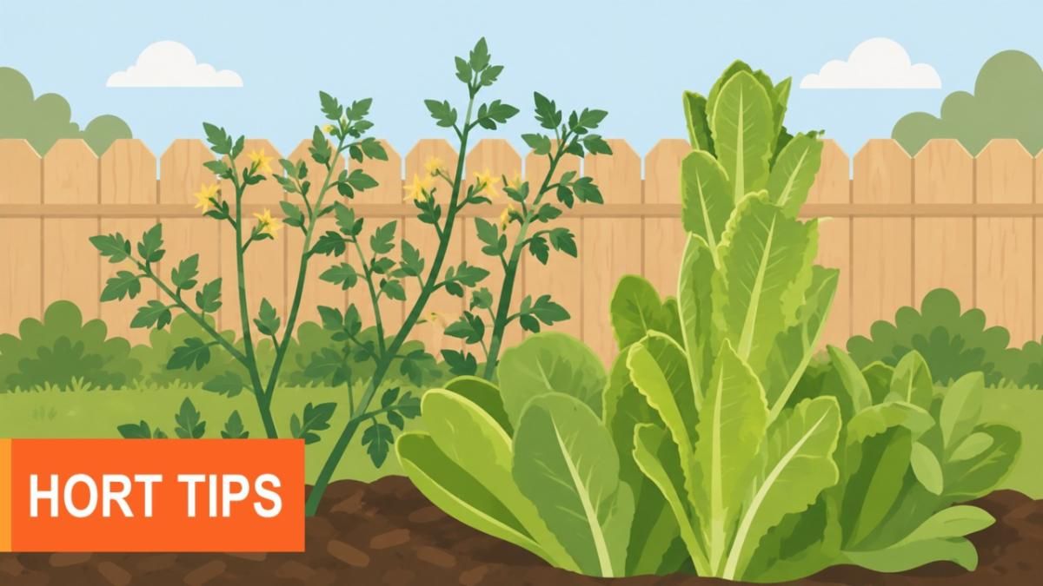

05/15/2026

Garden Tips for Mid to Late-May

Trees and Shrubs
- Prune and feed azaleas immediately after blooming.
- Insect Alert: (EPP-7306):
- Mimosa webworms on mimosa and honey locust.
- Lace bugs on sycamore, pyracantha, and azalea.
- Bagworms on juniper and arborviate.
- Elm leaf beetles and larvae on elms.
- Soak new transplants and newly planted trees unless rainfall is abundant.
- Pine needle disease treatments are needed in mid-May.
Flower Beds
- Annual bedding plants can be set out for summer color.
- Plant summer bulbs such as cannas, dahlias, elephant ear, caladiums, and gladiolus.
- Shake a leaf over white paper to look for spider mites. If the tiny specks begin to crawl, mites are present.
Vegetables
- Plant warm season crops like watermelon, cantaloupe, cucumber, eggplant, peppers, okra, and sweet potatoes.
- Continue maintaining cool season vegetables until they are ready for harvest. Increase irrigation during warm spells.
- Avoid planting vegetable plants too closely together. Crowding leads to a more humid microclimate, thus increasing chance for diseases.
- Scout diligently for common vegetable pests. It is much easier to control a small population than it is a large population of insects.
Lawn and Turf
- Cool-season lawns can be fertilized again. If you did not fertilize cool-season grasses in March and April, do so now.
- Warm-season lawns may be fertilized in May. (HLA-6420)
- The seeding of warm-season grasses such as bermudagrass, buffalograss, zoysiagrass, and centipedegrass is best performed in mid-May through the end of June. The soil temperatures are warm enough for germination and adequate growing season is present to promote winter hardiness.
- Dollar spot disease of lawns can first become visible in mid-May. Make certain fertilize applications have been adequate before ever applying a fungicide. (EPP-7658)
- Nutsedge plants become visible during this month. Post-emergent treatments are best applied for the first time this month (HLA-6421). Make certain warm-season grasses have completed green-up.
- The second application of pre-emergent annual grass herbicides can be applied in late-May or early June, depending upon timing of first application (HLA-6421). Check label for directions.
- Vegetative establishment of warm-season grasses can continue. (HLA-6419)
Fruit and Nuts
- Fruit spray programs should be diligently continued throughout May and early June.
- Late May is the best time to control borders in the orchard. Always check for label recommendations.
General
- Keep the bird feeder filled during the summer and help control insects at the same time.
- Schedule a group tour of the OKG Studio Gardens in Stillwater between the first of May and late October!
- Clean out the water garden and prepare for season. Divide and repot water garden plants.
- Begin feeding fish when water temperatures are over 50 F.

