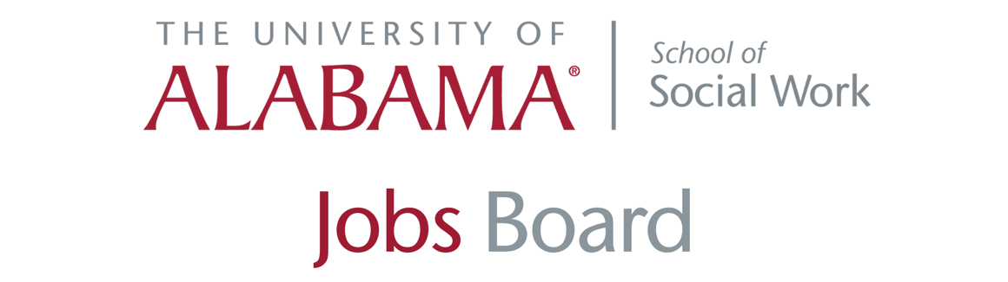
- Children’s Aid Society of Alabama: Four Openings
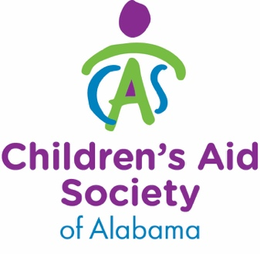
Pre-Adoption Team Leader, APAC, Birmingham, AL
Description:
Children's Aid Society of Alabama is a non-profit social services agency changing lives, building families, and strengthening communities in Alabama for over 100 years. APAC is a program of CAS. The Pre-Adoption Team Leader is responsible for coordinating APAC’s pre-adoption services statewide. The position guides and supervises APAC’s recruitment, training, and home study services related to adoptive family resources under the supervision of the APAC Program Director.

Qualifications:
· Master's degree in Social Work, LMSW or LICSW.
· Five years’ experience in Alabama’s child welfare services, with 5 years in adoption/foster care.
· Management experience, excellent communication, organizational, and problem-solving skills required.
· Ability to respond calmly and non-judgmentally to others, including persons in crisis.
· Ability to work as a team leader and player, encouraging a positive atmosphere for a teamwork approach. Computer proficiency.
· Ability to demonstrate cultural and socioeconomic proficiency.
· Understanding of trauma informed care.
· Must have reliable automobile, valid AL driver's license and liability insurance with bodily injury limits of 100/300; clearance with the Alabama Central Registry on Child Abuse and Neglect, and/or other clearances that may be legally mandated or authorized.

The Pre-Adoption Team Leader is a full-time position based in Birmingham, with travel, some overnight.

Apply at https://www.childrensaid.org/about_us/careers/

Family Advocate, APAC, Mobile, AL
Description:
Children's Aid Society of Alabama is a non-profit social services agency changing lives, building families, and strengthening communities in Alabama for over 100 years. APAC is a program of CAS. This position is responsible for supporting the Team Leader and assisting in providing all regional APAC services.

Qualifications:
Master’s Degree in Social Work or related degree, LMSW preferred. More than 3 years in casework or clinical work with adoptive/foster families. Prefer LMSW, LICSW license/eligible. Valid Alabama driver license and auto insurance minimum liability 100/300. Good communication and problem-solving skills. Computer proficiency. Ability to respond calmly and non-judgmentally to others, including persons in crisis. Ability to work with a team while evidencing the ability to think critically; plan and carry independent work when directed by a Regional Team Leader. Ability to demonstrate cultural and socioeconomic proficiency. Understanding of trauma informed care. Must have reliable automobile, valid AL driver's license, and auto insurance, clearance with the Alabama Central Registry on Child Abuse and Neglect, and/or other clearances that may be legally mandated or authorized.

Apply at https://www.childrensaid.org/about_us/careers/

Director of Community Services, Birmingham, AL
Description:
Children's Aid Society of Alabama is a non-profit social services agency changing lives, building families, and strengthening communities in Alabama for over 100 years. EPIC is a program of CAS. This position provides support to all members of the adoption triad through services described under essential functions; supervises EPIC; and implements and administers services under development.

Qualifications:
Master’s Degree in Social Work. Five years in clinical work with adoptive/foster families and experience in program development and supervision. LICSW; Valid Alabama driver’s license; Auto insurance minimum liability 100/300. Excellent communication and problem-solving skills; Computer proficiency; Ability to respond calmly and non-judgmentally to others, including persons in crisis, to think critically, and to plan and carry out independent work. Ability to demonstrate cultural and socioeconomic proficiency and practice trauma informed care.

Apply at https://www.childrensaid.org/about_us/careers/

Family Advocate, APAC, PART-TIME Position, Based in Mobile OR Montgomery
Description:
Children's Aid Society of Alabama is a non-profit social services agency changing lives, building families, and strengthening communities in Alabama for over 100 years. APAC is a program of CAS. This position is responsible for supporting the Regional Team Leader and assisting in providing all regional Alabama Pre/Post Adoption Connection (APAC) services. Travel and flexible schedule required. There is one part-time position available which can be based in Mobile or Montgomery.

Qualifications:
Master's degree in Social Work, LMSW or LICSW, license/eligibility. More than 3 years of experience in casework or clinical work with adoptive/foster families. Good communication and problem-solving skills. Computer proficiency. Ability to respond calmly and non-judgmentally to others, including persons in crisis. Ability to work with a team while evidencing the ability to think critically; plan and carry independent work when directed by the Regional Team Leader. Ability to demonstrate cultural and socioeconomic proficiency. Understanding of trauma-informed care. Must have reliable automobile, valid AL driver's license, and auto insurance, clearance with the Alabama Central Registry on Child Abuse and Neglect, and/or other clearances that may be legally mandated or authorized.

Apply at https://www.childrensaid.org/about_us/careers/

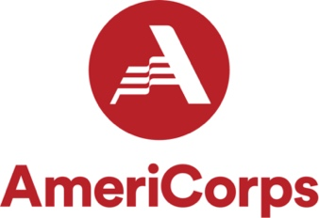
- Educate Alabama AmeriCorps Program: Enrichment Educator
AmeriCorps is a national program that places members in service opportunities across the nation. Members commit 675 service hours, which works out to be about 22 hours a week from now until the end of September. Members are also eligible to serve additional terms of service up to 4 years.

In exchange they are paid a living allowance of $500 per month and reimbursed for mileage, and at the end of their service commitment, they qualify for an education award that they can use towards tuition, student loans, etc. It is usually around $2,470. Members age 55+ can pass this education award on to their children, grandchildren, stepchildren, or foster children!

We have five open slots here we are trying to fill so that our school programs can continue to run at full capacity.

Anyone interested in the position can reach out to Kelsie Tibbetts at ktibbetts@tuscaloosaoneplace.org.

- ADMH: Infant and Early Childhood Mental Health Consultant
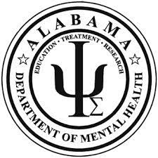
Infant and Early Childhood Mental Health Consultant will provide prevention based mental health support to adults that care for or treat young children ages birth to 5 in early intervention, preschool, other early childhood settings, pediatric healthcare settings, or substance use disorder treatment programs. Need a master’s degree in Psychology, Social Work, Counseling, or related field. Possess 24 months or more experience in a mental health setting providing prevention services or mental health therapy to children and their families OR as a mental health clinician specializing in psychotherapeutic work with young children and their families. Use an official application for Professional Employment (Exempt Classification) which may be obtained from our website at www.mh.alabama.gov. Only work experience detailed on the application will be considered. Applications should be submitted by the deadline to be considered. Announcements open until filled will remain open until a sufficient applicant pool is obtained.

- National Indian Child Welfare Association: Two Positions
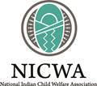
The National Indian Child Welfare Association (NICWA) is now recruiting for an annual giving and donor relations manager. Interested applicants may visit our website at https://www.nicwa.org/employment/, where they can find the attached job description and instructions on how to apply.

If candidates have questions, please direct them to contact deputy director Lindsay Early via email at lindsay@nicwa.org.

- Tuscaloosa’s One Place: Four Enrichment Educators

Tuscaloosa's One Place (TOP) is seeking an Executive Director to lead the agency's dedicated staff in providing diverse programming to strengthen families in the West Alabama community. TOP has made a difference in the lives of local families since 1999 as a family resource center providing social service programming in the following areas: After School & Child Development; Career & Personal Development; Family & Parenting; Teen Intervention & Support.

Qualifications include a master's degree in public administration, social work, education or related field; minimum of five years' experience in administrative management (non-profit preferred); experience in developing programs and service responsive to identified needs; and grant-writing experience. Interested applicants should submit a resume, three references and a cover letter outlining their interest in the position of Executive Director of Tuscaloosa's One Place. All applications will be kept confidential. Candidates will be notified before their references are contacted. Please send all documentation to Alisa Robertson, Chair TOP Executive Director Search Committee arobertson@westervelt.com.

- JBS: Multiple Positions

JBS Mental Health Authority is seeking applicants for several positions within their Children's Services Program:

(2) Group Care Coordinators - Part-Time, Master's level position to provide Group Therapy to identified youth in Jefferson County Schools. Licensure preferred. Starting $18 hour/up to 20 hours per week

(2) Clinical In-Home Intervention Team Leaders - full-time, Master's level position providing intensive in-home intervention as part of a team to identified youth living in Jefferson County. Applicant must have 1 year post master's experience working in a clinical mental health setting providing individual and family services to youth and families. Licensure preferred.

(1) Clinical In-Home Intervention Team Leader - full-time, Master's level position providing intensive in-home intervention as part of a team to identified youth living in Blount/St. Clair Counties. Applicant must have 1 year post master's experience working in a clinical mental health setting providing individual and family services to youth and families. Licensure preferred.

(1) In-Home Intervention Co-Therapist - full-time, Bachelor's level position in a health/human services field (psychology, social work, human development/family studies, criminal justice) providing intensive in-home intervention as part of a team to identified youth living in Jefferson County. Applicant should have experience working with youth and families.

(4) School Counselor - full-time, Master's level positions providing services to assigned school settings providing individual and family therapy to identified students who meet SED criteria. Licensure preferred. Available positions:
Pell City Schools
Oneonta City Schools
Blount County Schools
Jefferson County Schools (**Requires LPC licensure)

(1) Supportive Employment Specialist - full-time, Bachelor's level position working with our First Episode Psychosis clinic providing educational and workforce support to clients in the program. Must have the ability to seek educational and employment resources in the community.

(2) Therapeutic Mentor - part-time, High School diploma level position working with youth that have identified skill deficits. Applicant will work with assigned youth to teach, model, monitor and observe skills with youth and their families. $12 hour/ up to 20 hours per week. Positions available in Jefferson, Blount and St. Clair Counties.

Full job announcement can be found at www.jbsmha.com -- scroll down to the Job Announcements tab.

- Alabama Department of Human Resources: Multiple Positions
The Alabama Department of Human Resources is hiring BSWs and MSWs seeking opportunities to serve Alabama’s Children and Families. Responsibilities include development of social service plans for a caseload in child protective services, child foster care and/or adoptions; assessing child abuse and neglect; providing immediate crisis intervention, assessing need and delivery of services; arranging for clinical services; preparing reports and assessments. The following positions are available statewide:

Social Service Caseworker I; Social Worker I; Senior Social Worker I

Complete an Application for Examination Form available at www.personnel.alabama.gov or an Alabama Career Center Office.

Apply on-line, by mail or by fax. Applications will be accepted until further notice.

- Northwest Alabama Mental Health Center: Multiple Positions
The Northwest Alabama Mental Health Center is seeking to fill multiple positions in nine (9) categories including the following: Therapist, School Based Mental Health Therapist, In Home Intervention Therapist, LPN, Case Manager, Program Coordinator, Mental Health Tech, Child Mental Health Tech, Substance Abuse Tech. For complete job descriptions and locations, click here, and to apply to each job, visit www.nwamhc.com.

- School of Social Work: Graduate Assistant in Diversity Office
University of Alabama School of Social Work Chief Diversity Office is offering a Graduate Assistant Opportunity. Interested applicant preferences include the following: committed to promoting social and racial justice; foster a safe, accepting, racially diverse environment; flexible work schedule 20 hours per week; ability to perform resource development, researching, and program planning. For more information, contact Shayla Smith, LMSW, by email at stsmith7@ua.edu or by phone at 205-348-4529. Interested applicants also need to fill out a survey reach can be reached here.

- Birmingham AIDS Outreach: People First Social Worker
Birmingham AIDS Outreach is searching for a People First Social Worker. The purpose of People First is to build upon the remarkable findings of the previously-awarded HC3 program by providing streamlined HIV and HCV testing for the general public with an emphasis on those who use substances, strengths-based linkage to community PrEP providers, e.g., BAO’s Magic City Wellness Clinic (MCWC) or HIV and/or HCV treatment, and an evidence-based individual- and group-level intervention to motivate HIV, HCV, and substance use prevention and to encourage early retention in HIV and HCV treatment.

For a full job description, click here. For more information, contact Josh Bruce, MPH, Director of New Initiatives, at josh@birminghamaidsoutreach.org.

- Sevita Health: Foster Care Therapist
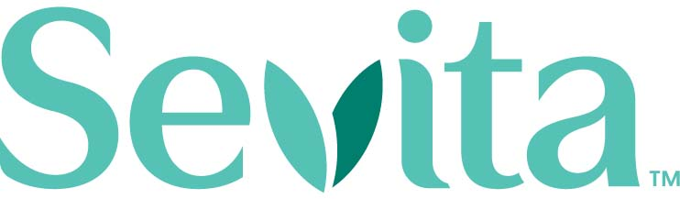
Sevita is searching for a master’s level clinical therapist for foster care youth to work in the Mobile, Alabama area. The position requires at least 2 years’ experience working in family and children’s services or a similarly related field. This role is part time or full time with a flexible schedule.

Contact for opening is Brent O’Keefe, Talent Acquisition Senior Recruiter, Brent.OKeefe@SevitaHealth.com. For more information, visit here

- The Bridge: Therapists (QSAP I) and Counselor (QSAP II)
Resumes are being accepted for the following programs/locations: Residential Adolescent Treatment program, Gadsden, AL; Mobile and Central Baldwin Counties’ Outpatient programs. These are full-time positions, providing treatment services, including substance abuse treatment, to clients and their families, consistent with the training, experience, and scope of practice established by their respective discipline and Alabama law. Resumes may be submitted to awinkles@bridgeinc.org, or faxed to 256-546-9038. Please identify which position and area you are interested in (Gadsden, Mobile, Central Baldwin Co.). For more information about The Bridge, please refer to www.bridgeinc.org. Click here for a description of available positions.

- Central Alabama Wellness: Case managers, MHT's, Employment Specialist

Central Alabama Wellness has several positions open for case managers, mental health technicians, employment specialists and more!

Visit our website https://centralalabamawellness.org/employment/ for more
information.

- Tri-Will, Inc.: Therapist
Tri-Wil, Inc. is searching for a full-time therapist interested in working in moderate level residential care with teenagers ages twelve to eighteen in Woodstock, Alabama. Duties include case management, managing intakes and treatment plans, conducting group and individual sessions, and responding to on call or crisis with a rotating on-call schedule. Applicants Must hold a valid license, High School Diploma and be 21-years of age. For more information, email triwil@triwil.com

- Tuscaloosa One Place: Bachelor's and master's level social workers
Tuscaloosa One Place is seeking experienced social workers. Duties include providing interventions, social and emotional support, and case management services to children and families in a school setting. Minimum of bachelor’s or master’s degree in social work or related field is preferred. Preference given to candidates with current Alabama social work license. Applicants must complete TOP application and submit resume tokbormann@tuscaloosaoneplace.org.

- Hospice of West Alabama: Full-time home care
Hospice of West Alabama is seeking a full-time home social worker. The candidate will work Monday through Friday with a weekend rotation. Apply.

- Youth Villages: Federal Policy Manager
Youth Villages, a leading non-profit organization dedicated to helping emotionally and behaviorally troubled children and their families, is seeking a federal policy manager for its office in Arlington, Virginia. The position requires a master's degree in law, public policy, or social work, and 10 or more years experience in child welfare or juvenile justice.

More information and to apply.

- Glenwood: Services coordinator, home manager, and more
Glenwood, an autism and behavioral health care provider in Alabama, has several positions open. To learn more about each position and to apply, visit Glenwood's employment page or click each link below:

Adult Residential Home Manager: responsible for monitoring Individuals served treatment plans; supervise and manage direct care staff. Other duties include completion of required administrative and individual-related paperwork, managing day-to-day administrative and programmatic tasks, and more.

Direct Support Professionals (DSP): to work in in Glenwood's Adult, Children and Adolescent and SED Residential Services programs making a positive impact in the lives of children and adults with an Autism diagnosis.

Registered Behavior Technician: serving children ages 2-6 with an autism spectrum disorder. This position’s role is to provide 1:1 early intensive behavioral intervention (EIBI) including naturalistic teaching, incidental teaching, and discrete-trial training to a young child with autism.

- CED Mental Health Center: Therapist, care coordinator positions
CED Mental Health, which operates in Cherokee, Etowah and DeKalb Counties in Alabama, has therapist positions open.

Apply here. For more information about the positions below, email Teresa Dawson, clinical director for CED.

- Al’s Pals: Grad student site supervisor
The Al's Pals mentorship program is seeking a currently enrolled graduate student to supervises UA mentors and student leaders at a Tuscaloosa City or County elementary school site, while assisting the Al's Pals Coordinator with leadership development for students participating in the Al's Pals program.

The Al's Pals site supervisor works closely with the coordinator of Al's Pals and the student team leaders in the daily running of the program at the elementary school sites that Al's Pals serves. The Site Supervisor will work 2 days a week from 2:30-5:30 p.m., Monday through Thursday at a site to ensure that attendance and incident reports are taken correctly, monitor classes at the location, serve as a liaison for Al's Pals with the community partner or school representative on site.

The position pays $10 an hour. For more information, contact Allison Espey, coordinator for Al's Pals, at 205-348-9934 or at allison.espey@ua.edu.

- Indian Rivers Behavioral Health: Direct care, clinicians

Indian Rivers Behavioral Health has a variety of open positions throughout its three-county area in the state. Positions include program therapists in the children's services department, direct care in residential settings, and clinicians for adult outpatients.

View all of Indian Rivers' job listings.

- Centurion Health (Ga.): Licensed mental health professional

Centurion, a mental health services provider for the Georgia Department of Corrections, is seeking a full-time mental health professional to join its team at Hays State Prison in Trion.

Candidate must hold a master’s degree in psychology, social work, counseling, or a related field.

The Licensed Mental Health Professional provides mental health case management services to patients in a correctional setting and consults with a multi-disciplinary team in providing comprehensive mental health care, including: intake and assessments, crisis intervention, treatment planning, and providing individual and group therapy.

More info.

- Impact America: Memphis and Birmingham positions
Impact America, a nationally recognized nonprofit organization that recruits recent college graduates to address consequences of poverty through health, economic, and education-based initiatives, has positions open in Birmingham and Memphis.

Students can easily apply using this link. If a student has any questions about the hiring process or about AmeriCorps, email Grace Standridge, Impact America’s recruitment manager.

Impact has the following positions open:

- Impact America AmeriCorps Member - Alabama and Tennessee
- SaveFirst Team Lead - Memphis Office, AmeriCorps Member
- FocusFirst Team Lead- Memphis Office, AmeriCorps Member

- SAFFT: Clinical therapist; family success manager
Cumming, Georgia-based Supporting Adoption and Foster Families Together, Inc. has several full-time and part-time open positions, including clinical therapist and family success manager. Learn more.

- Case managers, clinicians: Mental Health Center of North Alabama

The Mental Health Center of North Alabama has several positions open for adult clinicians, in-home therapists, in-school therapists and case managers.

MHCNA currently has 18 positions open in four different counties across North Central Alabama.

Visit the MHCNA jobs board for more info.

