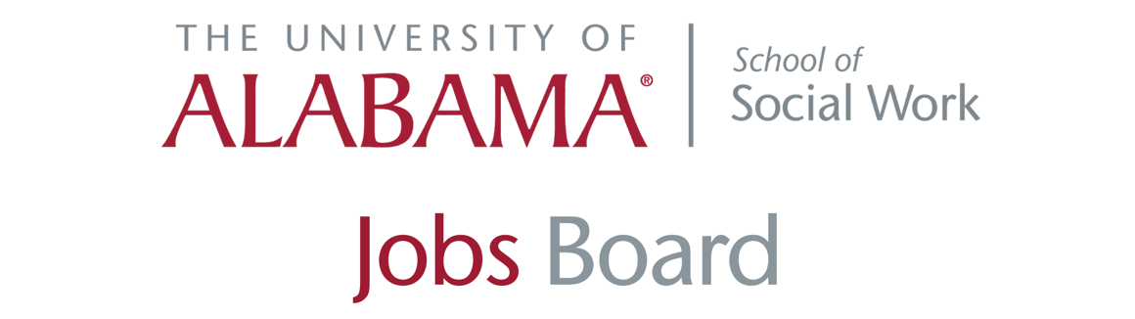

- Tuscaloosa City Schools: Social worker
Tuscaloosa City Schools is seeking a MSW-level social worker with at least three years of field experience. Applicants may go to the website and click on "Popular Links," which has a drop-down menu. Click on "Jobs" and then click on "Classified Jobs." This position closes TODAY.

More information (PDF download)

- SPM: Service coordinators

SPM, a property management company headquartered in Birmingham, is seeking a part-time service coordinator (Cullman area) and a full-time service coordinator (Birmingham area) for its independent living apartment communities in those areas.

The service coordinator must assist elderly and disabled residents living in affordable housing communities to identify, locate and acquire the services and supports necessary to become and remain self-sufficient.

A bachelor’s degree in social work, gerontology, psychology or related field and experience in human/social service-related field is required. In addition, it is preferable that applicants have knowledge of local community services, federal and state entitlement programs, and other resources for senior adults.

Interested candidates should forward their resume to tonyab@spm.net.

- Hospice of West Alabama: Full-time home care
Hospice of West Alabama is seeking a full-time home social worker. The candidate will work Monday through Friday with a weekend rotation. Apply.

- Youth Villages: Federal Policy Manager
Youth Villages, a leading non-profit organization dedicated to helping emotionally and behaviorally troubled children and their families, is seeking a federal policy manager for its office in Arlington, Virginia. The position requires a master's degree in law, public policy, or social work, and 10 or more years experience in child welfare or juvenile justice.

More information and to apply.

- Glenwood: Services coordinator, home manager, and more
Glenwood, an autism and behavioral health care provider in Alabama, has several positions open. To learn more about each position and to apply, visit Glenwood's employment page or click each link below:

Family and Community Services Coordinator: to lead and supervise the Family and Community Services (FACS) program within the guidelines of all accrediting groups.

Adult Residential Home Manager: responsible for monitoring Individuals served treatment plans; supervise and manage direct care staff. Other duties include completion of required administrative and individual-related paperwork, managing day-to-day administrative and programmatic tasks, and more.

Direct Support Professionals (DSP): to work in in Glenwood's Adult, Children and Adolescent and SED Residential Services programs making a positive impact in the lives of children and adults with an Autism diagnosis.

Registered Behavior Technician: serving children ages 2-6 with an autism spectrum disorder. This position’s role is to provide 1:1 early intensive behavioral intervention (EIBI) including naturalistic teaching, incidental teaching, and discrete-trial training to a young child with autism.

Behavior Teacher Assistant: in Allan Cott School serving children with an Autism diagnosis while working with a collaborative team of Special Educators, Board Certified Behavior Analysts, and Speech and Occupational Therapists.

- CED Mental Health Center: Therapist, care coordinator positions
CED Mental Health, which operates in Cherokee, Etowah and DeKalb Counties in Alabama, has therapist positions open.

Apply here. For more information about the positions below, email Teresa Dawson, clinical director for CED.

Positions available

Etowah County:
- ACT Therapist -- caseload of 26, three-person team, adult in-home services (requires master’s degree)
- In-Home Intervention Therapist -- caseload of six (Intensive in-home services with children and their families) (requires master’s degree)
- Outpatient Therapist (requires master’s degree)

DeKalb County:
- Outpatient Therapist (requires Master’s Degree)

CED Mental Health Center (serving Cherokee, Etowah and DeKalb Counties) Etowah County:
- Intensive Care Coordinator – Works with children/adolescents, their families and other agencies (bachelor’s degree required)

- Al’s Pals: Grad student site supervisor
The Al's Pals mentorship program is seeking a currently enrolled graduate student to supervises UA mentors and student leaders at a Tuscaloosa City or County elementary school site, while assisting the Al's Pals Coordinator with leadership development for students participating in the Al's Pals program.

The Al's Pals site supervisor works closely with the coordinator of Al's Pals and the student team leaders in the daily running of the program at the elementary school sites that Al's Pals serves. The Site Supervisor will work 2 days a week from 2:30-5:30 p.m., Monday through Thursday at a site to ensure that attendance and incident reports are taken correctly, monitor classes at the location, serve as a liaison for Al's Pals with the community partner or school representative on site.

The position pays $10 an hour. For more information, contact Allison Espey, coordinator for Al's Pals, at 205-348-9934 or at allison.espey@ua.edu.

- Indian Rivers Behavioral Health: Direct care, clinicians

Indian Rivers Behavioral Health has a variety of open positions throughout its three-county area in the state. Positions include program therapists in the children's services department, direct care in residential settings, and clinicians for adult outpatients.

View all of Indian Rivers' job listings.

- Cullman City Schools: Mental health services specialist

Cullman City Schools is seeking mental health services specialists to work with K-12 students. The ideal candidate must hold a bachelor’s degree in social work, counseling or other mental health field.

One position will work with K-6 students, while the other will work with students in grade 7-12.

Applicants must apply through the Teach in Alabama website.

- Family Life Center: Assessor
Family Life Center seeks an assessor in the Gadsden area to provide substance abuse psychosocial assessments to individuals who may have substance abuse disorders.

A Master’s degree from a nationally or regionally accredited college or university in psychology, social work, or behavioral health field with equivalent clinical coursework is required. (Experience does not substitute for education)

Must be a team player with excellent time management and organizational skills. Phone calls and walk-in applications WILL NOT be accepted. Please email letters of interest and resume to shereel@familylifecenter.ws.

- Centurion Health (Ga.): Licensed mental health professional

Centurion, a mental health services provider for the Georgia Department of Corrections, is seeking a full-time mental health professional to join its team at Hays State Prison in Trion.

Candidate must hold a master’s degree in psychology, social work, counseling, or a related field.

The Licensed Mental Health Professional provides mental health case management services to patients in a correctional setting and consults with a multi-disciplinary team in providing comprehensive mental health care, including: intake and assessments, crisis intervention, treatment planning, and providing individual and group therapy.

More info.

- The Bridge: therapist positions
The Bridge, a treatment facility for substance use disorder and behavioral rehabilitation for adolescents, has four job openings:

Recovery Aid – Residential Program (Northwood) in Gadsden
Support clients throughout the daily schedule of activities including meals, education, recreation, group time, and sleeping hours. Consult and collaborate with clinical and medical staff. More info

Therapist – Adult Outpatient Program in Fort Payne
The therapist (QSAP1) will provide treatment services, including substance abuse treatment, to clients and their families, consistent with the training, experience, and scope of practice established by their respective discipline and Alabama law. More info

Outpatient Therapist (QSAP I)- DeKalb/Cherokee/Etowah/Calhoun Counties
The Outpatient Therapist is responsible for the delivery of substance abuse/co-occurring and early intervention treatment services to assigned clients at the designated school location, clients home, other appropriate community setting, or office. More info

- Impact America: Memphis and Birmingham positions
Impact America, a nationally recognized nonprofit organization that recruits recent college graduates to address consequences of poverty through health, economic, and education-based initiatives, has positions open in Birmingham and Memphis.

Students can easily apply using this link. If a student has any questions about the hiring process or about AmeriCorps, email Grace Standridge, Impact America’s recruitment manager.

Impact has the following positions open:

- Impact America AmeriCorps Member - Alabama and Tennessee
- SaveFirst Team Lead - Memphis Office, AmeriCorps Member
- FocusFirst Team Lead- Memphis Office, AmeriCorps Member

- SAFFT: Clinical therapist; family success manager
Cumming, Georgia-based Supporting Adoption and Foster Families Together, Inc. has several full-time and part-time open positions, including clinical therapist and family success manager. Learn more.

- Case managers, clinicians: Mental Health Center of North Alabama

The Mental Health Center of North Alabama has several positions open for adult clinicians, in-home therapists, in-school therapists and case managers.

MHCNA currently has 18 positions open in four different counties across North Central Alabama.

Visit the MHCNA jobs board for more info.

- Children's Policy Cooperative: Visitation Coaches

The Children's Policy Cooperative of Jefferson County is hiring part-time supervised visitation coaches to provide visitation supervision and family coaching to non-custodial parents and children in temporary out-of-home placement, in shared custody situations as well as those in which there is a domestic violence history between parents. More info.

- Huntsville Psychiatric clinic

Peachtree Psychiatric Professionals is looking for a full-time clinician to join our growing team in Huntsville, Alabama at our satellite clinic, Huntsville DBT. This position will provide in-office and telehealth clinical care to adults, adolescents, and/or children in our outpatient practice. The position will require structured clinical hours, weekly supervision, and training provided in DBT and other specialty areas. Click here for more information.

