Plymouth Church - Standish Women’s Organization
Preorder your decorative holiday wreaths made from fresh Douglas Fir boughs. Wreaths are very full and medium green in color.
Payment in full is due by check or cash at the time of ordering. Checks should be made payable to Plymouth Church with a notation in the memo line stating Standish wreaths
*Orders must be received by the Church Office no later than Sunday, September 12, 2021
PICK UP NOTICE:
No-contact pick up will be Sunday, November 21, by the porte cochere entrance before and after church.
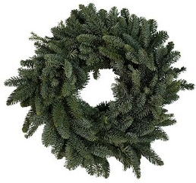

Wreaths and Greenery | Decoration Options (circle your choices) | Quantity
Small Undecorated Wreath Approximate diameter 23” - 25” Price: $ 24.00 | No options available | _______
Small Decorated Wreath Approximate diameter 23” - 25” Price: $ 34.00 | Bow: Burgundy / Red  Berries: Burgundy / Red / None  Pinecones: Natural / White Tipped / None | _______
Large Undecorated Wreath Approximate diameter 28” - 30” Price: $ 30.00 | No options available | _______
Large Decorated Wreath  Approximate diameter 28” - 30”  Price: $ 40.00 | Bow: Burgundy / Red  Berries: Burgundy / Red / None  Pinecones: Natural / White Tipped / None | _______

Total Amount Due: ______________________

Pick Up Date: Sunday, November 21

Name: ______________________________________________________

Phone Number: __________________________ Email: _____________________________________

----------------------------------------------------- Office Use Only -----------------------------------------------------
PAID info – Check # _________ or Cash

