May
2025
RISING STARS THERAPEUTIC FARM  This month’s theme is “Birds, birds, birds”! We’re going to get our feeders ready and look for nests and new generations of birds around the farm (including baby chicks!). | 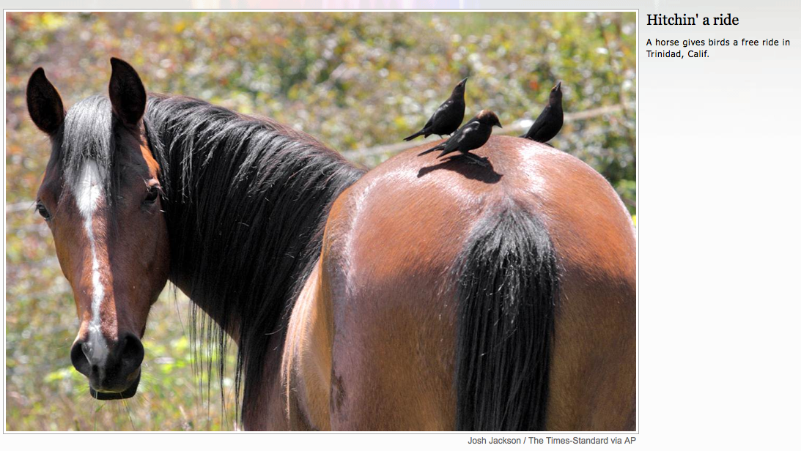
Weekly Activities | Monday | Tuesday | Wednesday | Thursday | Friday | Saturday
 |  |  |  | 1 | 2 | 3
1p-2p
Bocce
4 | 5 | 6 | 7 | 8 | 9 | 10
Barn Manager Trivia: Most correct answers wins! | Farrier coming to shoe Charlie: 10a |  |  | 1p-2p  Drawing at the Farm
11 | 12 | 13 | 14 | 15 | 16 | 17
Make a pool noodle horse |  |  |  | No activity today; Sea Dogs game
18 | 19 | 20 | 21 | 22 | 23 | 24
Pool noodle horse rodeo |  |  |  | 1p-2p  Homemade bird feeders
25 | 26 | 27 | 28 | 29 | 30 | 31
Sensory Trails open this week!! |  |  |  | 1p-2p  Cornhole
PLEASE RSVP TO ALLY AT astrout@oeime.org or by calling 376-4911, ext. 3075.

