March
2025
RISING STARS THERAPEUTIC FARM  This month’s theme is “Spring is Coming”. The snow will end, we’re getting ready for planting and better weather, and buds are coming up. Hang in there!!  PLEASE RSVP TO AMANDA AT atherrien@oeime.org or by calling 376-4911, ext. 3075  PLEASE RSVP TO AMANDA AT atherrien@oeime.org or by calling 376-4911, ext. 3075. | 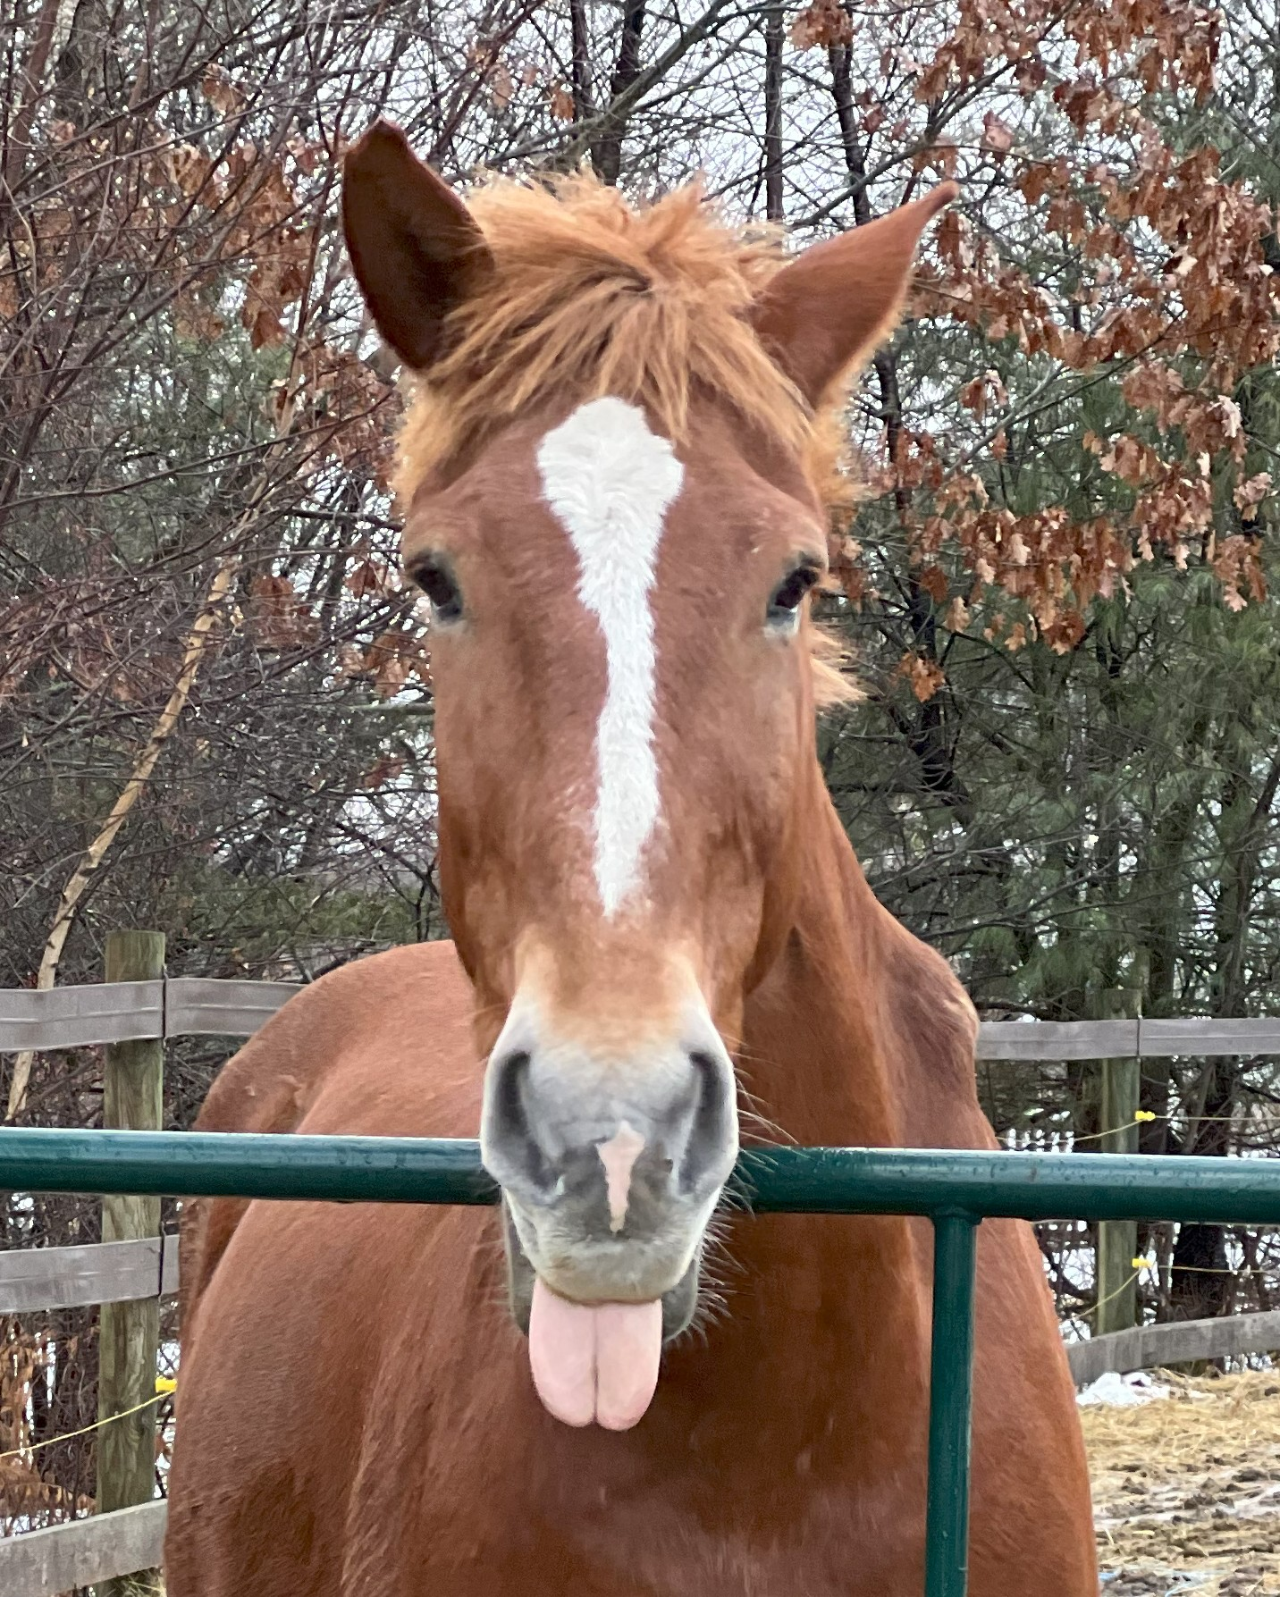
Weekly Activity | Sunday | Monday | Tuesday | Wednesday | Thursday | Friday | Saturday
 |  |  |  |  |  |  | 1
Weekly activities are available to anyone stopping in throughout the week! Come join the fun!
 | 2 | 3 | 4 | 5 | 6 | 7 | 8
Farm Olympics  Stop in and test your farm toughness!  Prizes next week for those who participated! |  | Chili cook-off  Bring your favorite chili dish to share with peers!  Vote at 1:45pm  1pm-2pm |  |  | Storytime at the farm  Come read your favorite book to our mini and donkey in our warm barn  1pm-2pm
 | 9 | 10 | 11 | 12 | 13 | 14 | 15
Farm trivia week!  Come test your knowledge on the farm’s animals! |  | Horse spa day  Grooming, relaxation, and gentle music  1pm-2pm |  |  | How to talk horse  Demo and discussion  1pm-2pm
 | 16 | 17 | 18 | 19 | 20 | 21 | 22
Rainbow and gold hunt!  A leprechaun stopped in and hid their gold! Look for the rainbows and find the gold at the end of the rainbows!! |  | St.Patty’s Day!    Activities and crafts  1pm-2pm |  |  | Storytime at the farm  Come read your favorite book to our mini and donkey in our warm barn  1pm-2pm
 | 23 | 24 | 25 | 26 | 27 | 28 | 29
Spring planning week!  Please email Amanda if you are interested in being a part of our spring garden group! |  | Farm bingo  25¢ per game  1-2 | Garden group planning  1-2  Please RSVP

