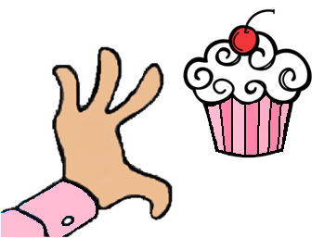
The Cupcakery Café & Bake Shop
THANKSGIVING ORDER FORM
All Thanksgiving orders are due by close of business on Friday, 11/18. We will do our best to accommodate orders after that, but make no promises (please call for confirmation for late orders). We will have product available in the case all that week for sale outside of special orders. Orders can be faxed to 376-4913, emailed to info@thecupcakery.org, or called in at 784-2253.
Pies | Price | Qty.
Apple | 11.95
Apple Crumb | 12.95
Blueberry | 15.95
Pumpkin | 12.95
Chocolate Cream | 13.95
Coconut Cream | 13.95
Banana Cream | 13.95
NY Style Cheesecake | 27.95
Pumpkin Cheesecake with Gingersnap Crust and Caramel Syrup | 28.95
Key Lime Pie | 13.95
Bourbon Brown Butter Pecan Pie | 17.95

Breads | Price | Qty.
Banana Bread | 5.99
Banana Bread (mini) | 1.99
Pumpkin Bread | 5.99
Pumpkin Bread (mini) | 1.99

See our website for samples of our Thanksgiving themed cakes and cupcakes!
Goodies | Price | Qty.
Chocolate Whoopie Pies | 2.89
Pumpkin Whoopie Pies | 2.89
Oatmeal Cream Pie Whoopie Pies | 2.89
Chocolate Chip Cookies | 2.49
Peanut Butter Cookies | 2.49
Pumpkin/CC Cookies | 2.49
Decorated Sugar Cookies | 3.49
Assorted Macarons | 1.99
6” Decorated Cake | 19.99
8” Decorated Cake | 24.99
10” Decorated Cake | 29.99
Cupcakes | 2.79
Thanksgiving Cake Pops | 2.49

For cakes, cupcakes, and macarons please indicate flavors/decorations/quantities when ordering.

