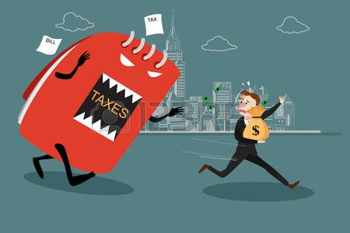  taxes for  - small business workshop  It’s that time of year. “Tax Season” Taxes shouldn’t be scary join our free Tax workshop.  Taxes and Financial Records  The tax and financial aspect of running your business are often confusing and intimidating don’t let it scare you. This workshop will help you better understand what to track, what you can claim and what tax implications are for running your business. It will also provide helpful tips on the easiest ways to keep records, how to use your financial information to help run your business.  Light refreshments will be provided. Please RSVP to Aboriginal Business & Community Development Centre 250-562-6325
  ABDC will be hosting a tax workshop for small business
  Join Matt Hutcheon on Wednesday March 7th 3:00 to 6:00pm
  Matt has been preparing personal and small business taxes for more than 20 years!
  Reserve your spot today!!
  You Have Room for Another One Here!
  Aboriginal business development centre
  555 George Street
  Prince George BC V2L 1R8
  250-562-6325
  www.abdc.bc.ca

