Supporting Pregnant and Parenting Families with Paid Family and Medical Leave
The Paid Leave website is available in 15 languages:
English, Amharic, Arabic, Farsi, Korean, Cambodian, Lao, Oromo, Punjabi, Russian, Simplified Chinese, Somali, Tagalog, Traditional Chinese, and Vietnamese.

Help Me Grow Washington has created this toolkit to help those who support pregnant and parenting families. Whether you are working with them from pregnancy or interacting right after birth, knowing about this benefit can help support a family through a significant chapter of their life.
This toolkit has three parts:
- What resource navigators need to know about Paid Family and Medical Leave
- What type of promotional materials are available for families
- Tools to prepare your client for applying
This toolkit will focus on providing a consistent starting place for those who are helping families to navigate this benefit. It will also only focus on pregnant and parenting families. Paid family leave is for the adoption, birth, or placement of a child, for the care of a family member with a serious health condition, and for a qualifying military service request. We recommend visiting the Paid Family and Medical Leave website provided by the Employment Security Department (ESD) www.paidleave.wa.gov to learn more about all the different types of leave.

Section One: What do resource navigators need to know about Paid Family and Medical Leave?
There are two types of leave:
- Medical leave: This leave is for individuals to use for themselves.
  - For those who are pregnant or recently had a child, including pregnancy or birth with complications.
  - Any leave needed by the birthing parent after giving birth.
- Family Leave: This leave is for family member who are caring for another
  - Care for a pregnant family member
  - Leave time to bond with a new baby or child in the family

Who qualifies?
A person must have worked 820 hours in their qualifying period. They can be full-time, part-time, temporary, and/or seasonal worker. They also do not need to be currently employed to be eligible for paid leave. The Employment Security Department will look at a 12-month period to determine their work hours.
How much time is included?
Up to 12 weeks is the standard amount of paid leave in a year. Someone might be eligible for 16 weeks if they had a personal medical event and family caregiving event happen in the same year, like giving birth to a baby. In cases with complications during pregnancy, an individual could take up to 18 weeks.
More Information
For a full explanation of the Paid Leave benefit, please review the Benefit Guide (English, Spanish). This will prepare you for potential questions about the benefit.

Section Two: Promoting and educating your community about Paid Family and Medical Leave
While WA Paid Leave has been law since 2017, it was not until 2020 that people could start applying for benefits. The program has continued to evolve since then. Here are resources that can help you promote and educate your communities about paid leave.
Six things to know about Paid Leave: You can print this document out as a flyer or hang up on a bulletin board. It points out foundational information about paid leave.
Parents’ Guide: This guide is most applicable to parents who are requesting leave to bond with a new child, caring for a family member with a serious health condition like pregnancy or post-partum, and recovery for their own pregnancy.

Section Three: Preparing a family for applying
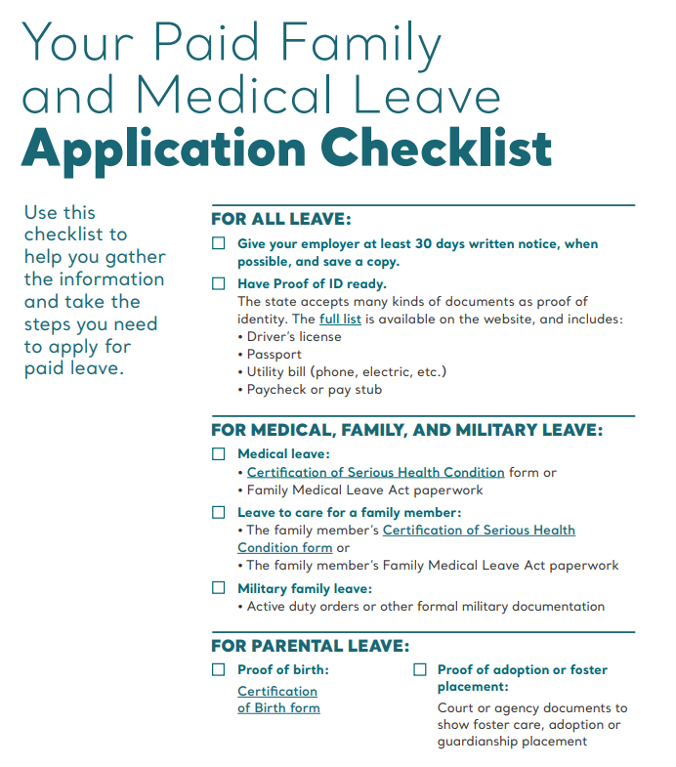
The first place to start is checking their eligibility. There is a quiz that can help check whether or not they qualify for paid leave. Start here!
The Employment Security Department has created a helpful checklist to keep track of important steps and documents.
They’ll need to notify their employer at least 30 days in advance of the event. If they need paid leave unexpectedly, they need to provide written notice to their employer as soon as possible. In these cases, they should consider asking a family member, friend, or neighbor to provide this for them. The ESD has an example of what this written notice could look like.
They’ll need to have proof of identification (ID). This could be their driver’s license, vehicle registration, a paycheck or pay stub, etc. A full list of acceptable ID is here.
Depending on which type of leave they are applying for, they’ll need to get a certification from a medical provider. The checklist above has links to the different forms depending on the situation.
If you need the certification forms in different languages, you’ll need to go to the website with the preferred language. The forms will be available on the website in English and the preferred language. Here’s an example using the Tagalog website: Medical Certification form in Tagalog
If the language you need is not one of the 15 included, you can request document translation and interpretation services for free at 833-717-2273, Washington Relay Service 711.
Applying online can be done in English and Spanish. All other languages need to complete the paper form and mail their full application and all documentation to the Employment Security Department.
If the family authorizes someone else to act on behalf of the applicant, they can request a Designated Authorized Representative. Call 833-717-2273 to get a copy of this form.
The employer of the applicant will also need to complete paperwork. An applicant should work with their employer to complete these documents. Visit the Employer page for more information.
After Applying
Once an application has been submitted, it can take 2-3 weeks to process the application. This webpage has more information about what to do while the applicant waits to hear about their application.
If the application is approved, the next step will be to learn more about the claims process. Visit here to learn about filing for weekly claims.

Final Thoughts
While this toolkit is meant to be a starting place, there is likely to be more information an applicant might need. An applicant can always send a secure message to the Paid Family and Medical Leave team using their SAW account or call (833)7171-2273.
Help Me Grow WA supports resource navigation for families with young children and people who are pregnant. If the family you are working with could benefit from additional resources, the Help Me Grow WA statewide hotline is available at 1-800-322-2588 and you can visit our website https://helpmegrowwa.org/ for more information.

