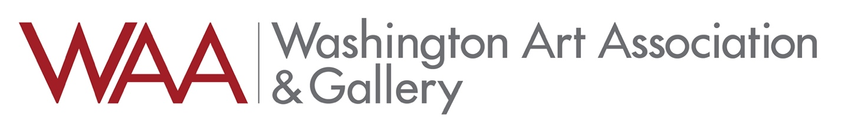

Holiday Form

Work may not be dropped off unless it is prepared for hanging and or display.

The commission will be 60%/40% artist/WAA

Artwork for sale at Washington Art Association is fully insured while on Washington Art Association’s premises.

Payment for any sales will be sent within 30 days of the exhibition’s conclusion.

Artwork consigned to Washington Art Association may be reproduced for our promotion and marketing purposes.

Artist Name:

Mailing Address:

Email: Cell phone:

ARTIST Initials Price:

Name of work

___________________________________________________________________
Use this section to tag your work

ARTIST Initials Price:

Name of work

