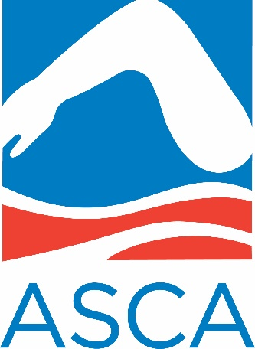

END-OF-THE-YEAR MEMBERSHIP DRIVE

JOIN-RENEW-EXTEND
ASCA MEMBERSHIP BY THE END OF 2022
To get entered in a drawing for:
FIVE x 2023 ASCA WORLD CLINIC REGISTRATIONS
10 ASCA Finis Jackets
15 ASCA Polo shirts
25 ASCA T-shirts

BECOME A 100% ASCA TEAM BY THE END OF 2022*
To get entered in a drawing for:
FULL DAY VISIT TO YOUR TEAM FROM RUSSELL MARK
*all full-time coaches must be ASCA members as of December 31, 2022.

GIVE THE GIFT OF ASCA MEMBERSHIP
TO A NEW COACH!
During the month of December 2022,
ASCA members can give the gift of ASCA membership for only $1
to any coach who has never been a member of ASCA.
To access this benefit, members can log into www.swimmingcoach.org
and click on “Give the Gift of ASCA Membership” under featured content.

