MULTIPLE TABLE PURCHASE DISCOUNT
3 - 5 TABLES 15% / 6 - 10 TABLES 20% / 11 PLUS TABLES 25%
 ELLOR FLAT - $1399.00 + TAX AND SHIPPING
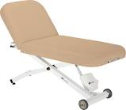ELLORA ELECTRIC TILT - $1849.00 + TAX AND SHIPPING
ELLORA ELECTRIC SALON - $2399.00 + TAX AND SHIPPING 

