

A Center of Grace in Whittier, California

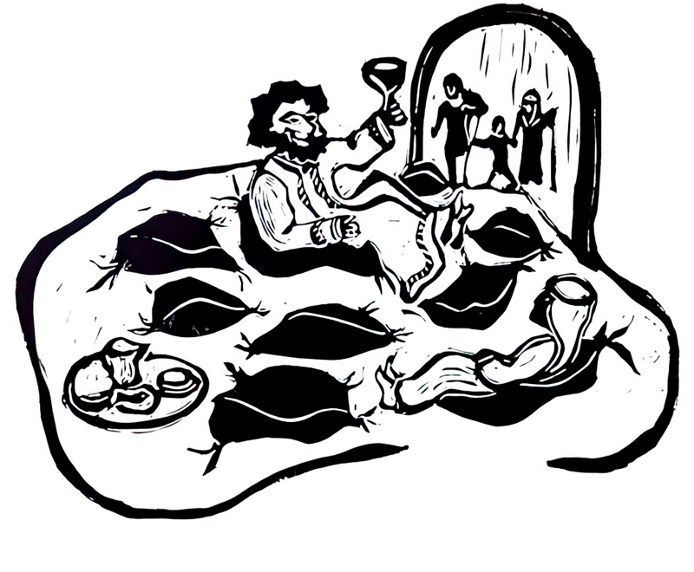

The Twelfth Sunday after Pentecost
August 31, 2025
10:00 a.m.
Holy Eucharist

Jesus Christ is the reason we are together. The goals of St. Matthias Church
and all of its related ministries are to build our relationship with God through
Jesus Christ and to build community with the people God has sent to us.
A time to prayerfully prepare for worship.

Prelude Voluntary on Mit Freuden zart Hans-Heinz Hasse
Chaconne on Mit Freuden zart James Biery

Please stand as the tower bell tolls.

Processional Hymn Sing praise to God… Mit Freuden zart
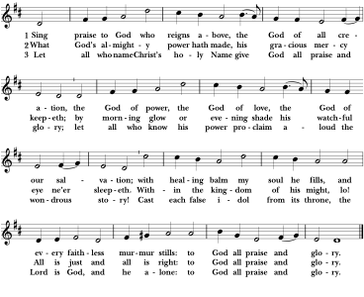
The Hymnal 1982: #408: Words: Johann Jakob Schütz (1640-1690); tr. Frances Elizabeth Cox (1812-1897), alt.Music: Mit Freuden zart, melody from “Une pastourelle gentille,” 1529; adapt. Pseaumes cinquante de David, 1547, and Kirchengeseng darinnen die Heubtartickel des Christlichen Glaubens gefasset, 1566; harm. Ralph Vaughan Williams (1872-1958), after Heinrich Reimann (19th cent.)

Please remain standing.

THE WORD OF GOD
Celebrant Blessed be God: Father, Son and Holy Spirit.
People And blessed be God’s kingdom, now and for ever. Amen.
Celebrant& People Almighty God, to you all hearts are open, all desires known, and from you no secrets are hid: cleanse the thoughts of our hearts by the inspiration of your Holy Spirit, that we may perfectly love you, and worthily magnify your holy Name; through Christ our Lord. Amen.

Gloria in excelsis Robert Powell
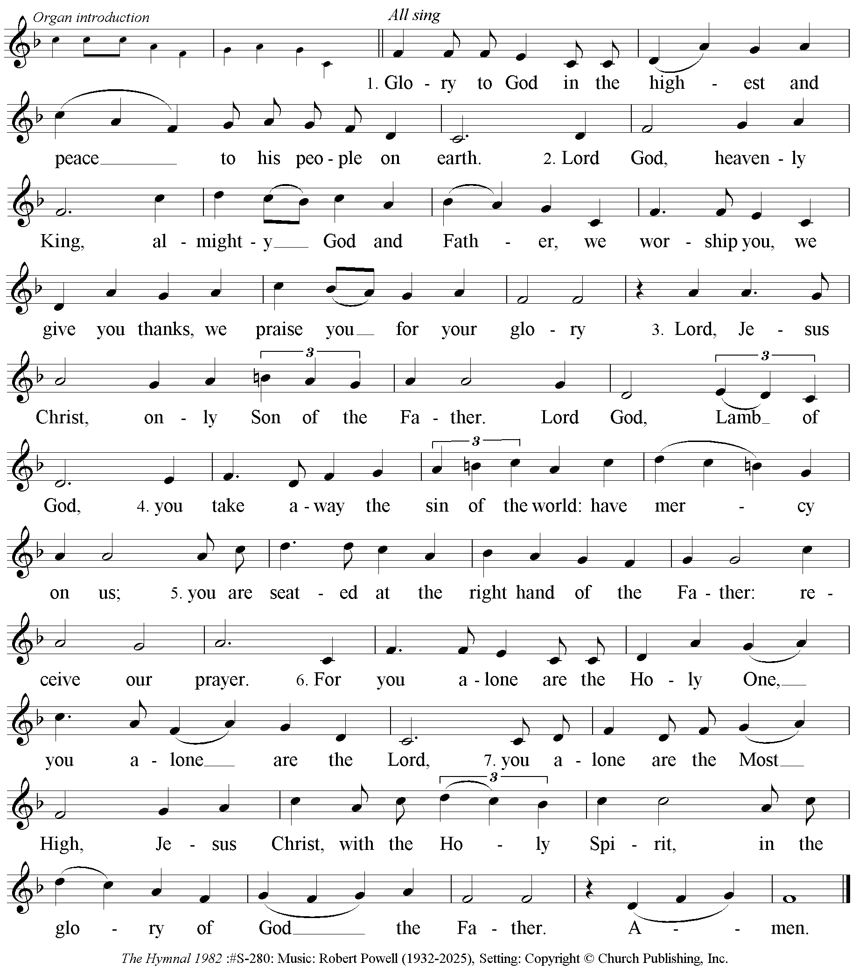
The Collect of the Day

Celebrant The Lord be with you.
People And also with you.

Celebrant Let us pray.

Lord of all power and might, the author and giver of all good things: Graft in our hearts the love of your Name; increase in us true religion; nourish us with all goodness; and bring forth in us the fruit of good works; through Jesus Christ our Lord, who lives and reigns with you and the Holy Spirit, one God for ever and ever. Amen.

The First Reading Sirach 10:12-18

The beginning of human pride is to forsake the Lord;
the heart has withdrawn from its Maker.
For the beginning of pride is sin,
and the one who clings to it pours out abominations.
Therefore the Lord brings upon them unheard-of calamities,
and destroys them completely.
The Lord overthrows the thrones of rulers,
and enthrones the lowly in their place.
The Lord plucks up the roots of the nations,
and plants the humble in their place.
The Lord lays waste the lands of the nations,
and destroys them to the foundations of the earth.
He removes some of them and destroys them,
and erases the memory of them from the earth.
Pride was not created for human beings,
or violent anger for those born of women.

Reader The Word of the Lord.
People Thanks be to God.

Psalm 81: 1, 10-16 Robert Knox Kennedy
Change pitches from the reciting tone to the black notes on the words in bold
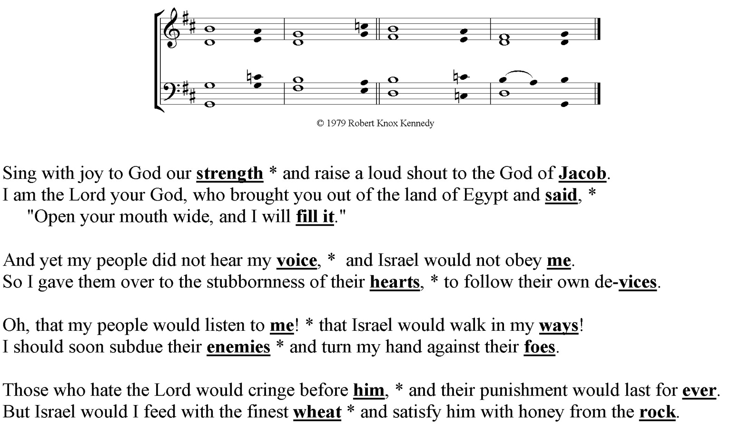

The Second Reading Hebrews 13:1-8, 15-16

Let mutual love continue. Do not neglect to show hospitality to strangers, for by doing that some have entertained angels without knowing it. Remember those who are in prison, as though you were in prison with them; those who are being tortured, as though you yourselves were being tortured. Let marriage be held in honor by all, and let the marriage bed be kept undefiled; for God will judge fornicators and adulterers. Keep your lives free from the love of money, and be content with what you have; for he has said, "I will never leave you or forsake you." So we can say with confidence,

"The Lord is my helper; I will not be afraid. What can anyone do to me?"

Remember your leaders, those who spoke the word of God to you; consider the outcome of their way of life, and imitate their faith. Jesus Christ is the same yesterday and today and forever.

Through him, then, let us continually offer a sacrifice of praise to God, that is, the fruit of lips that confess his name. Do not neglect to do good and to share what you have, for such sacrifices are pleasing to God.

Reader The Word of the Lord.
People Thanks be to God.
Please stand.

Sequence Hymn As we gather at your table… Raquel
Stanzas 1 & 2 before the Gospel; Stz.3 following the Gospel
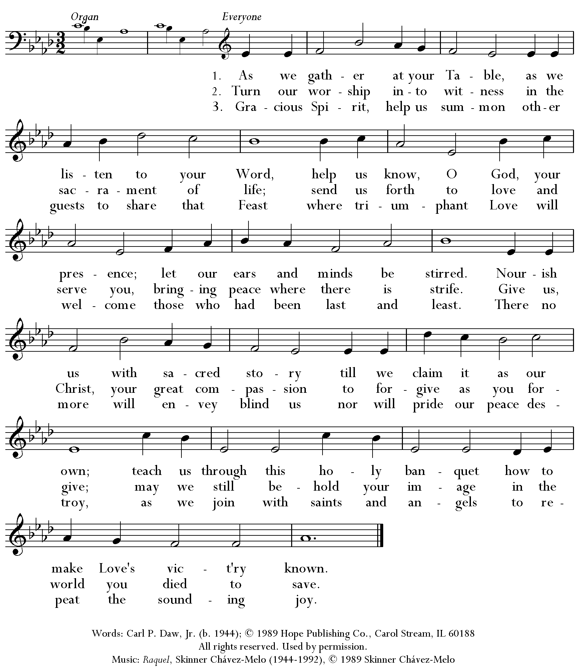

The Gospel Luke 14:1, 7-14

Celebrant The Holy Gospel of our Lord Jesus Christ according to Luke.
People Glory to you, Lord Christ.
On one occasion when Jesus was going to the house of a leader of the Pharisees to eat a meal on the sabbath, they were watching him closely.
When he noticed how the guests chose the places of honor, he told them a parable. "When you are invited by someone to a wedding banquet, do not sit down at the place of honor, in case someone more distinguished than you has been invited by your host; and the host who invited both of you may come and say to you, `Give this person your place,' and then in disgrace you would start to take the lowest place. But when you are invited, go and sit down at the lowest place, so that when your host comes, he may say to you, `Friend, move up higher'; then you will be honored in the presence of all who sit at the table with you. For all who exalt themselves will be humbled, and those who humble themselves will be exalted."
He said also to the one who had invited him, "When you give a luncheon or a dinner, do not invite your friends or your brothers or your relatives or rich neighbors, in case they may invite you in return, and you would be repaid. But when you give a banquet, invite the poor, the crippled, the lame, and the blind. And you will be blessed, because they cannot repay you, for you will be repaid at the resurrection of the righteous."

Celebrant The Gospel of the Lord
People Praise to you, Lord Christ

The Sermon The Rev. Carole Horton-Howe

The Nicene Creed Please stand.

We believe in one God, the Father, the Almighty,
Maker of Heaven and Earth, of all that is, seen and unseen.

We believe in one Lord, Jesus Christ, the only Son of God,
Eternally begotten of the Father, God from God, Light from Light,
True God from true God, begotten, not made, of one Being with the Father.
Through him all things were made.

For us and for our salvation he came down from Heaven:
By the power of the Holy Spirit he became incarnate from the Virgin Mary,
And was made man.
For our sake he was crucified under Pontius Pilate;
He suffered death and was buried.
On the third day he rose again in accordance with the Scriptures;
He ascended into Heaven and is seated at the right hand of the Father.
He will come again in glory to judge the living and the dead,
And his kingdom will have no end.

We believe in the Holy Spirit, the Lord, the giver of life,
Who proceeds from the Father and the Son.
With the Father and the Son he is worshiped and glorified.
He has spoken through the Prophets.
We believe in one holy catholic and apostolic Church.
We acknowledge one baptism for the forgiveness of sins.
We look for the resurrection of the dead,
And the life of the world to come. Amen.

Prayers of the People

Let us pray for the Church and for the world.

Grant, Almighty God, that all who confess your Name may be united in your truth, live together in your love, and reveal your glory in the world.
Silence
Lord, in your mercy
Hear our prayer.

Guide the people of this land, and of all the nations, in the ways of justice and peace; that we may honor one another and serve the common good.
Silence
Lord, in your mercy
Hear our prayer.

Give us all a reverence for the earth as your own creation, that we may use its resources rightly in the service of others and to your honor and glory.
Silence
Lord, in your mercy
Hear our prayer.

Bless all whose lives are closely linked with ours, and grant that we may serve Christ in them, and love one another as he loves us.
Silence
Lord, in your mercy
Hear our prayer.

Comfort and heal all those who suffer in body, mind, or spirit; give them courage and hope in their troubles, and bring them the joy of your salvation.
Silence
Lord, in your mercy
Hear our prayer.

We commend to your mercy all who have died, that your will for them may be fulfilled; and we pray that we may share with all your saints in your eternal kingdom.
Silence
Lord, in your mercy
Hear our prayer.

The Celebrant adds a concluding Collect.

O Lord our God, accept the fervent prayers of your people; in the multitude of your mercies, look with compassion upon us and all who turn to you for help; for you are gracious, O lover of souls, and to you we give glory, Father, Son, and Holy Spirit, now and for ever. Amen

A Prayer for Peace

Eternal God, in whose perfect kingdom no sword is drawn but the sword of righteousness, no strength known but the strength of love: so mightily spread abroad your Spirit that all people may be gathered under the banner of your Son, the Prince of Peace. Guide the leaders of the nations of the world into the way of justice and truth, and establish peace among them. Jesus commanded us to love our enemies: Lead them and us from prejudice to truth; deliver them and us from hatred, cruelty and revenge; and in your good time enable us all to stand reconciled before you. Amen.

Confession of Sin and Absolution

We pray to you also for the forgiveness of our sins.
Silence may be kept.
Leader and People Most merciful God,
we confess that we have sinned against you
in thought, word, and deed,
by what we have done,
and by what we have left undone.
We have not loved you with our whole heart;
we have not loved our neighbors as ourselves.
We are truly sorry and we humbly repent.
For the sake of your Son Jesus Christ,
have mercy on us and forgive us;
that we may delight in your will,
and walk in your ways,
to the glory of your Name.
Amen.

Celebrant Almighty God have mercy on you, forgive you all your sins through our Lord Jesus Christ, strengthen you in all goodness, and by the power of the Holy Spirit keep you in eternal life.
Celebrant & People Amen.

The Peace

Announcements

Offertory Magnificat Charles Villiers Stanford
My soul doth magnify the Lord: and my spirit hath rejoiced in God my Saviour.
For he hath regarded the lowliness of his handmaiden. For behold, from henceforth all generations shall call me blessed. For he that is mighty hath magnified me: and holy is his Name. And his mercy is on them that fear him: throughout all generations. He hath shewed strength with his arm: he hath scattered the proud in the imagination of their hearts. He hath put down the might from their seat: and hath exalted the humble and meek. He hath filled the hungry with good things, and the rich he hath sent empty away. He rememb’ring his mercy hath holpen his servant Israel: as he promised to our forefathers. Abraham and his seed, for ever. Glory be to the Father, and to the Son, and to the Holy Ghost; as it was in the beginning, is now, and ever shall be: world without end. Amen.

The Parish Choir
Presentation - Doxology Old 100th
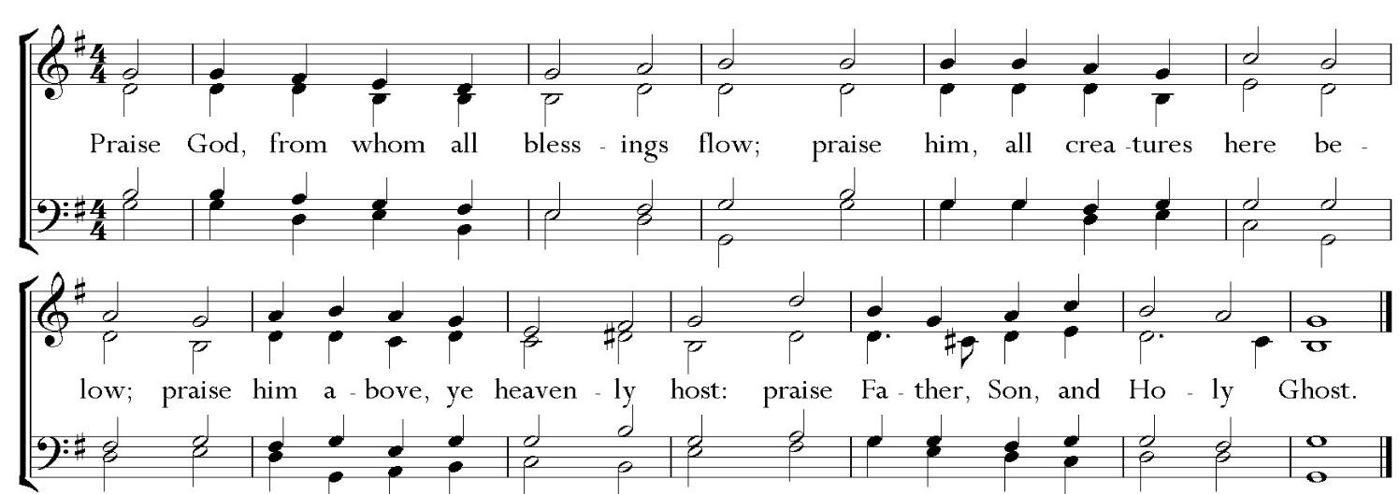

The Great Thanksgiving Eucharistic Prayer “B” | Please remain standing.

Celebrant The Lord be with you.
People And also with you.

Celebrant Lift up your hearts.
People We lift them to the Lord.

Celebrant Let us give thanks to the Lord our God.
People It is right to give God thanks and praise.

Celebrant It is right, and a good and joyful thing, always & everywhere to give thanks to you, Father Almighty, creator of Heaven and Earth.

Here a proper preface is said.

Celebrant Therefore we praise you, joining our voices with angels and archangels and with all the company of Heaven, who forever sing this hymn to proclaim the glory of your Name:
Sanctus Richard Proulx
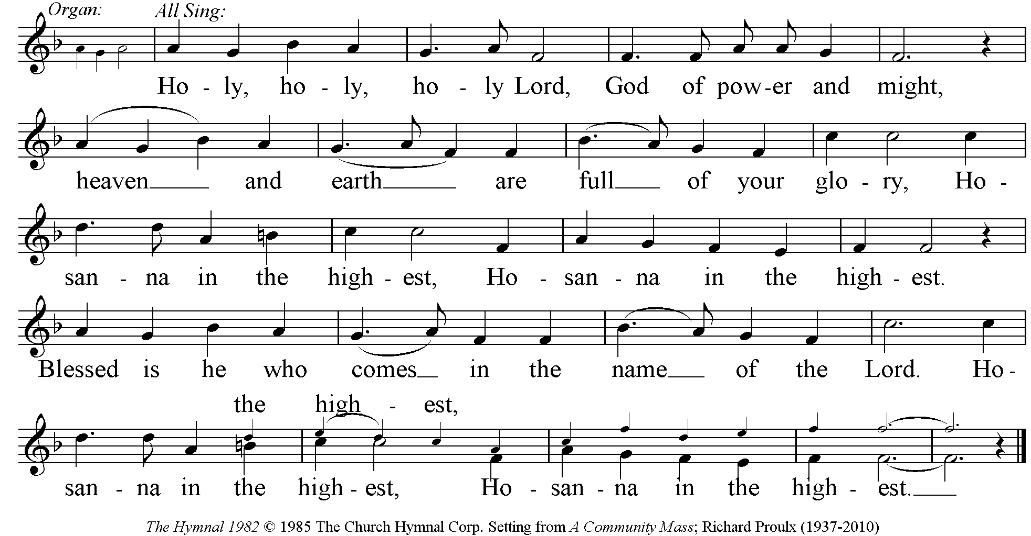

The People stand, sit, or kneel as they are most comfortable.

Celebrant We give thanks to you, O God, for the goodness and love which you have made known to us in creation; in the calling of Israel to be your people; in your Word spoken through the prophets; and above all in the Word made flesh, Jesus, your Son. For in these last days you sent him to be incarnate from the Virgin Mary, to be the Savior and Redeemer of the world.
In him, you have delivered us from evil, and made us worthy to stand
before you. In him, you have brought us out of error into truth, out of sin into righteousness, out of death into life.

On the night before he died for us, our Lord Jesus Christ took bread; and when he had given thanks to you, he broke it, and gave it to his disciples, and said, "Take, eat: This is my Body, which is given for you. Do this for the remembrance of me."
After supper he took the cup of wine; and when he had given thanks, he gave it to them, and said, "Drink this, all of you: This is my Blood of the new Covenant, which is shed for you and for many for the forgiveness of sins. Whenever you drink it, do this for the remembrance of me."
Therefore, according to his command, O Father,

Celebrant & People We remember his death,
We proclaim his resurrection,
We await his coming in glory;

Celebrant And we offer our sacrifice of praise and thanksgiving to you, O Lord of all; presenting to you, from your creation, this bread and this wine.

We pray you, gracious God, to send your Holy Spirit upon these gifts that they may be the Sacrament of the Body of Christ and his Blood of the new Covenant. Unite us to your Son in his sacrifice, that we may be acceptable through him, being sanctified by the Holy Spirit. In the fullness of time,
put all things in subjection under your Christ, and bring us to that heavenly country where, with his mother, Mary, St. Matthias and all your saints, we may enter the everlasting heritage of your sons and daughters; through Jesus Christ our Lord, the firstborn of all creation, the head of the Church, and the author of our salvation.

By him, and with him, and in him, in the unity of the Holy Spirit all honor and glory is yours, Almighty Father, now and for ever.

Celebrant & People Amen.

Celebrant And now, as our Savior Christ has taught us, we are bold to say

People & Celebrant Our Father, who art in heaven,
hallowed be thy Name,
thy kingdom come, thy will be done,
on earth as it is in heaven.
Give us this day our daily bread.
And forgive us our trespasses,
as we forgive those who trespass against us.
And lead us not into temptation
but deliver us from evil.
For thine is the kingdom,
and the power, and the glory,
forever and ever. Amen.

The Breaking of the Bread

The Celebrant breaks the consecrated bread. A period of silence is kept.

Fraction Anthem Gerald Near
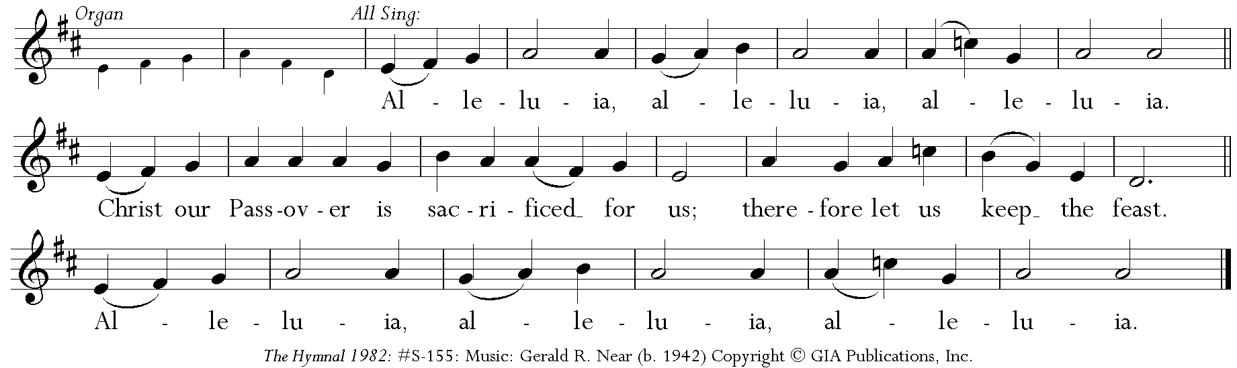

Celebrant The Gifts of God for the People of God.
Take them in remembrance that Christ died for you
and feed on him in your hearts by faith, with thanksgiving.

All are welcome to receive Communion.

Communion Hymn All who hunger gather gladly… Holy Manna
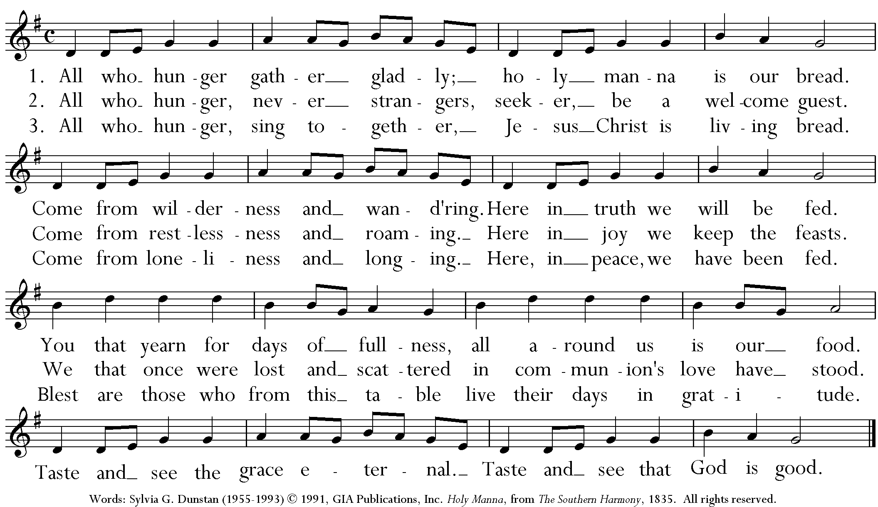

Celebrant Let us pray

Celebrant & People Eternal God, heavenly Father,
you have graciously accepted us
as living members of your Son
our Savior Jesus Christ,
and you have fed us with spiritual food
in the Sacrament of his Body and Blood.
Send us now into the world in peace,
and grant us strength and courage
to love and serve you with gladness
and singleness of heart;
through Christ our Lord.
Amen.
The Blessing

Closing Hymn All praise to thee… Engelberg
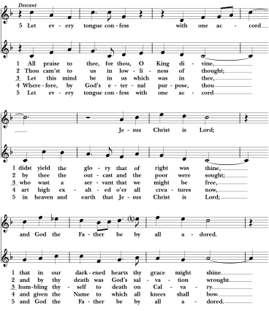
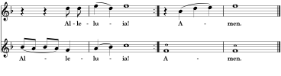
The Hymnal 1982: #477: Words: F. Bland Tucker (1895-1984). Music: Engelberg, Charles Villiers Stanford (1852-1924);
desc. Richard Proulx (1937-2010)

Celebrant Go in peace to love and serve the Lord, doing the loving thing. Alleluia! Alleluia! Alleluia!
People Thanks be to God. Alleluia! Alleluia! Alleluia!

Postlude Voluntary on Engelberg David Cherwein
_______________________________________________________________

The Bible texts of the Old Testament, Epistle and Gospel lessons are from the New Revised Standard Version Bible, copyright 1989 by the Division of Christian Education of the National Council of the Church of Christ in the USA, and used by permission. The Collects, Psalms and Canticles are from the Book of Common Prayer, 1979. From The Lectionary Page: http://lectionarypage.net

Image on Cover
Title: A Parable - Where to Sit Date:2019
Copyright Permission: The artist has granted permission for the non-commercial use of this image with attribution. The artist must be contacted for other uses.
Attribution: Hochhalter, Cara B.. A Parable - Where to Sit, from Art in the Christian Tradition, a project of the Vanderbilt Divinity Library, Nashville, TN. https://diglib.library.vanderbilt.edu/act-imagelink.pl?RC=59048 [retrieved August 26, 2025]. Original source: Cara B. Hochhalter.
Notes: PLEASE USE THIS BRIEF CREDIT INFORMATION FOR FREE, NON-COMMERCIAL CONGREGATIONAL PRINTING: Cara B. Hochhalter, A Parable - Where to Sit.http://diglib.library.vanderbilt.edu/act-imagelink.pl?RC=59048
Institution: | Vanderbilt University Collection: Art in the Christian Tradition

______________________________________________________________________
This week at St. Matthias
- Sunday, August 31
- THE TWELFTH SUNDAY AFTER PENTECOST
  - 8AM - Holy Eucharist, In-Person
  - 10AM - Holy Eucharist, In-Person & Facebook
  - 11:15AM - ECW Ice Cream Social & Bingo, Lewis Hall
- Monday, September 1
- LABOR DAY - Office Closed
- Wednesday, September 3
  - 10AM - Bible Study & Holy Eucharist, In-Person & ZOOM
  - 6PM - Advancement Committee Meeting, Chase Room
- Thursday, September 4
  - 3:30PM - Worship Committee Meeting, ZOOM
- Saturday, September 6
  - 8AM - Men Eating Badly, Greenleaf Café
  - 11AM - Kathy Bias Memorial Service
- Sunday, September 7
- THE THIRTEENTH SUNDAY AFTER PENTECOST
  - 8AM - Holy Eucharist, In-Person
  - 10AM - Holy Eucharist, In-Person & Facebook (Nursery and Sunday School provided
  - 11:30AM - Prayer Vigil, Chapel
  - 11:30AM - CHOIR REHEARSAL RESUMES

You may reach Rev. Carole via email now at her official St. Matthias email address. Her new email address is carole@stmatthiaswhittier.org.

COME JOIN US FOR SOME FUN AND GAMES! The Annual ECW Ice Cream Social and Bingo is TODAY, immediately following the 10AM service.

Bible Study resumes this Wednesday, September 3, at 10AM in the Chapel. We will be studying Acts.

St. Matthias T-Shirts from the first order can be picked up today! T-shirts include the St. Matthias logo on the front and our special mission statement, “Doing the Loving Thing”, on the back. They can be ordered in blue or red. Order forms are available in the narthex or by the Wardman door. We hope everyone will take advantage of this opportunity to represent St. Matthias. We need 20 shirts before we can place the 2nd order.

HOMECOMING SUNDAY is September 14th! Mark your calendars and plan to stay for lunch, fellowship and opportunities to serve St. Matthias.

We look forward to a visit from our Bishop of the Los Angeles Diocese on Sunday, October 5, 2025, at the 10AM worship service. In order that we can plan effectively for his visit, it would be helpful to know if there are any individuals who would like to be confirmed. This will allow time to coordinate and complete the appropriate confirmation classes. Please advise Rev. Carole as soon as possible if you wish to be confirmed by the Bishop in October.

Electronic recycling will be Saturday October 11th. 9am-Noon in our parking lot. More details to follow. This will be a fundraiser and outreach to the community.

In September, St. Matthias will be selling gift cards from various retailers and merchants through RaiseRight. The Raise Right program gives back a small percentage to St. Matthias’s ECW. It’s a great way to support and contribute to all of the community and church events hosted by ECW. The gift cards can be used for most of your shopping needs, for grocery stores, gas stations, restaurants and special occasions. Claudia Gonzalez and Sophie will be heading this program up and more information will be announced soon. The sheets with participating stores are in the narthex and inside the Wardman street entrance.
PRAYERS
Please pray for these people throughout this week.
Names can be added on the prayer list in the narthex or by phoning the office.
Al Selmanaj  Mandy Knight | Repose of the Soul of  Luci Rudd | Elizabeth Barringer
Irene Anderson | Bob Anderson | Frank Ramos
Joan Giglianti | Lou Giglianti | Richard and Pam Reid
Robin Lee | Miriam Neal | JD Neal
Carol McCracken | Caroline Palmer | Rev. Jude Lyons
Kent Myers | Sandy Johnson | Peggie DeLeon
Marina & Richard | Carol Frohnapfel | Angela Pekar & Family
Veronica Castro | Adrienne Lavagnino | John Frohnapfel
Jim Hines | Kathy Adams | Becky & Bob Jaramillo
Eric Stiens | Maria Parra Lopez | Lucky Wickramasuriya
Anita Robledo | Bonnie Edmunds | Jessie Malvize
Sally Rojas | Scott Rigdon | Larry Edson
Nataly Jimenez & Family | Jackie Gibson | Rachel Neal
Jessica Norton | Don Bailey | Marla Murphy
Carrie Sue Tennant |  | Pam Becker

Saint Matthias Episcopal Church
7056 Washington Avenue, Whittier, CA 90602

Tel: (562) 698-9741 Fax: (562) 698-4347
Website: www.stmatthiaswhittier.org Email: office@stmatthiaswhittier.org

