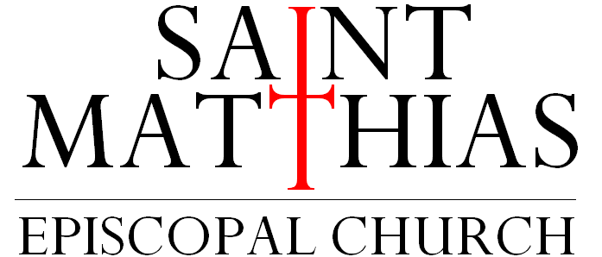

A Center of Grace in Whittier, California
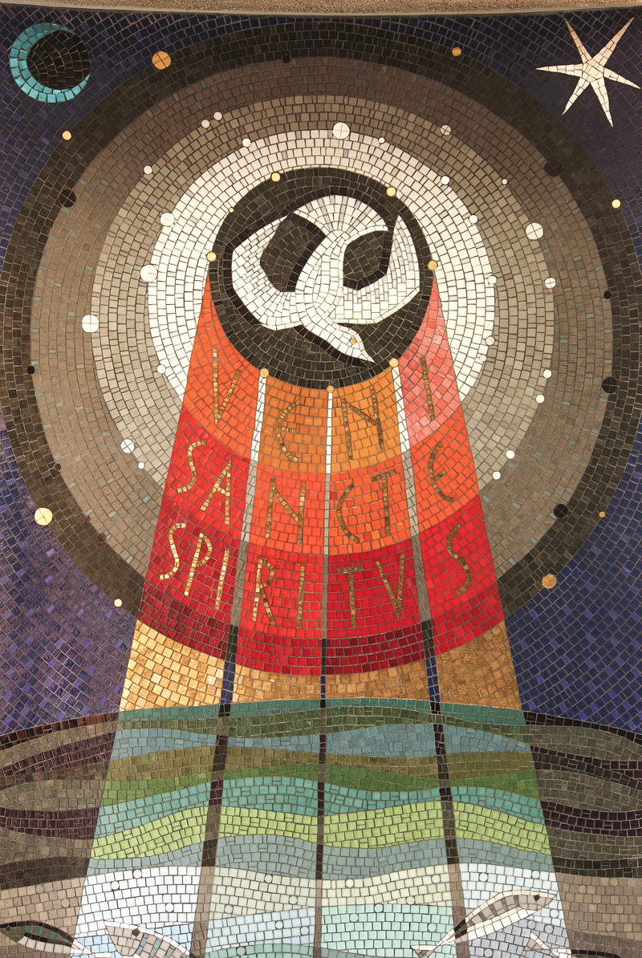
Pentecost
June 8, 2025
8:00 a.m.
Holy Eucharist

Jesus Christ is the reason we are together. The goals of St. Matthias Church
and all of its related ministries are to build our relationship with God through
Jesus Christ and to build community with the people God has sent to us.

Prelude Charissa Harjo
Please stand as you are able at the tolling of the bell.

Entrance Hymn Like the murmur of the dove’s song #513
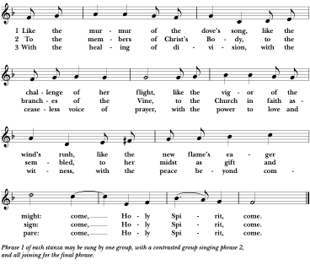
The Hymnal 1982: #513: Music: Bridegroom, Peter Cutts (1937-2024) Words: Copyright © 1982 by Hope Publishing Co., Carol Stream, IL. 60188). All rights reserved. Used by permission. Music: © 1969 by Hope Publishing Company, Carol Stream, IL 60188. All Rights Reserved. Used by permission.

Please remain standing.

THE WORD OF GOD

Celebrant Alleluia, Christ is risen.
People The Lord is risen indeed. Alleluia.

Celebrant Almighty God, to you all hearts are open, all desires known, and from you no secrets are hid: Cleanse the thoughts of our hearts by the inspiration of your Holy Spirit, that we may perfectly love you, and worthily magnify your holy Name; through Christ our Lord. Amen
The Collect of the Day

Celebrant The Lord be with you.
People And also with you.
Celebrant Let us pray.

O God, who on this day taught the hearts of your faithful people by sending to them the light of your Holy Spirit: Grant us by the same Spirit to have a right judgment in all things, and evermore to rejoice in his holy comfort; through Jesus Christ your Son our Lord, who lives and reigns with you, in the unity of the Holy Spirit, one God, for ever and ever. Amen.

The First Reading Acts 2: 1-21

When the day of Pentecost had come, the disciples were all together in one place. And suddenly from heaven there came a sound like the rush of a violent wind, and it filled the entire house where they were sitting.
Divided tongues, as of fire, appeared among them, and a tongue rested on each of them. All of them were filled with the Holy Spirit and began to speak in other languages, as the Spirit gave them ability.

Now there were devout Jews from every nation under heaven living in Jerusalem. And at this sound the crowd gathered and was bewildered, because each one heard them speaking in the native language of each. Amazed and astonished, they asked, "Are not all these who are speaking Galileans? And how is it that we hear, each of us, in our own native language? Parthians, Medes, Elamites, and residents of Mesopotamia, Judea and Cappadocia, Pontus and Asia, Phrygia and Pamphylia, Egypt and the parts of Libya belonging to Cyrene, and visitors from Rome, both Jews and proselytes, Cretans and Arabs-- in our own languages we hear them speaking about God's deeds of power." All were amazed and perplexed, saying to one another, "What does this mean?" But others sneered and said, "They are filled with new wine."

But Peter, standing with the eleven, raised his voice and addressed them, "Men of Judea and all who live in Jerusalem, let this be known to you, and listen to what I say. Indeed, these are not drunk, as you suppose, for it is only nine o'clock in the morning. No, this is what was spoken through the prophet Joel:

`In the last days it will be, God declares,
that I will pour out my Spirit upon all flesh,
and your sons and your daughters shall prophesy,
and your young men shall see visions,
and your old men shall dream dreams.
Even upon my slaves, both men and women,
in those days I will pour out my Spirit;
and they shall prophesy.
And I will show portents in the heaven above
and signs on the earth below,
blood, and fire, and smoky mist.
The sun shall be turned to darkness
and the moon to blood,
before the coming of the Lord's great and glorious day.

Then everyone who calls on the name of the Lord shall be saved.' "

Reader The Word of the Lord.
People Thanks be to God.

Psalm 104: 25-35, 37
25 O Lord, how manifold are your works! *
in wisdom you have made them all; the earth is full of your creatures.
26 Yonder is the great and wide sea with its living things too many to number, *
creatures both small and great.
27 There move the ships, and there is that Leviathan, *
which you have made for the sport of it.
28 All of them look to you *
to give them their food in due season.
29 You give it to them; they gather it; *
you open your hand, and they are filled with good things.
30 You hide your face, and they are terrified; *
you take away their breath, and they die and return to their dust.
31 You send forth your Spirit, and they are created; *
and so you renew the face of the earth.
32 May the glory of the Lord endure for ever; *
may the Lord rejoice in all his works.
33 He looks at the earth and it trembles; *
he touches the mountains and they smoke.
34 I will sing to the Lord as long as I live; *
I will praise my God while I have my being.
35 May these words of mine please him; *
I will rejoice in the Lord.
37 Bless the Lord, O my soul. *
Hallelujah!

The Second Reading Romans 8:14-17

All who are led by the Spirit of God are children of God. For you did not receive a spirit of slavery to fall back into fear, but you have received a spirit of adoption. When we cry, "Abba! Father!" it is that very Spirit bearing witness with our spirit that we are children of God, and if children, then heirs, heirs of God and joint heirs with Christ--if, in fact, we suffer with him so that we may also be glorified with him.

Reader The Word of the Lord.
People Thanks be to God.
Please stand.

Gradual Hymn Holy Spirit, ever living #511, v.1
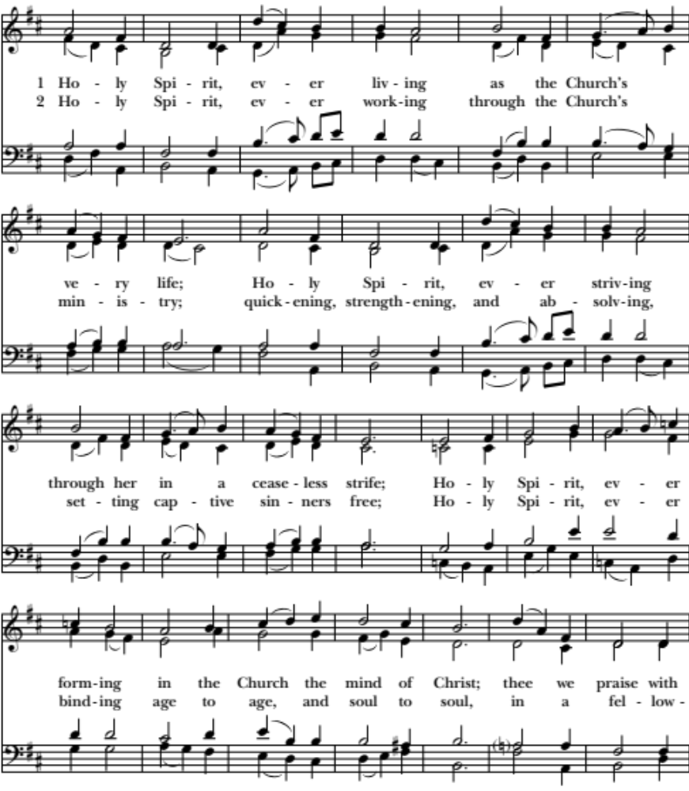
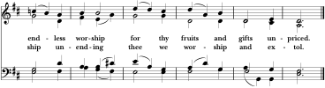
The Hymnal 1982: #511: Words: Venantius Honorius Fortunatus (540?-600?); tr. English Hymnal, 1906, alt. Music: Salve festa dies, Ralph Vaughan Williams (1872-1958) Copyright: Words & Music: By permission of Oxford University Press.
The Gospel John 14:8-17

Celebrant The Holy Gospel of our Lord Jesus Christ according to John.
People Glory to you, Lord Christ.

Philip said to Jesus, "Lord, show us the Father, and we will be satisfied." Jesus said to him, "Have I been with you all this time, Philip, and you still do not know me?
Whoever has seen me has seen the Father. How can you say, `Show us the Father'? Do you not believe that I am in the Father and the Father is in me? The words that I say to you I do not speak on my own; but the Father who dwells in me does his works. Believe me that I am in the Father and the Father is in me; but if you do not, then believe me because of the works themselves. Very truly, I tell you, the one who believes in me will also do the works that I do and, in fact, will do greater works than these, because I am going to the Father. I will do whatever you ask in my name, so that the Father may be glorified in the Son. If in my name you ask me for anything, I will do it.

"If you love me, you will keep my commandments. And I will ask the Father, and he will give you another Advocate, to be with you forever. This is the Spirit of truth, whom the world cannot receive, because it neither sees him nor knows him. You know him, because he abides with you, and he will be in you."

Celebrant The Gospel of the Lord
People Praise to you, Lord Christ

Gradual Hymn Holy Spirit, ever living #511, v. 2
The Sermon The Rev. Carole Horton Howe

The Nicene Creed Please stand.

We believe in one God, the Father, the Almighty,
Maker of Heaven and Earth, of all that is, seen and unseen.

We believe in one Lord, Jesus Christ, the only Son of God,
Eternally begotten of the Father, God from God, Light from Light,
True God from true God, begotten, not made, of one Being with the Father.
Through him all things were made.
For us and for our salvation he came down from Heaven:
By the power of the Holy Spirit he became incarnate from the Virgin Mary,
And was made man.
For our sake he was crucified under Pontius Pilate;
He suffered death and was buried.
On the third day he rose again in accordance with the Scriptures;
He ascended into Heaven and is seated at the right hand of the Father.
He will come again in glory to judge the living and the dead,
And his kingdom will have no end.

We believe in the Holy Spirit, the Lord, the giver of life,
Who proceeds from the Father and the Son.
With the Father and the Son he is worshiped and glorified.
He has spoken through the Prophets.
We believe in one holy catholic and apostolic Church.
We acknowledge one baptism for the forgiveness of sins.
We look for the resurrection of the dead,
And the life of the world to come. Amen.

The Prayers of the People Form VI
The Reader and People pray responsively.
In peace, we pray to you, Lord God.
Silence
For all people in their daily life and work;
For our families, friends, and neighbors, and for those who are alone.
For this community, the nation, and the world;
For all who work for justice, freedom, and peace.
For the just and proper use of your creation;
For the victims of hunger, fear, injustice, and oppression.
For all who are in danger, sorrow, or any kind of trouble;
For those who minister to the sick, the friendless, and the needy.
For the peace and unity of the Church of God;
For all who proclaim the Gospel, and all who seek the Truth.
For Sean, our Presiding Bishop, and John our Bishop; and all bishops and other ministers
For all who serve God in his Church.
For the special needs and concerns of this congregation.
Silence. The People may add their own petitions.

Hear us, Lord:
For your mercy is great.
We thank you Lord, for all the blessings of this life
Silence
The People may add their own thanksgivings

We will exalt you, O God our King;
And praise your Name for ever and ever.

We pray for all who have died, that they may have a place in your eternal kingdom.
Silence
The People may add their own petitions
Lord, let your loving-kindness be upon them;
Who put their trust in you.
We pray to you also for the forgiveness of our sins.
Silence may be kept.
Leader and People Most merciful God,
we confess that we have sinned against you
in thought, word, and deed,
by what we have done, and by what we have left undone.
We have not loved you with our whole heart;
we have not loved our neighbors as ourselves.
We are truly sorry and we humbly repent.
For the sake of your Son Jesus Christ,
have mercy on us and forgive us; that we may delight in your will, and walk in your ways,
to the glory of your Name. Amen.

Celebrant Almighty God have mercy on you, forgive you all your sins through our Lord Jesus Christ, strengthen you in all goodness, and by the power of the Holy Spirit keep you in eternal life.

Celebrant & People Amen.

The Peace
Announcements

THE HOLY COMMUNION

Offertory Charissa Harjo

Presentation - Doxology Old 100th
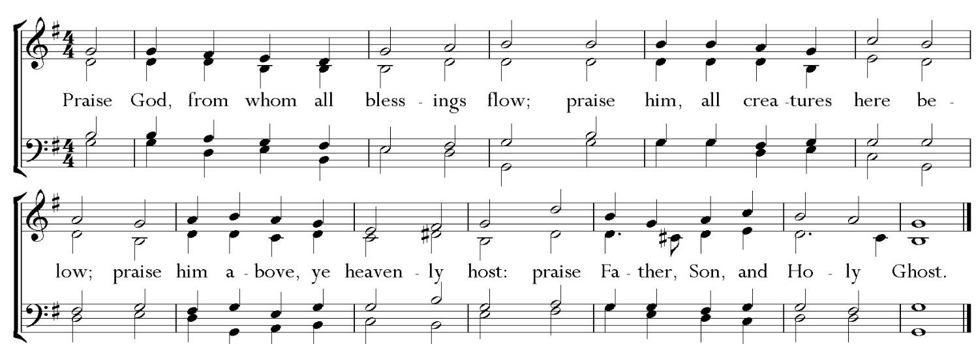

The Great Thanksgiving Eucharistic Prayer “A” | Please remain standing.

Celebrant The Lord be with you.
People And also with you.

Celebrant Lift up your hearts.
People We lift them to the Lord.

Celebrant Let us give thanks to the Lord our God.
People It is right to give God thanks and praise.

Celebrant It is right, and a good and joyful thing, always & everywhere to give thanks to you, Father Almighty, creator of Heaven and Earth.

Here a proper preface is said.
Through Jesus Christ our Lord. In fulfillment of his true
promise, the Holy Spirit came down [on this day] from
heaven, lighting upon the disciples, to teach them and to lead
them into all truth; uniting peoples of many tongues in the
confession of one faith, and giving to your Church the power
to serve you as a royal priesthood, and to preach the Gospel
to all nations.

Celebrant Therefore we praise you, joining our voices with angels and archangels and with all the company of Heaven, who forever sing this hymn to proclaim the glory of your Name:

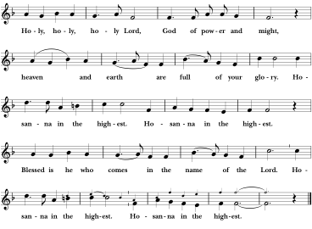
Sanctus
The People stand, sit, or kneel as they are most comfortable.

Celebrant Holy and gracious Father: In your infinite love you made us for yourself; and, when we had fallen into sin and become subject to evil and death, you, in your mercy, sent Jesus Christ, your only and eternal Son, to share our human nature, to live and die as one of us, to reconcile us to you, the God and Father of all.
He stretched out his arms upon the cross, and offered himself in obedience to your will, a perfect sacrifice for the whole world.

On the night he was handed over to suffering and death, our Lord Jesus Christ took bread; and when he had given thanks to you, he broke it, and gave it to his disciples, and said, “Take, eat: This is my Body, which is given for you. Do this for the remembrance of me.”

After supper he took the cup of wine; and when he had given thanks, he gave it to them, and said, “Drink this, all of you: This is my Blood of the new Covenant, which is shed for you and for many for the forgiveness of sins. Whenever you drink it, do this for the remembrance of me.”
Therefore we proclaim the mystery of faith.

Celebrant & People Christ has died. Christ is risen. Christ will come again.
Celebrant We celebrate the memorial of our redemption, O Father, in this sacrifice of praise and thanksgiving. Recalling his death, resurrection, and ascension, we offer you these gifts. Sanctify them by your Holy Spirit to be for your people the Body and Blood of your Son,
the holy food and drink of new and unending life in him. Sanctify us also that we may faithfully receive this holy Sacrament, and serve you in unity, constancy, and peace;
and at the last day bring us with all your saints into the joy of your eternal kingdom. All this we ask through your Son Jesus Christ.

By him, and with him, and in him, in the unity of the Holy Spirit all honor and glory is yours, Almighty Father, now and forever.
Celebrant & People Amen.

Celebrant And now, as our Savior Christ has taught us, we are bold to say

People & Celebrant Our Father, who art in heaven, hallowed be thy Name,
thy kingdom come, thy will be done,
on earth as it is in heaven.
Give us this day our daily bread.
And forgive us our trespasses,
as we forgive those who trespass against us.
And lead us not into temptation but deliver us from evil.
For thine is the kingdom, and the power, and the glory,
forever and ever. Amen.

The Breaking of the Bread

The Celebrant breaks the consecrated bread. A period of silence is kept.

Celebrant Alleluia. Christ our Passover is sacrificed for us;
People Therefore let us keep the feast. Alleluia.

Celebrant The Gifts of God for the People of God. Take them in remembrance that Christ died for you and feed on him in your hearts by faith, with thanksgiving.

All are welcome to receive Communion.
Communion Hymn O, spirit of life #505
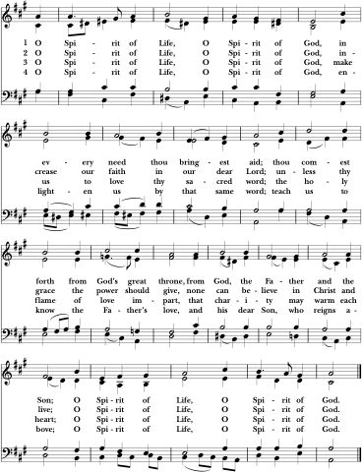
The Hymnal 1982: #505: Words: Johann Niedling (1602-1668); tr. John Caspar Mattes (1876-1948), alt. Music: O heiliger Geist, melody from Geistliche Kirchengesang, 1623; harm. Johann Sebastian Bach (1685-1750); arr. Alastair Cassels-Brown
(1927-2001)
Celebrant Let us pray

Celebrant & People Eternal God,
heavenly Father,
you have graciously accepted us
as living members of your Son
our Savior Jesus Christ,
and you have fed us with spiritual food
in the Sacrament of his Body and Blood.
Send us now into the world in peace,
and grant us strength and courage
to love and serve you with gladness
and singleness of heart;
through Christ our Lord.
Amen.
The Blessing

Dismissal Hymn Come down, O Love divine #516
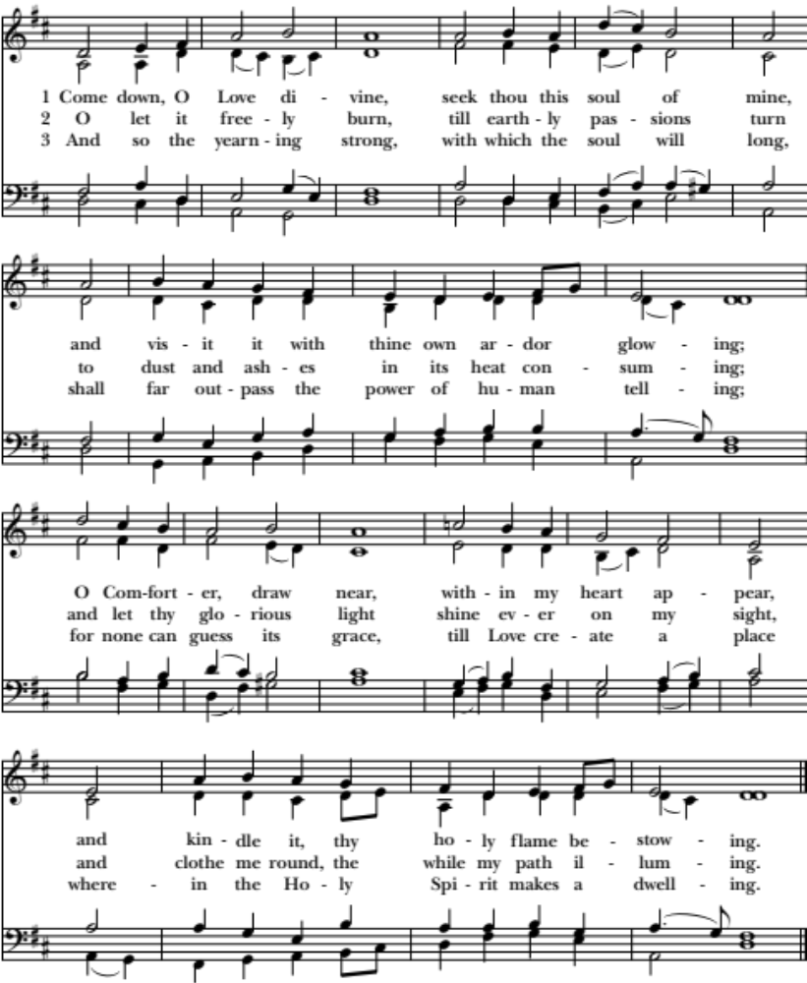
The Hymnal 1982: #516: Words: Bianco da Siena (d. 1434?); tr. Richard Frederick Littledale (1833-1890), alt. Music: Down Ampney, Ralph Vaughan Williams (1872-1958) Copyright: Music: By permission of Oxford University Press.

Celebrant Go in peace to love and serve the Lord, doing the loving thing.
People Thanks be to God. Alleluia! Alleluia! Alleluia!

Postlude Charissa Harjo
_______________________________________________________________
Image on Cover

Title: Veni Sancti Spiritus
Date: ca. 1965
Artist: Kossowski, Adam
Building: Roman Catholic Church of St Aloysius
Object/Function: Mosaic, City/Town: London , Country: United Kingdom
Scripture: Acts 2:1-21, General Subject: Pentecost, Holy Spirit, Dove
Permalink: https://diglib.library.vanderbilt.edu/act-imagelink.pl?RC=56946
(Use this link to refer back to this image.)
Copyright Source: https:www.flickr.com/photos/paullew/8750321716-Fr Lawrence Lew, O.P.
Attribution: Kossowski, Adam. Veni Sancti Spiritus, from Art in the Christian Tradition, a project of the Vanderbilt Divinity Library, Nashville, TN. https://diglib.library.vanderbilt.edu/act-imagelink.pl?RC=56946 [retrieved May 30, 2025].
Institution: Vanderbilt University Collection: Art in the Christian Tradition

The Bible texts of the Old Testament, Epistle and Gospel lessons are from the New Revised Standard Version Bible, copyright 1989 by the Division of Christian Education of the National Council of the Church of Christ in the USA, and used by permission. The Collects, Psalms and Canticles are from the Book of Common Prayer, 1979. From The Lectionary Page: http://lectionarypage.net

Our 10:00 a.m. service is streamed live each week at facebook.com/stmatthiaswhittier
and remains available for later viewing and sharing.

Saint Matthias Episcopal Church
7056 Washington Avenue, Whittier, CA 90602

Tel: (562) 698-9741 Fax: (562) 698-4347
Website: www.stmatthiaswhittier.org Email: office@stmatthiaswhittier.org

