Phase 0: Project Management

Planning Category 0.1: Establish Planning and Management Structures

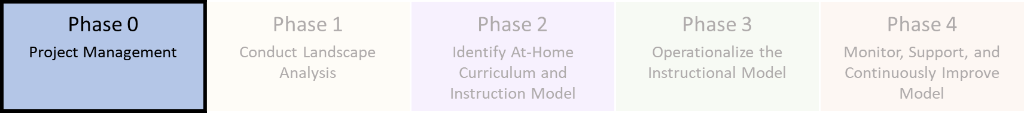

Planning Category Activities
- Outline cross-departmental district task force expectations, structure, and meeting cadence for instructional continuity planning.
- Create a project plan with activities, owners, and timelines. Note: Districts can adapt the Instructional Continuity Planning Tool spreadsheet to be relevant to local context.

Planning Guidance
Consider the following as you establish planning and management structures:
- The Instructional Continuity Planning Guide (this document) provides district leaders with guidance and curated resources that are aligned to each planning category in the Instructional Continuity Planning Framework. Please visit the Instructional Continuity Framework Overview presentation for additional information about the framework. This guide includes additional explanation about the planning activities outlined in the tool, including guiding questions, suggested people to involve in each phase, and tips and recommendations for implementation. This guide also highlights a mix of resources created by TEA and in the field.
- Building an Instructional Continuity Task Force: As districts are preparing to develop and/or improve their Instructional Continuity plans, the following guiding questions may be considered when developing a task force:
  - Who should be on the district leadership team?
  - What subcommittees are needed?
  - What is the goal of each subcommittee?
  - When will teams meet to discuss updates and make decisions?
  - How will teams meet?
- Building a Task Force Project Plan: Once a task force is developed, it is recommended districts build out a project plan to support the work of the group. The Instructional Continuity Planning Tool, an editable, Excel-based, step-by-step roadmap to guide district leaders through at-home instructional model implementation. The tool can be customized and provides a way to assign and track completion of individual activities. The tool is broken down into the phases and planning sub-categories of the Instructional Continuity framework. Please note, these curated resources have been provided as categorized examples for district leaders, however TEA recommends districts update the documents to reflect their local context.
- To get started with project planning:
  - Open the Instructional Continuity Planning Tool and skim it to become familiar with the five phases and 15 planning categories.
  - Choose where to start in the phases and planning categories. The tool is designed to be sequential, so start with the earliest planning category that your district leadership team has not yet completed.
  - Plan your approach. Reference this Instructional Continuity Planning Guide for guidance, tips, and resources related to each phase and planning category. Assign each activity to a district owner.
  - Track progress with the planning tool. Refer to the suggested day timeline in the planning tool to help keep your team on track. Mark each activity complete in the customizable Excel planning tool, then move on to next planning category.

Suggested Staff Support
- District: Superintendent and/or the Chief Academic Office are likely the best district staff to lead the Instructional Continuity task force and pull in other leaders after team is established. Superintendent may consider creating planning subcommittees based on district size in alignment with the proposed planning sub-categories.
- School: It is recommended to bring a sample set of school leaders to sit on the task force as needed.

TEA Resources Posted
- Instructional Continuity Framework Overview
- TEA Instructional Continuity Planning Tool: Editable, Excel-based, step-by-step roadmap to guide district leaders through at-home instructional model implementation

Additional Resources
- Instruction Partners Key Actions-Guiding Questions: Provides a set of questions and options to be considered when developing task force

District-Created Examples
- Wylie ISD March 16 Instructional Plan in Case of Closure

