
KANSAS SUNFLOWER REGENT
To become a Kansas Sunflower Regent,
complete this form and mail it with your check to
KFRW Treasurer Marcia Brungardt
10917 W 1st St., Wichita, KS 67212
To pay by credit card, call Marcia directly at (316) 670-9831﻿
﻿
You can also pay by scanning the QR code below.

GOLD LEVEL
$500 for 2026
or
$950 for 2026 & 2027
_____
SILVER LEVEL
$250 for 2026
or
$450 for 2026 & 2027
_____

BRONZE LEVEL
$100 for 2026
or
$175 for 2026 & 2027

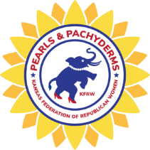
KANSAS SUNFLOWER REGENTS

NAME: _
EMAIL: _
PHONE #: _________________ CLUB: _______________________
FULL ADDRESS: __________________________________________
________________________________________________________
DATE PAID: _________________ FORM OF PAYMENT: __________
Check # (if applicable) ____________
OCCUPATION: ___________________________________________
(This is required by the Kansas Ethics Commission)

- I am paying for the following year(s) ______________________
as a __________________________ Regent.
(Bronze, Silver or Gold)
THANK YOU FOR SUPPORTING THE KANSAS FEDERATION.



