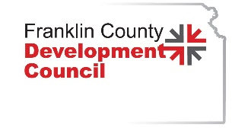

Workforce Report
Submitted by Paul Bean
April 2024

I recently attended the national conference of the National Association of Workforce Boards. As a board member of our regional workforce board, it was an informative and insightful conference. This document is being written to share with you the ideas, trends, and disruptions relative to workforce that were shared at the conference.

Our Shrinking Labor Pool

We are all aware that our labor pool is shrinking which is making it difficult to find new talent for our job openings. This is not a short-term event and it is a global issue. In the next year 4.1 million people will retire from the workforce in the United States. Unemployment is at historic lows across the country. The unemployment rate in Franklin County for February was 3.1% A key factor is how many of the remaining eligible workforce are participating.

According to the Brookings Institute, the national labor participation rate is 61.8%. This is the lowest level in 45 years. Kansas labor participation rate in January was 66.1% so slightly better than the national level. The good news is that ages 25-54, the prime working age, has a national participation rate of 81.8%. The main workforce demographic is participating at a high level historically. This group is also found to be job jumping much more frequently, representing low loyalty to current employers. This group is also declining in numbers. Birthrates across the United States and the globe are declining. So, participation is high, but with a smaller pool of people.

In 2021 the United States had 3.66 million births and 3.5 million deaths. The population of the United States is 327 million. In 2021 our national population growth was .003% which is basically no growth. According to Statista, our birthrate is at its lowest since 1990 (Last date provided). The birthrate has been declining since a peak in 2007. The birthrate is down 23% since 2000. So, the number of younger people entering the workforce is declining. When compared with the rapid rate of people leaving the workforce it is easy to see that challenges that are before us in relation to workforce will be with us for years.

Building Our Workforce

At the NAWB conference we had some great presenters speak about workforce challenges and opportunities. Represented in this group was the Vice President of Global Education & Workforce Development at IBM, a Director of Workforce and Economic Development at Amazon, the acting Secretary of Labor, the Maryland Governor, a Walmart executive, and the head of global sales at FESTO, which is an automation technology company. We also had speakers from several community colleges from the Chancellor level to the Director level. The information I will be sharing came from these presenters.

There are several disrupters to our workforce pipeline and the skills required in the future workforce. I have already discussed the shrinking workforce as one of those disrupters. Another disrupter is the rapid rate of change and innovation currently taking place in our world. This has a tremendous impact on how to prepare our future workforce and support our existing workforce.

World knowledge is changing rapidly. In 1800 societal knowledge doubled every 100 years. In 1900 it doubled every 50 years. Today, it doubles every 12 hours. It is believed that with the future development of artificial intelligence, the knowledge growth will become even more rapid. This represents an ever changing and highly competitive marketplace for innovation, production, and workforce development. This means we need to think about how we prepare our future workforce. Our education delivery systems for future workforce will need to adjust as will our hiring practices.

One suggestion was called, “Just In Time Education”. The emphasis is on fast tracking our degree and certificate programs as “knowledge” is transforming the workplace at such a rapid pace. One target audience for this type of programing is the “New Majority Learner”. These are adults without a post-secondary degree or certification and represent 40% of our current workforce. What type of 8-16 week programs can be created to meet industry needs for their workforce. Education must move at the pace of industry in the future.

It was also suggested that in K-12 education we think of building a system for careers. The example given was how we provide opportunities for sports throughout childhood. We start with little league, summer programs, middle school, high school, college, etc. What type of career building program can be designed to support the skill development of our youth for our future workforce needs?

Questions we need to answer include: How do we get industry and our education partners together to coordinate more closely for the future? How do we educate school boards and accreditation agencies on the new dynamics at play? How should federal/state/local funding be targeted to assist? What are we doing now that we need to stop or adjust? What are we not doing that we should? Who needs to be at the table?

Artificial Intelligence (AI)

Artificial Intelligence is probably the largest disrupter and the one that is hardest to predict. As mentioned above, AI will only increase the speed of innovation and production. As a result, it will have a large impact on the labor pool. What jobs will no longer be completed by humans and what new jobs will AI create requiring a newly skilled workforce. Much of this is still unknown but we do have some idea of the general impact.

We are already seeing the impact of new technology on the workforce. The pandemic accelerated the move to robotics in manufacturing. We are even seeing jobs replaced in retail checkouts, fast food restaurants, and other employment opportunities. This is low level AI working through robotics.

It is believed that the next wave of jobs most at risk from AI are the white-collar jobs, while the blue-collar jobs will be less impacted. Jobs requiring analysis, critical thinking, reporting, strategic planning, marketing, etc., will be supported by or replaced by AI in the coming years. AI can do these jobs much quicker and with lower error rates. The need then is to understand the “new” jobs needed and how do we “fast track” the learning of the necessary skills. What are the human roles that support and enhance the AI impact?

It is also important to understand that AI is still a work in progress. The programing of AI can and does reflect biases that exist within the programmer. Two examples of this were given. In one test 100 applications were reviewed by AI for consideration of an imaginary job. The only difference on the applications was the name of the applicant. Of the names that implied a minority, 44% did not get selected for further consideration by AI. Another example was AI was asked to print a picture of a beautiful woman in four different settings. In each case, the woman was white. It is important for us to understand the risk and limitations that can reside in AI as it is further developed.

The last example of the impact of AI could be found in this report. If I had used AI to write this report it would have been completed in a matter of seconds. I would list my key points and the report would have been written quickly by AI. I will have spent a couple of hours writing this report.

New Focus In Hiring/Promotion

Many of the presenters spoke on the topic of Skills Based Hiring. Companies such as Amazon, IBM, Walmart, and others are moving in this direction. Skills Based Hiring is a dynamic shift in consideration of what hiring professionals are looking for in an applicant. It emphasizes the “skills” that the applicant can provide, more than the completion of a degree or certificate. However, the “skills” can be obtained by the degree or certificate as well as lifetime learning.

The larger companies I mentioned earlier have removed the requirement of a degree for many, not all, of their positions within the company. Instead of valuing a degree, they are seeking to understand the actual skills that an applicant can bring to the job. These may be lifetime learning, experiential, and of course educational methods of gaining a skill. It is not necessarily skills instead of a degree/certificate, but what skills did you get from your degree/certificate. They encourage applicants to speak to the skills they gained from their degree, more so than the degree itself. A large percentage of new hires are not working in a field related to their degree. Hiring is based on skills more and more each day.

The discussion did not reflect that degrees were no longer relevant. Of course, for some jobs they are most definitely required. I do not think we want a doctor operating on us without proper training. But the message was that the doctor’s skills are as important as is his degree. The achievement of earning a medical degree is an indication of a certain skill level, but not the whole story of how good of a doctor he/she is. The same is true for other professions. That is the logic behind Skills Based Hiring.

What Do We Do Now?

I walked away from the conference understanding that our workforce world is changing in many ways. We all know of the applicant shortage and I have spent some time in this report sharing what is behind this shortage and why it is not a short-term problem. The number of people just does not equal the number of jobs. We are and will see a dramatic shift to robotics and AI as technology allows. As a result, we must have discussions as to how to address the changes we know are coming.

We know the primary workforce is age 25-54. We also know that this group will see dramatic disruption in what their job entails and how the job is done. Training and support will be critical. We know this group (especially on the younger end) are not loyal to an employer as maybe other generations were in general. The work environment will be important to retention of this workforce as will additional training, retraining, and overall support systems. The interesting note to build upon is that in a survey mentioned at the conference, these younger workers have more trust in their employer than they do government and education institutions. How does industry utilize this trust more effectively?

My biggest takeaway from the conference is that we must enable our industry/business to partner more directly with our education partners. Educational organizations will benefit from coordinating more directly with the business/industry community by building programs that are streamlined and meeting the current (and ever changing) needs of the business/industry community. This will generate strong partnerships for job placement and potential revenue from creative commercial partnerships. It may allow for programs to be created that can be built for business/industry leadership to help them keep up with various innovations and trends. It will also assist the educational organizations in measurement for job placement results. Programs will need to be developed and delivered quickly, and may not have a long shelf life.

The business/industry community can benefit greatly from building workforce pipelines that are connecting them to future workforce and the ability to quickly retrain existing workforce. These connections and benefits will increase retention, productivity, and recruitment outcomes. It was shared several times that skills-based hiring is resulting in higher retention reflective of job satisfaction. The skills are meeting up with the job requirements and producing positive results for the employer and the employee. Working with our education partners can also lead to great opportunities for internships, apprenticeships, and quality applicant recruitment. By connecting more directly with our education partners, business/industry will be well positioned for the people entering the workforce every year.

Skills based hiring is a long-term shift, not a short-term shift. But it is beginning to happen. Systems, attitudes, and methods of measurement will need to be created/adjusted. Coming from higher ed I can tell you that our education partners will need help from our business/industry partners in helping our accrediting organizations understand the need for change in how accreditation is determined. It cannot be left up to just our education partners. Our education partners will need to listen to the needs of business/industry in return.

As the Executive Director of the Franklin County Development Council, I am ready to help facilitate these discussions to help our community become a leader in workforce development. It will be critical to our opportunities for growth and prosperity. I will be visiting with the FCDC board for direction and support on this issue. I welcome comment/feedback from all the FCDC membership. I am happy to sit down and have a one-on-one conversation with anyone that would welcome this discussion.

It will be important that we continue to work to attract new housing and affordable childcare. It would be a mistake in my opinion to not continue to work to attract new and additional talent to our community if we expect to fill Proximity Park and help our existing industry grow. The private sector must continue to work with public officials to provide an attractive commercial environment for industry and business to consider locating and growing in our communities.

In addition to this written report, I am attaching some other articles for your information. One is a “Good Jobs Principles” sheet. This is hopefully helpful as you consider a workplace environment that will help with recruitment and retention of your workforce. I see this one as low hanging fruit.

I am also attaching an article that speaks in more depth about Skills Based Hiring. I hope you find it helpful.

In closing I want to thank our local workforce board, the Heartland Works Area II, for providing the funding for me to attend this conference. No local tax dollars were used for me to attend this conference. The local area workforce board is a tremendous resource that we can turn to for support and guidance on our workforce challenges and goals. Our local workforce board is a key asset to our community as we work to build a strong workforce that includes opportunity for all members of our community. I am proud to be a member of this board and help represent our community and support our 17-county region that is covered by the Heartland Works Area II.

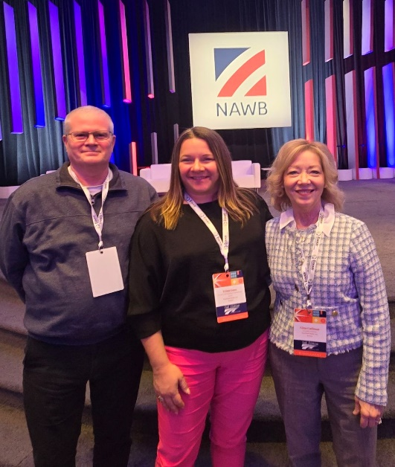
Paul Bean – Board Member, Heartland Works
Trina Goss – Board Chair, Heartland Works
Gina Coffman – Executive Director, Heartland Works

