Franklin County Development Council
“It’s A Great Day to Live In Franklin County!”

Monthly Report to Ottawa, Franklin County, and Membership
August 2024
Respectfully Submitted by Paul Bean, Executive Director

Industrial Development

We had five RFI’s during the month of June. We were able to submit on one for a manufacturing company. We declined on one due to the request for 1,000 acres. We declined on three as they required an existing building

Workforce

I recently attended a conference in Topeka that was hosted by Go Topeka. The guest speaker was Mark Perna who is an expert on generational trends and attributes. He spoke in detail on Gen Z as they are continuing to make more and more of our workforce in partnership with Millennials.

By the year 2030 these two generations will make up 80% of our workforce. So, it is important that employers understand some of the general traits of these two generations.
- 2000–Present: New Silent Generation or Generation Z
- 1980 to 2000: Millennials or Generation Y
He has a number of tools and videos that might be helpful to us “older” folks as we learn how to engage and motivate these younger members of our workforce. Here is one video on engagement:

https://www.youtube.com/watch?v=lApNcpaBlaw

This was an informative conference of which I hope to share more information with our members over the coming months.

Housing

The City of Ottawa presented numbers that speak to the need for more housing. We know we need housing for workforce, but we also need housing to spread our property tax cost to more citizens. The total property value that is used to compute property tax rose by $12,937,086. Only 13% of that increase was represented by new housing being built. The remainder of the increase came from the increased valuation of existing housing. This represents that the existing homeowners continue to carry a larger and larger burden from the property tax aspect.

Property Taxes are arrived at by a combination of the total property valuation and the mill rates set by each taxing authority. Below is a three-year history of the mill rates set by the taxing authorities for Ottawa as presented by the City of Ottawa.
 | 2022 Mills | 2023 Mills | 2024 Mills
USD 290 | 61.076 | 60.185 | 60.013
Franklin County | 58.043 | 53.786 | 49.431
City of Ottawa | 45.968 | 46.011 | 44.844
Recreation Commission | 6.009 | 6 | 5.98
State of Kansas | 1.5 | 1.5 | 1.5
Frontier Extension District | 1.429 | 1.27 | 1.173
 | 174.025 | 168.752 | 162.941

FCDC supports and encourages aggressive efforts by our community leaders to encourage and stimulate new housing developments. This will help us attract more workforce but also spread the property tax burden amount more households. I heard on KOFO today that an item being mentioned the most as the most important need as they meet with the public on their strategic plan, is housing. It will take a public private partnership to truly solve our housing shortage for the long term.

FCDC hosted a meeting of realtors and local builders to discuss how we can jump start a new housing development. More discussion will follow.

Princeton

We assisted in hosting Representative Sharice Davids recent visit to Princeton. She met with city commissioners and citizens to learn more about the stormwater issues occurring in the community. She has submitted a grant for over $600,000 to the appropriations committee of the house of representatives to provide funding for the improvements needed in Princeton. We hope to hear back on funding by the end of the year with expectation that funds would arrive in late 2025.

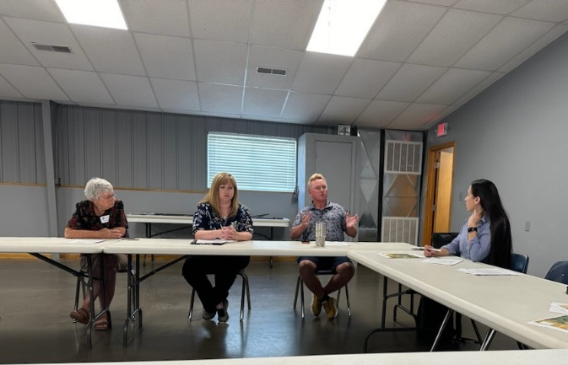

In 2025 FCDC will be working to pull together a comprehensive grant request that would impact all cities and towns within Franklin County. This work will be done in coordination with Rep Davids office and leadership at the county and community levels.

Executive Director Comments

Power has reemerged as a challenge for our community. We continue to have power outages on the north side of town which impacts our existing industry and our residents. I am hearing frustration from the industry on the north side as to their feeling of a lack of timely communication from the city when the power outages occur. They also indicate a frustration with not seeing a long-term solution to the problem. This raises concerns as to retention of existing industry and recruitment of new industry.

The ongoing power issues have a negative impact on the production cycles of our existing industry. In addition, in some instances it is damaging equipment and machinery of our industrial partners. This impacts cost and profitability of our local industry. In addition, it discourages consideration of expansion of operations. I have had discussion with industry that is/was interested in expansion but with the inconsistent power supply those thoughts/discussions are on hold.

My largest fear if we cannot solve this issue in a manner acceptable to our industry, we might lose one or two of them to a community that can better provide a stable power source. We live in a competitive world as we have seen with recruitment to Proximity Park. We must remember our existing industry could look for what they believe to be “better” solutions.

It is the position of FCDC that the power issues should be a top priority to maintain the industry we have and to be better positioned to attract new industry. This includes better communication and a more stable power supply. This does not address the other issue that FCDC has raised regarding the need for increased power capabilities to attract new industry related to new manufacturing technologies.

FCDC continues to work on a new comrehensive strategic plan. This new plan will serve to guide our efforts, energy, and funds for the next five years. Goals and objectives will be reviewed and update on an annual basis within the time frame of the overal strategic goals.

