Franklin County Development Council
“It’s A Great Day to Live In Franklin County!”

Monthly Report to Ottawa, Franklin County, and Membership
April 2025
Respectfully Submitted by Paul Bean, Executive Director

Industrial Development

Fashion Inc hosted the FCDC industrial luncheon. We had a terrific turnout and of course received great hospitality from the folks at Fashion Inc. Guest received an overview from Lonnie King and then were treated to tours of the facility. It is amazing all that this great company does across the country.

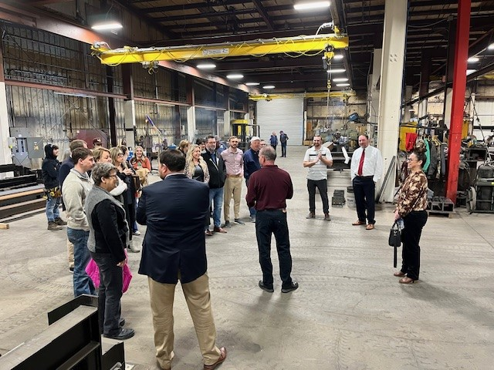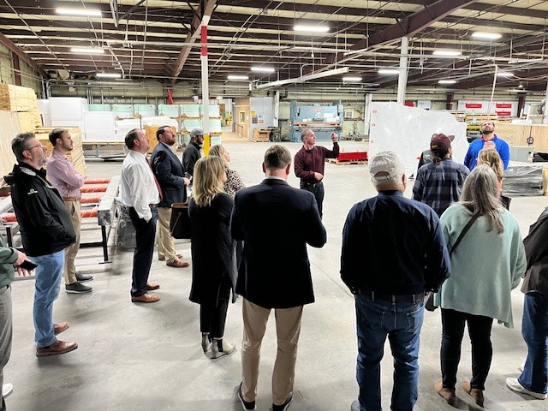

If your industry would like to host an industry luncheon, please let me know. It is a great opportunity to share all you do in your industry and for our community!

Wellsville

We submitted a Safe Pathways grant for improvements to sidewalks, crossings, and ADA access points. This was a grant request of just over $131,000 toward a total project cost of $187,000. We hope to receive a response by the end of June.

Workforce

We are hosting a lunch on April 7th for the area USD superintendents and Kansas Works. This is to help build connections between Kansas Works programming and our local school districts.

We continue to work on hosting a group of soldiers from Ft. Riley on April 23rd. We will have 15-20 soldiers visiting our community that day. During the morning they will receive a tour of some of our industry, a tour of Ottawa, and then be provided lunch and further information while we host them at Ottawa University.

We have also been coordinating the placement of the KS Works Mobile Van when it is in Ottawa each month. Last month it was at Bank Midwest. In April it will be at Ottawa University and in May it will be at Eugene Field. I appreciate the support of our partners here in Ottawa as we work to better promote this service and make it available to our younger job seekers as well.
Housing
FCDC paid for a new housing study that was completed this past month. This study was for all of Franklin County but also had specific reports included for Ottawa and Wellsville. This information has been shared with the municipalities, realtors, and developers.

Membership

Our membership budget for 2025 is $50,000. It appears that we will surpass our membership goal this year. When the last payments are processed, we will have received $51,000 or more in dues this year. THANK YOU to our loyal and supportive members!!!!

Executive Director Comments

We continue to work with Witt O’Brien to find potential funding sources for various needs throughout Franklin County. As grant opportunities are presented, we have been forwarding them to the cities and the county. Some funding is currently on hold, but we continue to apply in the event funds are released in the future. “Don’t ask, Don’t get!”

The FCDC board held a strategic planning session in April. This was a great discussion as the board begins to define the priorities for FCDC for the next 5 years. I more robust report will follow but the key areas of focus appear to be Housing, Workforce, & Childcare. These are of course all interrelated. A big THANK YOU to Ryan Wilkerson who facilitated the discussion.

