Franklin County Development Council
“It’s A Great Day to Live In Franklin County!”

Monthly Report to Ottawa, Franklin County, and Membership
September 2025
Respectfully Submitted by Paul Bean, Executive Director

Industry Recruitment

We have received a several inquiries from Commerce and KCADC in recent weeks. Most of these need acreage that we do not currently have available. We will need to hold discussions between the city and the county as to how FCDC can facilitate discussions that could involve both entities. We do have a land owner with land adjacent to Proximity Park that is open to discussion if we have a solid lead.

The questions that need to be worked out involved utility availability and any potential thought to annexation if a project were to choose land adjacent to the park.

FCDC Leadership Teams

Housing
We continue to work with potential developers on various projects.

Childcare

We have gathered a listing of area childcare providers. Will be working on a survey to discover from the providers their needs, challenges, and opportunities.

Existing Industry Support

We will be hosting a morning coffee for discussion regarding the benefits and challenges created by the “Big Beautiful Bill”. This event will be on October 14th at Ottawa University from 8:00 AM to 9:00 AM. Invitations will be going out later this month.

Workforce

We have asked and received a listing of votech schools on the East Side of the State. We hope to work to build connections with all of these schools with our area industry.

Paul visited Ft. Riley’s job fair in September. Much of this effort has had its funding cut so will not be as robust in 2026. However, there will be an opportunity for Ottawa and area industry/businesses to highlight opportunities on November 13th. Ottawa will have a section at their on base job fair to promote our community and careers. Below are pictures from their event in September.
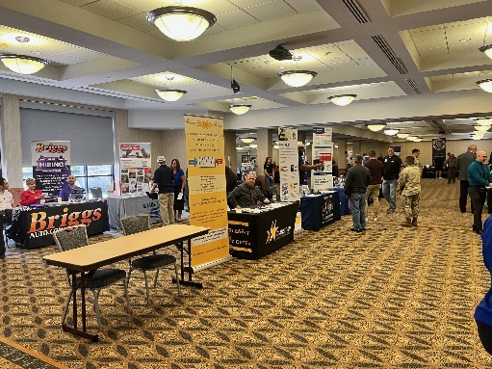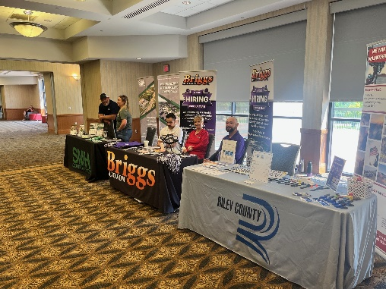

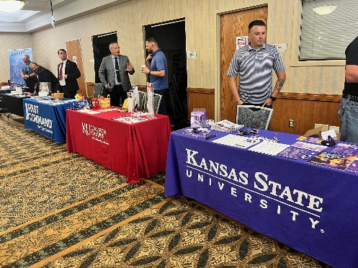

FCDC continues to work with our area school districts as we prepare for the 2025 Franklin County Career Day. The event will be held at Ottawa University on November 5th during the morning. FCDC is now accepting reservations for industry/business/school participation. You can reserve a table to be in the gym and talk to students about your industry/business/school. You can also help sponsor the t-shirts that will be given to all the students. The sponsorship is $100 to have your business listed on the back of the shirt.

FCDC continues to be ready to support Ryland Miller’s efforts to get Make My Move activated in our community. He continues to be on top of this as we wait to get the state funding so we can begin to actively work this program to recruit workforce to our community. We are ready to act, just waiting on the state funding.

eCommunity

We are hosting a lenders luncheon to share updates on the eCommunity loan programs. This event is being held September 11th at PrimeTime Grille from 11:30 – 1:00

Pomona

FCDC is working with the City of Pomona to help update and rewrite their city wide comprehensive plan. The plan was last updated in 1993. FCDC will be meeting with their planning commission for regular updates on the progress. Over a period of several months FCDC will update data and work to get a sense of goals and objectives to present to the commission for consideration. FCDC will work with the planning commission and the city commission to create a draft. Then we hope to facilitate a town hall meeting to receive community feedback before any plan is officially adopted.

Wellsville

We continue to work with the city on grant request. Currently we are working on a grant for improvements to Pendleton Street. KDOT will begin work on 33 hwy this spring as they widen the road and put in a roundabout. We are working to coordinate our grant request to KDOT for Pendleton with this project currently in motion.

We are also considering grants for safe pathways, also from KDOT and for playground equipment. In addition, we have had conversations with the Wellsville Recreation Commission about their desire for growth in facilities.

Franklin County

FCDC recently worked with the county on another federal grant request. This one is to replace/repair two bridges in the county. This grant is under the BIL program, so we have submitted to the State of Kansas for their consideration of a match. Later this month we will submit the federal application.

Earlier this summer we submitted a federal grant for some funding to assist with flood mitigation and safety. The state of Kansas has approved the match subject to funding from the Federal government. Now we just wait to see what/if the federal government will do for us.

Executive Director Comments

I am a member of the board of the Kansas Economic Development Alliance. Our annual conference is this month. I will be in Dodge City September 22-24 for this conference. Economic Development professionals from across the state will attend this informative conference.

FCDC continues to push the Kansas Works staff to advocate for a position to be filled that would bring a fulltime employee to Franklin County to work on workforce and job placement. The last report from Kansas Works was that they are currently interviewing for this position. This would be a position funded by Kansas Works. This person would work closely with industry and education organizations on filling workforce pipelines.

Our four leadership teams continue to meet and work on our focus areas, Workforce Development, Housing, Childcare, & Industry Support. I am grateful for the time and effort these folks are putting into working to find solutions to these barriers to economic growth in our community!

Thank you to all of our members. Your support is making a difference!

