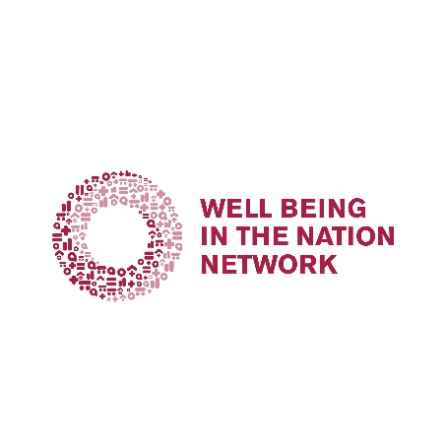

Stories and Dialogue

The Story and Dialogue Cooperative anchors the big ideas of WIN through voices and perspectives of stewards working in communities and organizations across the country. Stories, in a variety of formats, elevate the possibilities of well-being initiatives, shifting the dominant narrative around intergenerational health and equity. Dialogues spark new conversations, facilitating action steps for implementing policy recommendations and pilot measures.

Join us on Tuesday, April 14th at 9 am PT/12 pm ET to create our WIN-COVID dialogue guide. Cooperative members will integrate elements from the Living Room Conversations guide and Communities WIN to develop a tool for collective reflection and action.

Interested in learning more about the Cooperative or participating in the April 14th session? Contact Elizabeth Hartig: ehartig@communityinitiatives.com.

