STEPtember Registration Instructions
- Follow the link to register: https://www.steptember.us/register/us
- Fill in your information and continue.
- Link your registration to Forge Health! Screenshots are below:

- Select “Yes, I want to join an organization or school”
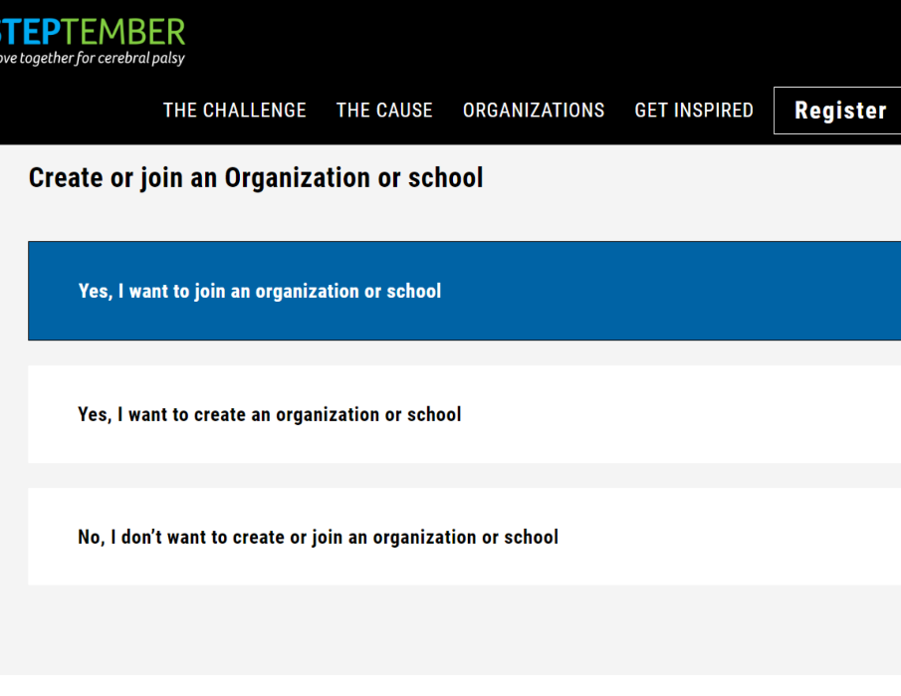

- Search for Forge Health
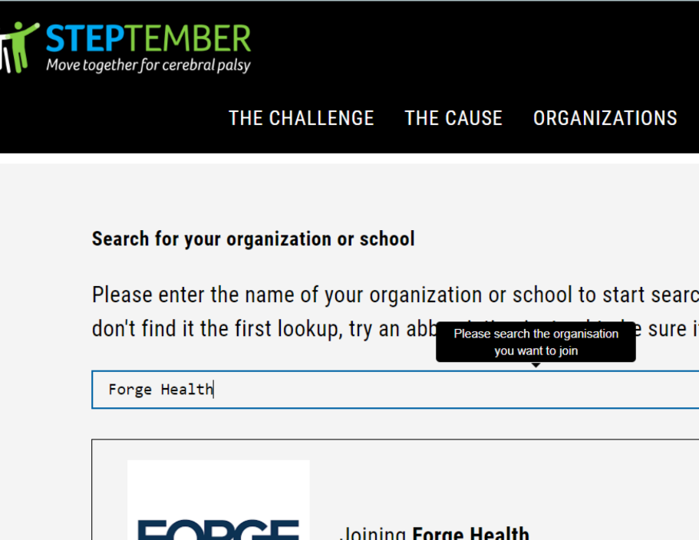

- You can create a team with others in your office, or you can participate on your own, this option is voluntary and completely up to you.
- Feel free to donate any amount or set a fundraising goal for yourself, but this is NOT required. You can skip these steps to continue.
- Your registration should be all set. Feel free to go back and edit your goals or team at any point

