FAWCO Friendship Quilt 2019 Instructions
It was exciting to hear that the next FAWCO Conference will be in Edinburgh (and I hope you can all come!) Robert Louis Stevenson, Walter Scott, Arthur Conan Doyle, Muriel Sparks, Ian Rankin, Iain Banks… What do all these writers have in common? All Scottish, and there are too many more to list them all. Scottish writers have created genres and helped steer the course of English-language literature. And of course we can’t forget Andrew Carnegie, who emigrated to the US, made a vast fortune in the steel and railway industries, and then spent a vast fortune founding local public libraries. We’re approaching the end of the SDG Education Target Project fundraising cycle, symbolized by that stack of books on the FAWCO Foundation’s website. (Go have a look, we’re well on the way to exceeding our goal!) So maybe it’s time to put those books on a shelf and make a Library Quilt. Credit for this idea goes to Randi DeBourg. (Disclaimer: The money we raise on the Quilt Raffle is not earmarked for a particular program. The Foundation uses it to top up wherever something is under-funded.)
Go look at your own bookshelf and pick a few favorites. Measure how wide the spine of each book is, and add a half inch for seam allowances. Our bookshelf will finish at 9” high, so cut strips for each of your books that are up to 8.5” long. For the shadow in the back of the shelf, use navy blue. Add a little strip of navy blue to the top of each “book”, press the seams open, and sew the strips together. You should have a little row of “books” with navy shadow at the top, 9.5” tall. Your block does not have to be 9.5” wide, any width is OK. But I’d really prefer not to see anyone send me the entire Encyclopedia Britannica (first published in 1768 by Colin MacFarquhar and Andrew Bell from you-know-where; the thistle is its logo.) Don’t forget to write the titles on, using Pigma acid-free archive pens (or embroidery if you love it more) and sign your name and/or your club somewhere. I don’t care what color your books are, as long as you use a navy blue shadow at the top.
Deadline: October 10, 2018. Rl.zollner@gmx.net for questions. When you mail me the blocks, make sure to include your own email so I can let you know they arrived.
Here’s mine, front and back: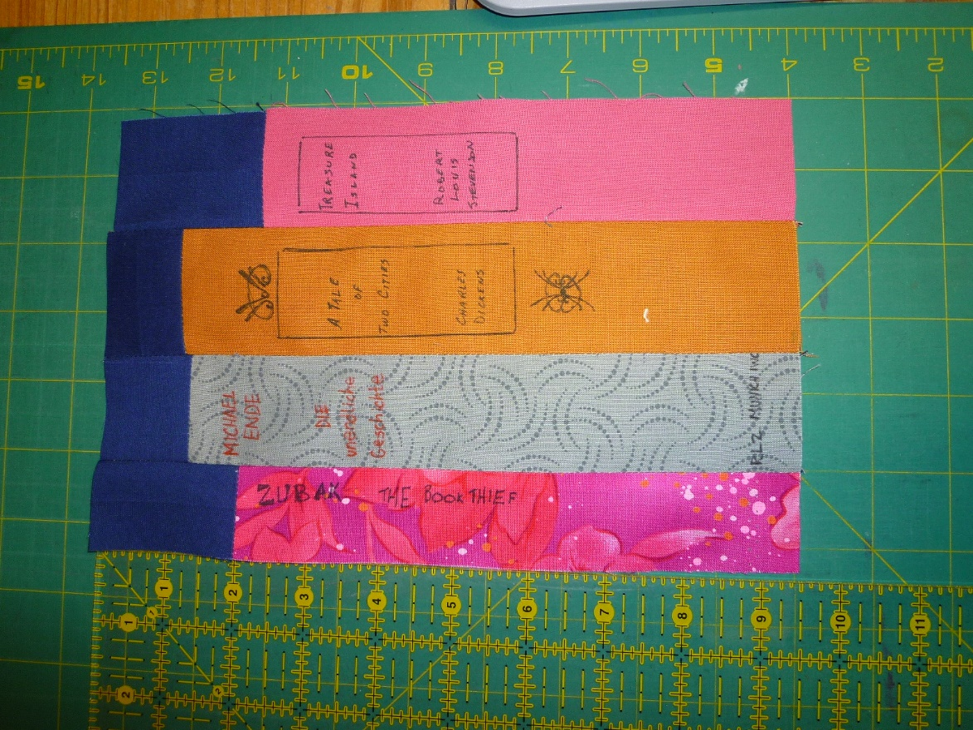
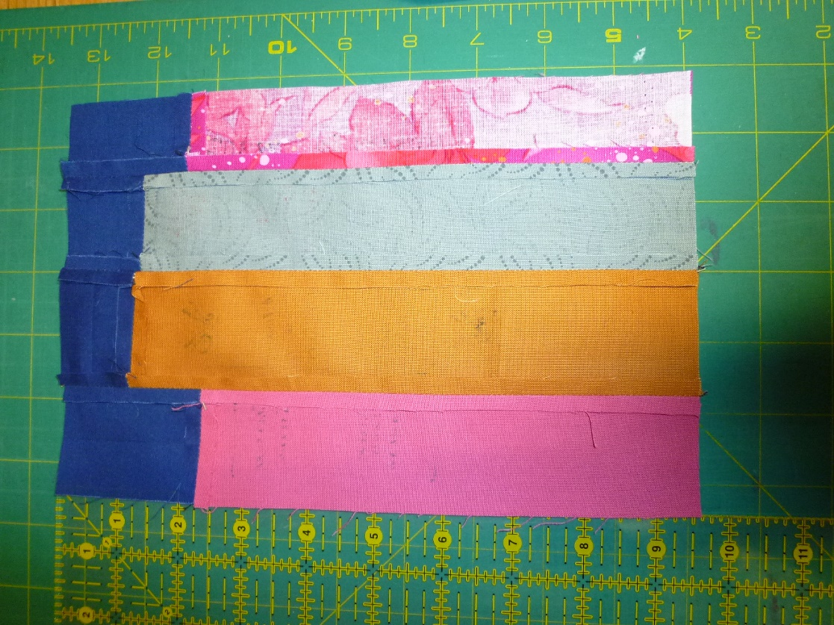
https://www.etsy.com/listing/219056902/custom-order-only-bookcase-quilt?ga_order=most_relevant&ga_search_type=all&ga_view_type=gallery&ga_search_query=library%20quilt&ref=sr_gallery-1-16
If the link works, it should show you one example of a finished quilt. There are lots more out there (search “library quilt” or “bookcase quilt”), but our quilt will be unique!

