Spotlight on ELAM/ELH Institutional Action Projects at the 30th Anniversary!

In honor of the 30th Anniversary of ELAM, we are pleased to feature an online poster event entitled ELAM Institutional Action Projects: Impact over 30 Years to highlight the IAP projects of our ELUM community. This showcase of your IAP posters (PowerPoint format) and abstracts (PDF format) will be shared via the online platform Fourwaves. ELUMs are encouraged to submit an abstract and poster, even if you are not attending the Anniversary.

The Fourwaves platform also enables you to include a recording of an oral presentation of your poster. If you are interested, you will be able to upload a recording created using your phone or Zoom to describe:
- the goal of your IAP
- a description of the work you did and the results you achieved during your ELAM/ELH fellowship
- the current status of your IAP and the outcomes realized since graduation from the program.
- Please also include how work on this project has influenced you as a leader and your leadership journey.

We implemented the Fourwaves platform at the spring 2024 Leaders Forum, to host the ELAM/ELH poster session virtually, and it was a great success! You can view the 2024 abstracts and posters here.

The showcase promises to be an inspiring demonstration of the deep and ongoing impact of participation in ELAM/ELH on Fellows, their institutions, and academic health sciences as evidenced by the outcomes of the Institutional Action Projects and the impact of this work on the Fellows’ leadership trajectories.

If you are interested in creating a submission, please reply to Barbara Overholser (bro29@drexel.edu) by January 15, 2025.

The deadline for submission of the abstract, poster, and oral presentation (optional) is February 21, 2025.

We encourage you to participate and share your success!

Sincerely,
Maryellen E. Gusic, MD, ELAM 2009
IAP Module Lead

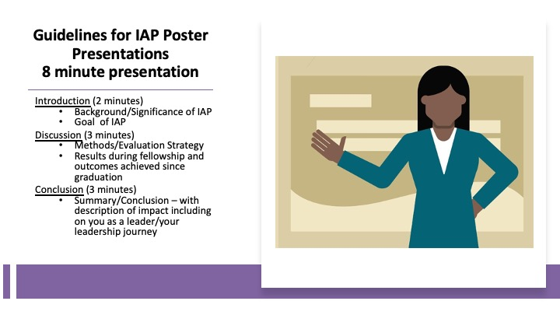
*Please feel free to use your phone or Zoom to make the video.

