
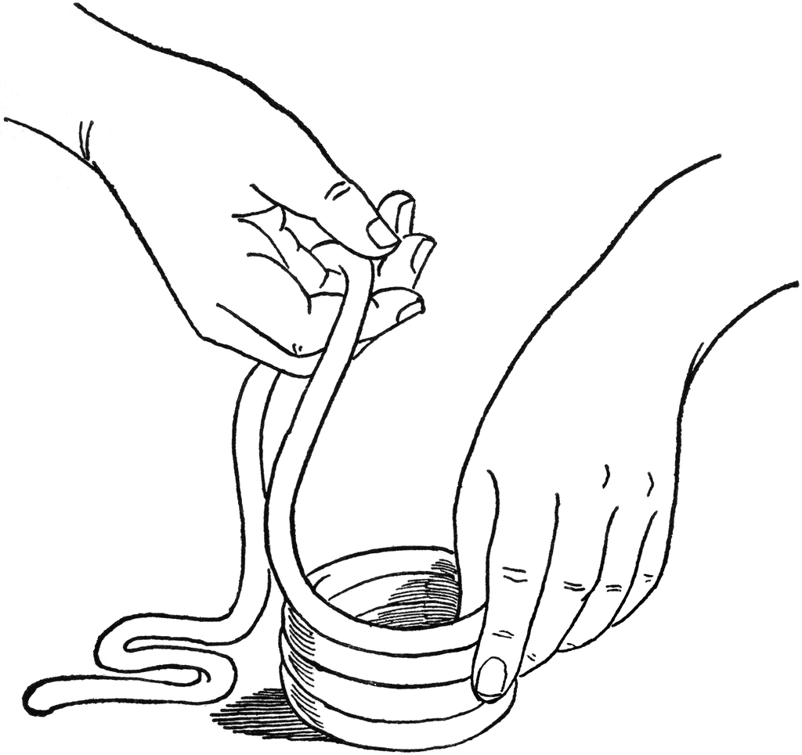
brams
A

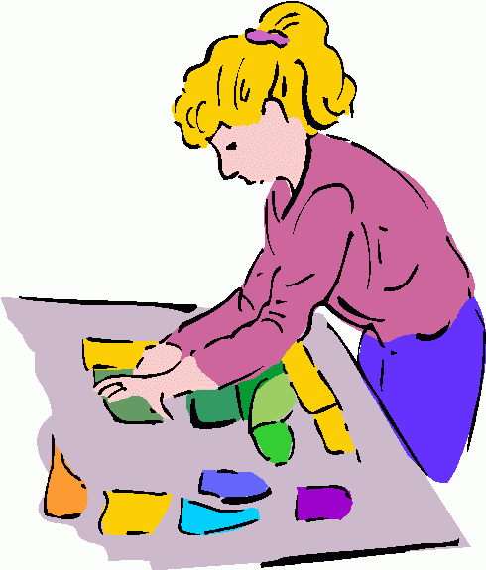
A
rt
A
fter-School
Dates: Tuesday Afternoons
January 15 – March 19 (No class 2/26 or 3/5)
Time: 3:30-5pm
Place: Abrams Hebrew Academy
Cost: $100
Explore many different mediums such as clay, nail polish marbelling, fabric painting, weaving and sculpture. We will work on projects that are not possible for me to do in a classroom setting. Class size is limited and open to 1st – 8th grades. Smocks are highly recommended.
Please send an extra snack with your child.
For more information, you can contact me at (609) 605-3073 or dmoskowitz@aha.jdschools.org
Registration Form
Name:______________________________________

Grade:___EmergencyPhone #_____________________

Anything I need to know?

Make checks payable to Donna Moskowitz
Check out my website at artdonnam.wix.com/art-by-donna or on Facebook at Art by Donna
By
Donna Moskowitz

